

**《数据结构》**

**实验报告**

|  |  |
| --- | --- |
| 院 系 | 自动化学院 |
| 专业班级 | 自动化理工交叉创新实验班1701 |
| 姓 名 | 李星毅 |
| 学 号 | U201712072 |
| 指导教师 | 韩守东 |

2018年 10 月 21 日

目录

一、问题描述 1

1. 实验要求 1

2. 实验任务描述 1

2.1 随机算法 1

2.2 四原色 2

2.3 哈夫曼 2

2.4 Dijkstra 2

2.5 堆排序 2

2.6 折半查找 2

3. 运行环境 3

二、算法设计 4

1. 随机算法 4

2. 四原色 5

3. 哈夫曼 6

4. Dijkstra 7

5. 堆排序 7

6. 折半查找 8

三、源码文档 9

四、测试分析 100

1. 随机算法 100

2. 四原色 109

3. 哈夫曼 118

4. Dijkstra 120

5. 堆排序 124

6. 折半查找 127

五、问题分析 133

1. 随机算法 133

2. 四原色 135

3. 哈夫曼 139

4. Dijkstra、堆排序、折半查找 141

六、总结与展望 142

参考文献 144

# 一、问题描述

1. 实验要求

输入：任意一张M*N的彩色图片

工具：VC++6.0、VS或者Mac/Linux平台下的其他编译器

OpenCV 1.0、2.x或者3.x

纯C语言或者C/C++语言

要求：不允许使用STL标准模板库

少用静态数组，多用指针和动态内存分配/释放

对源码中的文件、函数进行合理划分，保证模块独立性

函数、变量、常量等命名规范（去汉语拼音）

文件、函数宏观注释，核心变量、程序段微观注释

对输入进行合法性校验和功能、容错提示

尽量优化算法，确保低时空复杂度

2. 实验任务描述

2.1 随机算法

使用基于种子标记的分水岭算法（cv::watershed）对输入图像进行过分割。用户输入图像和整数K，要求程序自动计算K个随机种子点，确保各种子点之间的距离均>(M*N/K)^0.5（参考泊松圆盘随机取样算法），然后程序在原图中使用3*3小方块+区域编号[1,K]标出各种子点，并采用半透明+随机区域着色方式给出分水岭算法的可视化结果。

2.2 四原色

使用邻接表统计分水岭结果中各区域的邻接关系，并采用四原色法（合理选择初始着色区域，并基于图的广度优先遍历，采用队列对其他待着色区域进行着色顺利梳理，加速全图着色过程），对分水岭结果重新着色（使用堆栈，优化回退率）。

2.3 哈夫曼

以分水岭结果中各区域的面积大小作为权值，进行哈夫曼编码（考虑深度），解码，并绘制该哈夫曼树。

2.4 Dijkstra

假定分水岭结果是边权值为“相邻区域间质心距离”的无向图，使用迪杰斯特拉(Dijkstra)算法，用户输入任何2个[1,K]的区域编号，程序给出它们之间的最短距离和最短路径，并在分水岭结果图中突出显示该最短路径上的区域。

2.5 堆排序

根据分水岭结果中各区域的面积大小，使用堆排序（等）分别正序（从小到大）和逆序（从大到小）排序，并在各区域质心处显示排序后的“序号”（从1开始）。

2.6 折半查找

根据分水岭结果中各区域面积大小的排序结果，提示最大和最小面积，使用折半查找，用户输入查找范围（面积下界和上界），程序对所有符合要求的分水岭结果进行突出显示。

3. 运行环境

操作系统：Windows 10

IDE：Microsoft Visual Studio 2017

外源库：OpenCV3

# 二、算法设计

1. 随机算法

对于实验一，首先需要了解泊松圆盘随机取样算法。传统的泊松圆盘是基于在(r, 2r)的圆环之间“投标”，这样确实可以在图像中随机产生点，但是问题是，如果按照传统的泊松圆盘算法，是无法在确保各种子点之间的距离均>(M*N/K)^0.5之后仍然产生K个种子点。因此，需要对传统的泊松圆盘进行改进。对于改进措施，Google上给出了数不胜数的改进方案，但是要么就是难以实现，要么就是需要借助其他外源库，例如CGAL (Computational Geometry Algorithms Library)。因此，最后还是选择了相对较简单的改进方案，且实现的效果还是比较差强人意的。具体是参考了Fast Poisson Disk Sampling in Arbitrary Dimensions[1]这篇文章，算法如下：



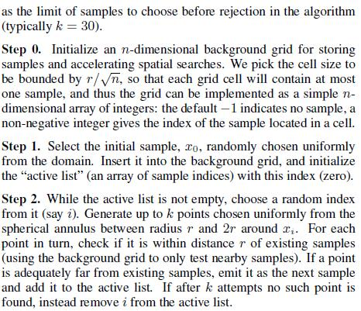

而对于分水岭算法，稍微了解一下之后参考了《OpenCV3编程入门》[2]的分水岭算法例程进行实现。

2. 四原色

实验二是一个数学上四色定理 (Four Color Theorem)的计算机验证实例。

第一步，统计分水岭结果中的区域邻接关系，根据计算机图论，可以采用邻接表来进行表示[3]。具体地，是通过分水岭算法中得到的maskImage中以八邻域的方式获取区域邻接关系，其中-1代表边缘，而大于零的数字代表区域编号。通过这个过程获得的邻接表还是较为初始的，对于后续的涂色不利，因此还需要优化邻接表，具体是先将邻接表每一个链表进行重新排序，按相邻区域数从大到小排。接下来，需要形成涂色最佳路径，具体是从邻接表中选取相邻区域数最多的表头（可能不止一个，随机选取一个），接下来基于图的广度优先遍历算法[3]，依次从该表头遍历，一直到该链表遍历完毕，随后找到从该链表中以未遍历过邻域的结点为表头的结点，又一次遍历到表尾，依此类推便形成了涂色最佳路径，其中涂色路径采用队列进行存储。

第二步，采用队列进行辅助梳理涂色过程，使用堆栈记录涂色过程。创建一个记录颜色是否被用的记录表，创建一个缓冲队列和一个中转站队列，前者用于存储回退出来的区域，后者用来调整缓冲队列的顺序。接下来，开始涂色，要求尽可能先用同一种颜色去涂，实在冲突再换颜色，如果遇到无法涂色，则回退上一步，换颜色再尝试，如果涂色队列非空，即未完成涂色，则继续尝试。每次涂色前，遍历堆栈中所有区域，判断是否有相邻区域涂相同颜色。如果没有，此颜色值入栈，继续赋值；如果有，颜色值增加，再次判断。如果四种颜色值均不满足要求，出栈，重新赋值，直到涂色完成。其中，如果涂色过程一直卡在某个地方，既不能继续往前涂，又不能往后退，那么就需要往回退50个试试重新规划路径。

3. 哈夫曼

哈夫曼树是指利用各种树节点之间的关系构成的一个树状结构，是一个二叉树，同时满足了孩子的总权值就是自己的权值，而且哈夫曼树要求权值乘上路程所得到的数最小。哈夫曼编码就是基于哈夫曼树形成的是一种用于无损数据压缩的熵编码（权编码）算法[4]。

第一步，构建哈夫曼树。创建一个长度为2n+1的数组，元素类型是哈夫曼树的结点。在森林中选取权值最小的两个结点，并且满足双亲的值为0，优先比较权值，如果权值一样小，则需要比较深度，为了使得码方差尽可能小，应优先选出深度较浅的去合并。考虑深度的问题即是码方差要尽可能小才使得哈夫曼树的深度尽可能小，对于降低码方差（码方差越小，哈夫曼码的长度越相近），一般情况下，若将新合并后的支路排到等概率/等权值的最上支路，将有利于缩短码长方差，且编出的码更接近于等长码，具体地，也就是要在多个权值相等的结点中，尽可能不要选取已经合并了的结点。构造一棵新的二叉树，置新二叉树根节点权值为其左右子树根节点权值之和。在森林里删除这两棵树，同时将新得到的二叉树加入到森林中。重复上述步骤，直到只含一棵树，这棵树即为哈夫曼树。

从叶子到根逆向求每个字符的哈夫曼编码，解码的过程就是从根结点出发，按字符‘0’或‘1’确定找左孩子或是右孩子，直到叶子结点，就求得了该哈夫曼码对应的字符

第二步，画哈夫曼树。该算法最初假设树的根位于图的顶部。结点定位算法仅涉及确定节点的x坐标。其y坐标可以通过结点所处的层次来决定。具体算法如下：

1. 后序遍历整颗树，初次确定每个点的prelim和modifier（最后，某个结点的x坐标决定于prelim和其祖宗的modifier之和）。通过modifier去初步调整相互交叉的地方，永远是把当前结点祖宗的modifier加起来（除了根节点），然后更新到当前结点的modifier里

2. 调整子树之间的间隔

3. 最后确定根节点的位置

4. Dijkstra

Dijkstra算法是从一个顶点到其余各顶点的最短路径算法，解决的是有向图中最短路径问题。主要特点是以起始点为中心向外层层扩展，直到扩展到终点为止[5]。

具体算法如下：

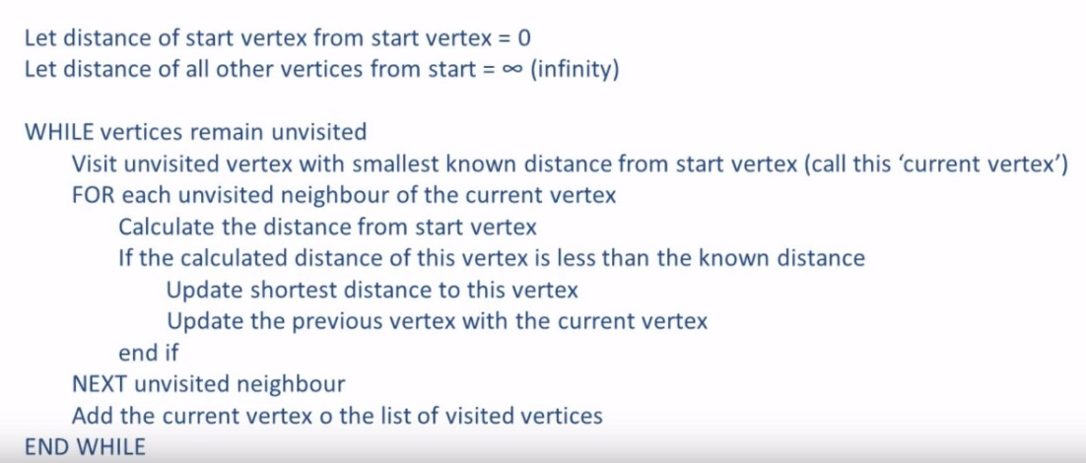

5. 堆排序

堆排序是利用堆这种数据结构所设计的一种排序算法。堆是一个近似完全二叉树的结构，并同时满足堆的性质：即子结点的键值或索引总是小于（或者大于）它的父节点[6]。

具体算法如下：

1. 将初始待排序关键字序列(R1,R2....Rn)构建成大顶堆，此堆为初始的无序区；
2. 将堆顶元素R[1]与最后一个元素R[n]交换，此时得到新的无序区(R1,R2,......Rn-1)和新的有序区(Rn),且满足R[1,2...n-1]<=R[n]；
3. 由于交换后新的堆顶R[1]可能违反堆的性质，因此需要对当前无序区(R1,R2,......Rn-1)调整为新堆，然后再次将R[1]与无序区最后一个元素交换，得到新的无序区(R1,R2....Rn-2)和新的有序区(Rn-1,Rn)。不断重复此过程直到有序区的元素个数为n-1，则整个排序过程完成。

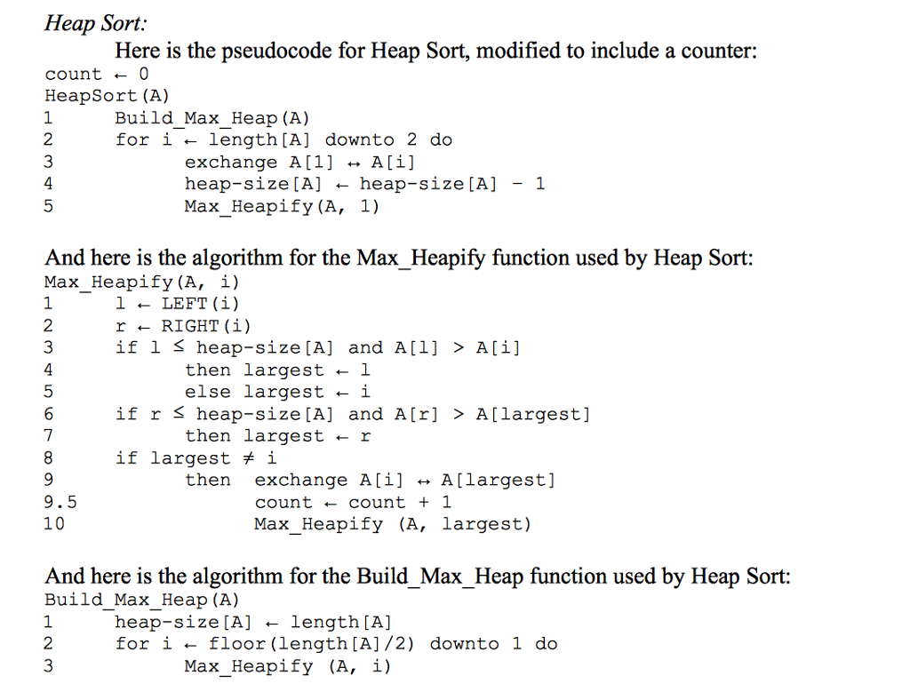

6. 折半查找

折半查找是一种效率较高的查找方法，要求线性表必须采用顺序存储结构，而且表中元素按关键字有序排列[7]。

具体算法如下：

首先，假设表中元素是按升序排列，将表中间位置记录的关键字与查找关键字比较，如果两者相等，则查找成功；否则利用中间位置记录将表分成前、后两个子表，如果中间位置记录的关键字大于查找关键字，则进一步查找前一子表，否则进一步查找后一子表。重复以上过程，直到找到满足条件的记录，使查找成功，或直到子表不存在为止，此时查找不成功。

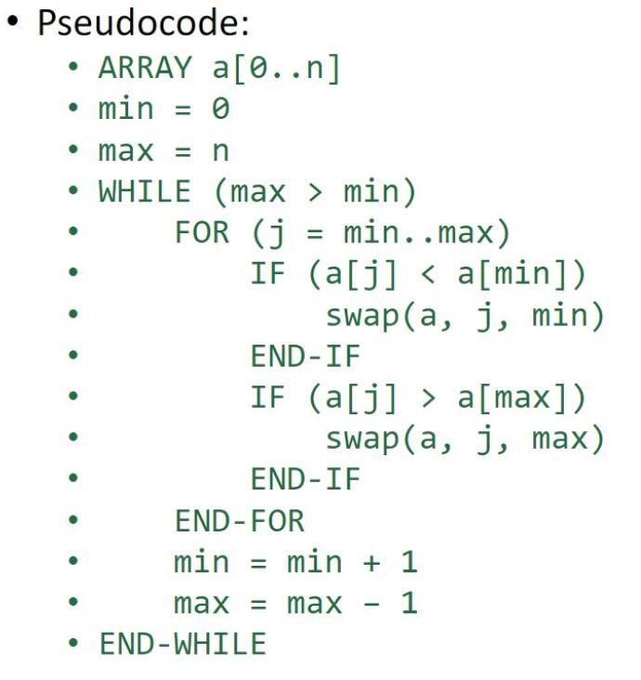

# 三、源码文档

*/\*\**

*\*\*\*\*\*\*\*\*\*\*\*\*\*\*\*\*\*\*\*\*\*\*\*\*\*\*\*\*\*\*\*\*\*\*\*\*\*\*\*\*\*\*\*\*\*\*\*\*\*\*\*\*\*\*\*\*\*\*\*\*\*\*\*\*\*\*\*\*\*\*\*\*\*\*\*\*\*\**

*\* @file main.h*

*\* @author 李星毅*

*\* @date 2018-10-19*

*\* @brief 该文件进行了include，宏定义等*

*\*\*\*\*\*\*\*\*\*\*\*\*\*\*\*\*\*\*\*\*\*\*\*\*\*\*\*\*\*\*\*\*\*\*\*\*\*\*\*\*\*\*\*\*\*\*\*\*\*\*\*\*\*\*\*\*\*\*\*\*\*\*\*\*\*\*\*\*\*\*\*\*\*\*\*\*\*\**

*\*/*

#pragma once

#include <opencv2/opencv.hpp>

#include <iostream>

#include <cmath>

#include "graph_coloring.h"

#include "heap_sort.h"

#include "random_sampling.h"

#include "huffman.h"

#include "dijkstra.h"

#include "binary_search.h"

using namespace cv;

using namespace std;

#define ERROR 0

#define OK 1

#define EXIT 2

#define NONE -1

#define TRUE 1

#define FALSE 0

#define INF 99999999

typedef int Status;

*/\*\**

*\*\*\*\*\*\*\*\*\*\*\*\*\*\*\*\*\*\*\*\*\*\*\*\*\*\*\*\*\*\*\*\*\*\*\*\*\*\*\*\*\*\*\*\*\*\*\*\*\*\*\*\*\*\*\*\*\*\*\*\*\*\*\*\*\*\*\*\*\*\*\*\*\*\*\*\*\*\**

*\* @file main.cpp*

*\* @author 李星毅*

*\* @date 2018-10-19*

*\* @brief 该文件包含了主函数，展示实验流程*

*\*\*\*\*\*\*\*\*\*\*\*\*\*\*\*\*\*\*\*\*\*\*\*\*\*\*\*\*\*\*\*\*\*\*\*\*\*\*\*\*\*\*\*\*\*\*\*\*\*\*\*\*\*\*\*\*\*\*\*\*\*\*\*\*\*\*\*\*\*\*\*\*\*\*\*\*\*\**

*\*/*

#include "main.h"

Mat g_maskImage, g_srcImage;

int main()

{

    g_srcImage = imread("fruits.jpg");

    Mat maskImage(g_srcImage.size(), CV_32S);

    Mat highlighted_path_image(maskImage.size(), CV_8UC3);

    int count = 0;

    HeapNode heap[MAX_AREA_NUM + 1];

    HeapInit(heap);

AdjacencyList AL;

    cout << "《数据结构》实验展示\n" << endl;

*// 实验一*

    PoissonDisk(maskImage, count);

*// 实验二*

    GraphColoring(AL, maskImage, count, heap, highlighted_path_image);

*// 实验三*

    Huffman(maskImage, count, heap);

*// 实验四*

    cout << "\n【实验四：Dijkstra算法】" << endl;

    while (1)

    {

        if (Dijkstra(AL, highlighted_path_image, maskImage) == EXIT)

        {

            cout << "按任意键进入下一实验..." << endl;

            waitKey(0);

            break;

        }

    }

*// 实验五*

    HeapSort(heap, count, AL, highlighted_path_image);

*// 实验六*

    cout << "\n【实验六：折半查找】" << endl;

    while (1)

    {

        if (BinarySearch(heap, count, maskImage, highlighted_path_image, AL) == EXIT)

            break;

    }

    cout << "\n《数据结构》实验已经全部展示完毕..." << endl;

    return 0;

}

*/\*\**

*\*\*\*\*\*\*\*\*\*\*\*\*\*\*\*\*\*\*\*\*\*\*\*\*\*\*\*\*\*\*\*\*\*\*\*\*\*\*\*\*\*\*\*\*\*\*\*\*\*\*\*\*\*\*\*\*\*\*\*\*\*\*\*\*\*\*\*\*\*\*\*\*\*\*\*\*\*\**

*\* @file random_sampling.h*

*\* @author 李星毅*

*\* @date 2018-09-19*

*\* @brief 该文件包含了随机算法的所有实现函数的原型*

*\*          - GridInit*

*\*        - GetCellPos*

*\*          - ActiveInit*

*\*          - ActiveAppend*

*\*          - ActiveRemove*

*\*      - GetPoint*

*\*          - IsPointValid*

*\*          - GetNeighbours*

*\*          - GetActiveLength*

*\*          - GetRandomActive*

*\*         - SampleAppend*

*\*          - PoissonDisk*

*\*\*\*\*\*\*\*\*\*\*\*\*\*\*\*\*\*\*\*\*\*\*\*\*\*\*\*\*\*\*\*\*\*\*\*\*\*\*\*\*\*\*\*\*\*\*\*\*\*\*\*\*\*\*\*\*\*\*\*\*\*\*\*\*\*\*\*\*\*\*\*\*\*\*\*\*\*\**

*\*/*

#pragma once

using namespace cv;

using namespace std;

typedef int Status;

typedef struct Active

{

    Point active_point;

    int active_index;

    struct Active *next;

} Active;

Status GridInit(Mat &grid, double w, int &samples_number, Active *actives, int r);

Status GetCellPos(Point pt, Vec2b &cell_pos, double w);

Status ActiveInit(Active *&actives);

Status ActiveAppend(Active *p, Point pt, int sample_index);

Status ActiveRemove(Active *p, int sample_index);

int GetActiveLength(Active *p);

Status GetNeighbours(Mat grid, Vec2b cell_pos, Mat &neighbours);

Status IsPointValid(Point pt, int r, double w, Mat grid);

Status GetPoint(Mat grid, Active ref_pt, Point &result_pt, int iteration_limit, int r, double w);

Status GetRandomActive(Active *actives, Active &ref_pt);

Status SampleAppend(Mat &grid, Point result_pt, Vec2b cell_pos, int sample_index);

Status PoissonDisk(Mat &maskImage, int &count);

*/\*\**

*\*\*\*\*\*\*\*\*\*\*\*\*\*\*\*\*\*\*\*\*\*\*\*\*\*\*\*\*\*\*\*\*\*\*\*\*\*\*\*\*\*\*\*\*\*\*\*\*\*\*\*\*\*\*\*\*\*\*\*\*\*\*\*\*\*\*\*\*\*\*\*\*\*\*\*\*\*\**

*\* @file random_sampling.cpp*

*\* @author 李星毅*

*\* @date 2018-09-19*

*\* @brief 该文件包含了随机算法的所有实现函数*

*\*          - GridInit*

*\*        - GetCellPos*

*\*          - ActiveInit*

*\*          - ActiveAppend*

*\*          - ActiveRemove*

*\*      - GetPoint*

*\*          - IsPointValid*

*\*          - GetNeighbours*

*\*          - GetActiveLength*

*\*          - GetRandomActive*

*\*         - SampleAppend*

*\*          - PoissonDisk*

*\*\*\*\*\*\*\*\*\*\*\*\*\*\*\*\*\*\*\*\*\*\*\*\*\*\*\*\*\*\*\*\*\*\*\*\*\*\*\*\*\*\*\*\*\*\*\*\*\*\*\*\*\*\*\*\*\*\*\*\*\*\*\*\*\*\*\*\*\*\*\*\*\*\*\*\*\*\**

*\*/*

#define _CRT_SECURE_NO_WARNINGS

#include "main.h"

extern Mat g_srcImage;

extern Mat g_maskImage;

*/\*\**

*\* @brief 创建一个网格，此函数中直接添加了第一个点，位于整张图的中心*

*\* @param grid: 网格*

*\* @param w: 每个格子的宽度*

*\* @param samples_number: 样本的数量*

*\* @param actives: 激活点列表*

*\* @param r: 种子点之间的最小距离*

*\* @return 函数执行状态*

*\*/*

Status GridInit(Mat &grid, double w, int &samples_number, Active *actives, int r)

{

    Point original(250, 250);

    Vec2b cell_pos;

    GetCellPos(original, cell_pos, w);

    short *data = grid.ptr<short>(cell_pos[1]);

    data[cell_pos[0] * grid.channels()] = original.x;

    data[cell_pos[0] * grid.channels() + 1] = original.y;

    data[cell_pos[0] * grid.channels() + 2] = 0;

    samples_number += 1;

    ActiveAppend(actives, original, 0);

*/*int j = 0;*/*

*/*for (int i = 1; i < M - 2; i += r, j++)*

*{*

*Point pt(i, 1);*

*GetCellPos(pt, cell_pos, w);*

*data = grid.ptr<short>(cell_pos[1]);*

*data[cell_pos[0] * grid.channels()] = pt.x;*

*data[cell_pos[0] * grid.channels() + 1] = pt.y;*

*data[cell_pos[0] * grid.channels() + 2] = 0;*

*samples_number += 1;*

*ActiveAppend(actives, pt, j);*

*}*

*for (int i = 1; i < M - 2; i += r, j++)*

*{*

*Point pt(i, N - 2);*

*GetCellPos(pt, cell_pos, w);*

*data = grid.ptr<short>(cell_pos[1]);*

*data[cell_pos[0] * grid.channels()] = pt.x;*

*data[cell_pos[0] * grid.channels() + 1] = pt.y;*

*data[cell_pos[0] * grid.channels() + 2] = 0;*

*samples_number += 1;*

*ActiveAppend(actives, pt, j);*

*}*

*for (int i = 1; i < N - 2; i += r, j++)*

*{*

*Point pt(1, i);*

*GetCellPos(pt, cell_pos, w);*

*data = grid.ptr<short>(cell_pos[1]);*

*data[cell_pos[0] * grid.channels()] = pt.x;*

*data[cell_pos[0] * grid.channels() + 1] = pt.y;*

*data[cell_pos[0] * grid.channels() + 2] = 0;*

*samples_number += 1;*

*ActiveAppend(actives, pt, j);*

*}*

*for (int i = 1; i < N - 2; i += r, j++)*

*{*

*Point pt(M - 2, i);*

*GetCellPos(pt, cell_pos, w);*

*data = grid.ptr<short>(cell_pos[1]);*

*data[cell_pos[0] * grid.channels()] = pt.x;*

*data[cell_pos[0] * grid.channels() + 1] = pt.y;*

*data[cell_pos[0] * grid.channels() + 2] = 0;*

*samples_number += 1;*

*ActiveAppend(actives, pt, j);*

*}*/*

    return OK;

}

*/\*\**

*\* @brief 该函数得到某点在网格中的位置*

*\* @param pt: 种子点*

*\* @param cell_pos: 种子点在网格中的位置变量*

*\* @param w: 每个格子的宽度*

*\* @return 函数执行状态*

*\*/*

Status GetCellPos(Point pt, Vec2b &cell_pos, double w)

{

    cell_pos[0] = (int)(pt.x / w);

    cell_pos[1] = (int)(pt.y / w);

    return OK;

}

*/\*\**

*\* @brief 创建一个激活点列表（本质是链表）*

*\* @param actives: 激活点列表*

*\* @return 函数执行状态*

*\*/*

Status ActiveInit(Active *&actives)

{

    if ((actives = (Active *)malloc(sizeof(Active))) == NULL)

        return ERROR;

    actives->next = NULL;

    return OK;

}

*/\*\**

*\* @brief 加入一个激活点（链表的插入）*

*\* @param p: 指向激活点的指针*

*\* @param pt: 种子点*

*\* @param sample_index: 样本下标*

*\* @return 函数执行状态*

*\*/*

Status ActiveAppend(Active *p, Point pt, int sample_index)

{

    Active *temp = NULL;

    while (p->next != NULL)

        p = p->next;

    if ((temp = (Active *)malloc(sizeof(Active))) == NULL)

        return ERROR;

    p->next = temp;

    temp->next = NULL;

    temp->active_point = pt;

    temp->active_index = sample_index;

    return OK;

}

*/\*\**

*\* @brief 移除激活点（链表的删除）*

*\* @param p: 某个激活点*

*\* @param sample_index: 样本下标*

*\* @return 函数执行状态*

*\*/*

Status ActiveRemove(Active *p, int sample_index)

{

    if (p->next == NULL)

        return ERROR;

    Active *temp = p->next;

    while (temp->next != NULL && temp->active_index != sample_index)

    {

        p = temp;

        temp = temp->next;

    }

    if (temp->active_index == sample_index)

    {

        p->next = temp->next;

        free(temp);

        temp = NULL;

    }

    return OK;

}

*/\*\**

*\* @brief 以某个激活点为基准，得到一个有效的新点*

*\* @param grid: 网格*

*\* @param ref_pt: 某个参考激活点*

*\* @param result_pt: 产生的有效的新点*

*\* @param iteration_limit: 迭代的最大次数*

*\* @param r: 种子点之间的最小距离*

*\* @param w: 每个格子的宽度*

*\* @return 函数执行状态*

*\*/*

Status GetPoint(Mat grid, Active ref_pt, Point &result_pt, int iteration_limit, int r, double w)

{

    int i = 0;

    RNG rng((unsigned)time(NULL));

    double theta = 0, rand_radius;

    Point pt;

    while (i < iteration_limit)

    {

        theta = rng.uniform((double)0, (double)(2 * PI));

        rand_radius = r + 1;

        pt.x = ref_pt.active_point.x + (int)(rand_radius * cos(theta));

        pt.y = ref_pt.active_point.y + (int)(rand_radius * sin(theta));

*// If this new point is out of the background, discard it*

        if (pt.x < 0 || pt.x > M || pt.y < 0 || pt.y > N)

            continue;

*// If this new point is inside the background, consider whether it is valid or not*

        if (IsPointValid(pt, r, w, grid))

        {

            result_pt.x = pt.x;

            result_pt.y = pt.y;

            return OK;

        }

        i++;

    }

    return ERROR;

}

*/\*\**

*\* @brief 检查产生的新点是否有效*

*\* @param pt: 某个种子点*

*\* @param r: 种子点之间的最小距离*

*\* @param w: 每个格子的宽度*

*\* @param grid: 网格*

*\* @return 函数执行状态*

*\*/*

Status IsPointValid(Point pt, int r, double w, Mat grid)

{

    Mat neighbours(5, 5, CV_16SC3, Scalar(NONE, NONE, NONE));

    Point nearby_point;

    double distance2;

*// Is the point a valid point to emit as a sample?*

*// It must be no closer than r from any other point: check the cells in its*

*// immediate neighbourhood*

    Vec2b cell_pos;

    GetCellPos(pt, cell_pos, w);

    GetNeighbours(grid, cell_pos, neighbours);

    for (int i = 0; i < neighbours.rows; i++)

    {

        for (int j = 0; j < neighbours.cols; j++)

        {

            short *data = neighbours.ptr<short>(i);

            if (data[j * neighbours.channels()] == NONE && data[j * neighbours.channels() + 1] == NONE && data[j * neighbours.channels() + 2] == NONE)

                continue;

            distance2 = pow((data[j * neighbours.channels()] - pt.x), 2) + pow((data[j * neighbours.channels() + 1] - pt.y), 2);

            if (distance2 < pow(r, 2))

                return FALSE;

        }

    }

    return TRUE;

}

*/\*\**

*\* @brief 得到某一个点的邻居点坐标和下标*

*\* @param grid: 网格*

*\* @param cell_pos: 种子点在网格中的位置变量*

*\* @param neighbours: 某个点的邻居矩阵*

*\* @return 函数执行状态*

*\*/*

Status GetNeighbours(Mat grid, Vec2b cell_pos, Mat &neighbours)

{

    int j = 0, i;

    int offset[25][2]

    {

        {-2, -2}, {-1, -2}, {0, -2}, {1, -2}, {2, -2},

        {-2, -1}, {-1, -1}, {0, -1}, {1, -1}, {2, -1},

        {-2, 0}, {-1, 0}, {0, 0}, {1, 0}, {2, 0},

        {-2, 1}, {-1, 1}, {0, 1}, {1, 1}, {2, 1},

        {-2, 2}, {-1, 2}, {0, 2}, {1, 2}, {2, 2},

    };

    for (i = 0; i < 25; i++)

    {

        if ((cell_pos[0] + offset[i][0]) > -3 && (cell_pos[0] + offset[i][0]) < grid.cols * grid.channels() && (cell_pos[1] + offset[i][1] >= 0 && (cell_pos[1] + offset[i][1]) < grid.rows))

        {

            short *grid_data = grid.ptr<short>(cell_pos[1] + offset[i][1]);

            if (i % 5 == 0 && i != 0)

                j++;

            short *neighbours_data = neighbours.ptr<short>(j);

            neighbours_data[(i % 5) * neighbours.channels()] = grid_data[(cell_pos[0] + offset[i][0]) * grid.channels()];

            neighbours_data[(i % 5) * neighbours.channels() + 1] = grid_data[(cell_pos[0] + offset[i][0]) * grid.channels() + 1];

            neighbours_data[(i % 5) * neighbours.channels() + 2] = grid_data[(cell_pos[0] + offset[i][0]) * grid.channels() + 2];

        }

        else

            continue;

    }

*//cout << neighbours << endl;*

    return OK;

}

*/\*\**

*\* @brief 返回激活点列表的长度*

*\* @param p: 指向激活点的指针*

*\* @return 激活点列表长度*

*\*/*

int GetActiveLength(Active *p)

{

    int length = 0;

    while (p->next != NULL)

    {

        length++;

        p = p->next;

    }

    return length;

}

*/\*\**

*\* @brief 在激活点列表中随机选择一个激活点*

*\* @param actives: 激活点列表*

*\* @param ref_pt: 某个参考激活点*

*\* @return 函数执行状态*

*\*/*

Status GetRandomActive(Active *actives, Active &ref_pt)

{

    RNG rng((unsigned)time(NULL));

    int i;

    int rand_index = rng.uniform(0, GetActiveLength(actives));

    for (i = 0; i < rand_index; i++)

        actives = actives->next;

    ref_pt.active_point = actives->next->active_point;

    ref_pt.active_index = actives->next->active_index;

    return OK;

}

*/\*\**

*\* @brief 将产生的新点添加到网格中*

*\* @param grid: 网格*

*\* @param result_pt: 生成的有效点*

*\* @param cell_pos: 某个点的网格中的位置变量*

*\* @param sample_index: 样本下标*

*\* @return 函数执行状态*

*\*/*

Status SampleAppend(Mat &grid, Point result_pt, Vec2b cell_pos, int sample_index)

{

    short *data = grid.ptr<short>(cell_pos[1]);

    data[cell_pos[0] * grid.channels()] = result_pt.x;

    data[cell_pos[0] * grid.channels() + 1] = result_pt.y;

    data[cell_pos[0] * grid.channels() + 2] = sample_index;

    return OK;

}

*/\*\**

*\* @brief 泊松圆盘实现函数，里面还包含了分水岭算法*

*\* @param maskImage: 记录分水岭区域轮廓的矩阵*

*\* @param count: 记录总共产生的种子点个数*

*\* @return 函数执行状态*

*\*/*

Status PoissonDisk(Mat &maskImage, int &count)

{

    Mat grayImage, srcImage;

    g_srcImage.copyTo(srcImage);

    cvtColor(g_srcImage, g_maskImage, COLOR_BGR2GRAY);

    cvtColor(g_maskImage, grayImage, COLOR_GRAY2BGR);

    g_maskImage = Scalar::all(0);

    Mat img = imread("fruits.jpg");

    RNG rng((unsigned)time(NULL));

    int K;

    cout << "【实验一：随机算法】" << endl;

    while (1)

    {

        cout << "请输入需要产生的随机点个数： ";

        cin >> K;

        if (K <= 0)

            cout << "输入有误，必须输入大于零的数..." << endl;

        else

            break;

    }

    double dTime = (double)getTickCount();

    int iteration_limit = 100;

    int samples_number = 0;

    int r = (int)sqrt(M * N / K);

    double w = r / sqrt(2);

    int grid_cols = (int)(M / w) + 1;

    int grid_rows = (int)(N / w) + 1;

    Mat grid(grid_cols, grid_rows, CV_16SC3, Scalar(NONE, NONE, NONE));

    Active *actives = NULL;

    if (!ActiveInit(actives))

    {

        cout << "Error: insufficient memory to initialize an active list..." << endl;

        exit(1);

    }

    if (!GridInit(grid, w, samples_number, actives, r))

    {

        cout << "Error: insufficient memory to initialize a grid..." << endl;

        exit(1);

    }

    while (GetActiveLength(actives))

    {

        Active ref_pt;

        Point result_pt;

*// Choose a random reference point from the active list*

        GetRandomActive(actives, ref_pt);

        if (GetPoint(grid, ref_pt, result_pt, iteration_limit, r, w))

        {

            Vec2b cell_pos;

            GetCellPos(result_pt, cell_pos, w);

            SampleAppend(grid, result_pt, cell_pos, samples_number);

            ActiveAppend(actives, result_pt, samples_number);

            samples_number++;

        }

        else

        {

            circle(img, ref_pt.active_point, 3, Scalar(255, 255, 255), -1);

            circle(g_maskImage, ref_pt.active_point, 3, Scalar(255, 255, 255), -1);

            circle(g_srcImage, ref_pt.active_point, 3, Scalar(255, 255, 255), -1);

*//char str[10];*

*//sprintf(str, "%d", count);*

*//putText(img, str, ref_pt.active_point, FONT_HERSHEY_PLAIN, 0.8, Scalar(0, 0, 0));*

            ActiveRemove(actives, ref_pt.active_index);

            count++;

        }

    }

    cout << "实际产生随机点个数：" << count << endl;

    imshow("【泊松圆盘】", img);

*// 分水岭算法*

    while (1)

    {

        int i, j, compCount = 0;

        vector<vector<Point>> contours;

        vector<Vec4i> hierarchy;

        findContours(g_maskImage, contours, hierarchy, RETR_CCOMP, CHAIN_APPROX_SIMPLE);

        if (contours.empty())

            continue;

        maskImage = Scalar::all(0);

        for (int index = 0; index >= 0; index = hierarchy[index][0], compCount++)

            drawContours(maskImage, contours, index, Scalar::all(compCount + 1), -1, 8, hierarchy, INT_MAX);

        if (compCount == 0)

            continue;

        vector<Vec3b> colorTab;

        for (i = 0; i < compCount; i++)

        {

            int b = theRNG().uniform(0, 255);

            int g = theRNG().uniform(0, 255);

            int r = theRNG().uniform(0, 255);

            colorTab.push_back(Vec3b((uchar)b, (uchar)g, (uchar)r));

        }

        watershed(srcImage, maskImage);

        Mat watershedImage(maskImage.size(), CV_8UC3);

        for (i = 0; i < maskImage.rows; i++)

            for (j = 0; j < maskImage.cols; j++)

            {

                int index = maskImage.at<int>(i, j);

                if (index == -1)

                    watershedImage.at<Vec3b>(i, j) = Vec3b(255, 255, 255);

                else if (index <= 0 || index > compCount)

                    watershedImage.at<Vec3b>(i, j) = Vec3b(0, 0, 0);

                else

                    watershedImage.at<Vec3b>(i, j) = colorTab[index - 1];

            }

        watershedImage = watershedImage * 0.5 + grayImage * 0.5;

        imshow("【分水岭算法】", watershedImage);

        dTime = (double)getTickCount() - dTime;

        printf("\n程序用时 = %gs\n", dTime * getTickFrequency());

        cout << "按任意键进入下一实验..." << endl;

        waitKey(0);

        break;

    }

    return OK;

}

*/\*\**

*\*\*\*\*\*\*\*\*\*\*\*\*\*\*\*\*\*\*\*\*\*\*\*\*\*\*\*\*\*\*\*\*\*\*\*\*\*\*\*\*\*\*\*\*\*\*\*\*\*\*\*\*\*\*\*\*\*\*\*\*\*\*\*\*\*\*\*\*\*\*\*\*\*\*\*\*\*\**

*\* @file graph_coloring.h*

*\* @author 李星毅*

*\* @date 2018-09-26*

*\* @brief 该文件包含了四原色的所有实现函数的原型*

*\*          - InitQueue*

*\*          - EnQueue*

*\*          - IsQueueEmpty*

*\*          - DeQueue*

*\*          - InitColoringStack*

*\*          - GetColoringStackLength*

*\*          - ColoringStackPush*

*\*          - ColoringStackPop*

*\*          - CreateAdjacencyList*

*\*          - ALOptimization*

*\*          - ShowAdjacencyList*

*\*          - TintingColors*

*\*          - GetRowUnvisitedNum*

*\*          - ChooseBestTintingArea*

*\*          - IsAllVerticesVisited*

*\*        - FormBestTintingPath*

*\*          - GraphColoring*

*\*          - GetAreaCentroid*

*\*          - GetAreaWeights*

*\*\*\*\*\*\*\*\*\*\*\*\*\*\*\*\*\*\*\*\*\*\*\*\*\*\*\*\*\*\*\*\*\*\*\*\*\*\*\*\*\*\*\*\*\*\*\*\*\*\*\*\*\*\*\*\*\*\*\*\*\*\*\*\*\*\*\*\*\*\*\*\*\*\*\*\*\*\**

*\*/*

#pragma once

#define MAX_VERTEX_NUM 1000

#define RED 0

#define GREEN 1

#define BLUE 2

#define YELLOW 3

#define NOT_TINTED -1

#define M 500

#define N 500

#define PI 3.1415926

using namespace cv;

using namespace std;

typedef int Status;

typedef struct HeapNode

{

    unsigned int area;

    int area_ID;

} HeapNode;

*// 弧节点*

typedef struct ArcNode

{

    int arc_serial_number;            *// 该弧的序号*

    int adj_area_num;  *// 该弧的相邻区域数*

    int weight; *// 面积权重*

    unsigned int centroids_dist;  *// 该弧的质心到顶点的质心的距离*

    struct ArcNode *next_arc;               *// 指向下一条弧的指针*

} ArcNode;

*// 顶点节点*

typedef struct VertexNode

{

    int vertex_serial_number;                   *// 顶点序号*

    int adj_area_num;  *// 顶点的相邻区域数*

    Point centroid;  *// 质心*

    ArcNode *first_arc;                         *// 指向第一条依附该顶点的弧的指针*

} VertexNode, AdjList[MAX_VERTEX_NUM];

*// 无向图的邻接表*

typedef struct AdjacencyList

{

    AdjList vertices;

    int vertex_num, arc_num;            *// 图的当前顶点数和弧数*

} AdjacencyList;

*// 队列节点结构*

typedef struct QNode

{

    int data;

    bool color_used[4];

    struct QNode *next;

} QNode, *QueuePtr;

*// 队列指针集合*

typedef struct LinkQueue

{

    QueuePtr front;         *// 队头指针*

    QueuePtr rear;          *// 队尾指针*

} LinkQueue;

*// 链栈结构体*

typedef struct ColoringStack

{

    int area_number;

    int color;

    struct ColoringStack *next;

} ColoringStack;

Status InitQueue(LinkQueue &Q);

Status EnQueue(LinkQueue &Q, int e);

Status IsQueueEmpty(LinkQueue Q);

Status DeQueue(LinkQueue &Q, int &e);

Status InitColoringStack(ColoringStack *(&s));

int GetColoringStackLength(ColoringStack *s);

Status ColoringStackPush(ColoringStack *(&s), int area_number, int color);

Status ColoringStackPop(ColoringStack *(&s), int *area_number);

Status CreateAdjacencyList(AdjacencyList &AL, Mat maskImage, int count);

Status ShowAdjacencyList(AdjacencyList AL);

Status TintingColors(AdjacencyList &AL, LinkQueue tinting_queue, Mat maskImage, Mat &highlighted_path_image);

int ChooseBestTintingArea(AdjacencyList AL, const int *visited);

int GetRowUnvisitedNum(AdjacencyList AL, int vertex_serial_number, const int *visited);

Status IsAllVerticesVisited(AdjacencyList AL, const int *visited);

Status ALOptimization(AdjacencyList &AL);

Status FormBestTintingPath(AdjacencyList AL, LinkQueue &tinting_queue);

Status GraphColoring(AdjacencyList &AL, Mat maskImage, int count, HeapNode *heap, Mat &highlighted_path_image);

Status GetAreaCentroid(AdjacencyList &AL, Mat maskImage, Mat four_primary_colors_image)

Status GetAreaWeights(AdjacencyList &AL, Mat maskImage, int count, HeapNode *heap);

*/\*\**

*\*\*\*\*\*\*\*\*\*\*\*\*\*\*\*\*\*\*\*\*\*\*\*\*\*\*\*\*\*\*\*\*\*\*\*\*\*\*\*\*\*\*\*\*\*\*\*\*\*\*\*\*\*\*\*\*\*\*\*\*\*\*\*\*\*\*\*\*\*\*\*\*\*\*\*\*\*\**

*\* @file graph_coloring.cpp*

*\* @author 李星毅*

*\* @date 2018-09-26*

*\* @brief 该文件包含了四原色的所有实现函数*

*\*          - InitQueue*

*\*          - EnQueue*

*\*          - IsQueueEmpty*

*\*          - DeQueue*

*\*          - InitColoringStack*

*\*          - GetColoringStackLength*

*\*          - ColoringStackPush*

*\*          - ColoringStackPop*

*\*          - CreateAdjacencyList*

*\*          - ALOptimization*

*\*          - ShowAdjacencyList*

*\*          - TintingColors*

*\*          - GetRowUnvisitedNum*

*\*          - ChooseBestTintingArea*

*\*          - IsAllVerticesVisited*

*\*        - FormBestTintingPath*

*\*          - GraphColoring*

*\*          - GetAreaCentroid*

*\*          - GetAreaWeights*

*\*\*\*\*\*\*\*\*\*\*\*\*\*\*\*\*\*\*\*\*\*\*\*\*\*\*\*\*\*\*\*\*\*\*\*\*\*\*\*\*\*\*\*\*\*\*\*\*\*\*\*\*\*\*\*\*\*\*\*\*\*\*\*\*\*\*\*\*\*\*\*\*\*\*\*\*\*\**

*\*/*

#define _CRT_SECURE_NO_WARNINGS

#include "main.h"

*/\*\**

*\* @brief 初始化空队列*

*\* @param Q: 链队列*

*\* @return 函数执行状态*

*\*/*

Status InitQueue(LinkQueue &Q)

{

    Q.front = Q.rear = (QueuePtr)malloc(sizeof(QNode));

    if (!Q.front)

        return ERROR;

    Q.front->next = NULL;

    return OK;

}

*/\*\**

*\* @brief 入队列*

*\* @param Q: 链队列*

*\* @param e: 进队列的元素*

*\* @return 函数执行状态*

*\*/*

Status EnQueue(LinkQueue &Q, int e)

{

    QueuePtr s;

    if ((s = (QueuePtr)malloc(sizeof(QNode))) == NULL)

        return ERROR;

    s->data = e;

    s->next = NULL;

    Q.rear->next = s;

    Q.rear = s;

    return OK;

}

*/\*\**

*\* @brief 检验该队列是否为空*

*\* @param Q: 链队列*

*\* @return 函数执行状态*

*\*/*

Status IsQueueEmpty(LinkQueue Q)

{

    if (Q.front->next == NULL)

        return TRUE;

    else

        return FALSE;

}

*/\*\**

*\* @brief 出队列*

*\* @param Q: 链队列*

*\* @param e: 出队列的元素*

*\* @return 函数执行状态*

*\*/*

Status DeQueue(LinkQueue &Q, int &e)

{

    QueuePtr p;

*// 队列已空，出队列不合法*

    if (Q.front == Q.rear)

        return ERROR;

    p = Q.front->next;

    e = p->data;

    Q.front->next = p->next;

*// 若队头是队尾   ,删除后将rear指向头结点*

    if (p == Q.rear)

        Q.rear = Q.front;

    free(p);

    p = NULL;

    return OK;

}

*/\*\**

*\* @brief 初始化链栈*

*\* @param s: 涂色辅助栈*

*\* @return 函数执行状态*

*\*/*

Status InitColoringStack(ColoringStack *(&s))

{

    if ((s = (ColoringStack *)malloc(sizeof(ColoringStack))) == NULL)

        return ERROR;

    s->next = NULL;

    return OK;

}

*/\*\**

*\* @brief 获取栈的实际深度*

*\* @param s: 涂色辅助栈*

*\* @return 涂色辅助栈的长度*

*\*/*

int GetColoringStackLength(ColoringStack *s)

{

    int length = 0;

    ColoringStack *temp = s;

    while (temp != NULL)

    {

        length++;

        temp = temp->next;

    }

    return length - 1;

}

*/\*\**

*\* @brief 入栈*

*\* @param s: 涂色辅助栈*

*\* @param area_number: 区域编号*

*\* @param color: 在该区域涂的颜色值*

*\* @return 函数执行状态*

*\*/*

Status ColoringStackPush(ColoringStack *(&s), int area_number, int color)

{

    ColoringStack *p;

    if ((p = (ColoringStack *)malloc(sizeof(ColoringStack))) == NULL)

        return ERROR;

    p->area_number = area_number;

    p->color = color;

    p->next = s;

    s = p;

    return OK;

}

*/\*\**

*\* @brief 出栈*

*\* @param s: 涂色辅助栈*

*\* @param area_number: 区域编号*

*\* @return 函数执行状态*

*\*/*

Status ColoringStackPop(ColoringStack *(&s), int *area_number)

{

    ColoringStack *p;

    if (s->next != NULL)

    {

        p = s;

        *area_number = s->area_number;

        s = s->next;

        free(p);

        p = NULL;

        return OK;

    }

    else

        return ERROR;

}

*/\*\**

*\* @brief 根据maskImage提供的contour信息构造邻接表*

*\* @param maskImage: 提供的contour信息的图像矩阵*

*\* @param count: 分水岭图像的区域数*

*\* @return 函数执行状态*

*\*/*

Status CreateAdjacencyList(AdjacencyList &AL, Mat maskImage, int count)

{

*/*cout << maskImage << endl;*/*

    int arc_num = 0;

    AL.vertex_num = count;

    for (int i = 0; i < count; i++)

    {

        AL.vertices[i].vertex_serial_number = i + 1;

        AL.vertices[i].first_arc = NULL;

    }

    int area1_ID, area2_ID;

*/*int edge[8];*/*

    int edge[8];

*// 遍历maskImage来获得区域邻接关系*

    for (int i = 1; i < maskImage.rows - 1; i++)

    {

        int *data1 = maskImage.ptr<int>(i - 1);

        int *data2 = maskImage.ptr<int>(i);

        int *data3 = maskImage.ptr<int>(i + 1);

        for (int j = 1; j < maskImage.cols - 1; j++)

        {

            int ref = data2[j];

            edge[0] = data1[j - 1];

            edge[1] = data1[j];

            edge[2] = data1[j + 1];

            edge[3] = data2[j - 1];

            edge[4] = data2[j + 1];

            edge[5] = data3[j - 1];

            edge[6] = data3[j];

            edge[7] = data3[j + 1];

*// 在maskImage中，值为-1的位置为contour，而大于零的位置为某区域，只需关注ref为边界点的情况*

            if (ref == -1)

            {

*// 若检测到参考点的值为-1，且周围的点有两种大于零的值，就可以判定有两个区域邻接*

*// 并且这两个邻接的区域的编号就是那两个大于零的值*

                for (int k = 0; k < 8; k++)

                {

                    if (edge[k] > 0)

                    {

                        area1_ID = edge[k];

                        break;

                    }

                }

                for (int k = 0; k < 8; k++)

                {

                    if (edge[k] > 0 && edge[k] != area1_ID)

                    {

                        area2_ID = edge[k];

                        break;

                    }

                }

*// 得知编号为area1_ID和area2_ID的两个区域邻接*

*// 现在只要将他们加入邻接表中即可，以下就是加入邻接表的过程*

                if (AL.vertices[area1_ID - 1].first_arc == NULL)

                {

                    ArcNode *p = NULL;

                    if ((p = (ArcNode *)malloc(sizeof(ArcNode))) == NULL)

                    {

                        cout << "Error: insufficient memory..." << endl;

                        exit(1);

                    }

                    p->next_arc = NULL;

                    p->arc_serial_number = area2_ID;

                    AL.vertices[area1_ID - 1].first_arc = p;

                    arc_num++;

                }

                else if (AL.vertices[area1_ID - 1].first_arc != NULL)

                {

                    int IsDuplicate = FALSE;

                    ArcNode *p = NULL;

                    ArcNode *temp = AL.vertices[area1_ID - 1].first_arc;

                    while (temp != NULL)

                    {

                        if (temp->arc_serial_number != area2_ID && temp->next_arc != NULL)

                            temp = temp->next_arc;

                        else if (temp->arc_serial_number == area2_ID || area2_ID == AL.vertices[area1_ID - 1].vertex_serial_number)

                        {

                            IsDuplicate = TRUE;

                            break;

                        }

                        else

                            break;

                    }

                    if (!IsDuplicate)

                    {

                        if ((p = (ArcNode *)malloc(sizeof(ArcNode))) == NULL)

                        {

                            cout << "Error: insufficient memory..." << endl;

                            exit(1);

                        }

                        p->arc_serial_number = area2_ID;

                        p->next_arc = NULL;

                        temp->next_arc = p;

                        arc_num++;

                    }

                }

                if (AL.vertices[area2_ID - 1].first_arc == NULL)

                {

                    ArcNode *p = NULL;

                    if ((p = (ArcNode *)malloc(sizeof(ArcNode))) == NULL)

                    {

                        cout << "Error: insufficient memory..." << endl;

                        exit(1);

                    }

                    p->next_arc = NULL;

                    p->arc_serial_number = area1_ID;

                    AL.vertices[area2_ID - 1].first_arc = p;

                    arc_num++;

                }

                else if (AL.vertices[area2_ID - 1].first_arc != NULL)

                {

                    int IsDuplicate = FALSE;

                    ArcNode *p = NULL;

                    ArcNode *temp = AL.vertices[area2_ID - 1].first_arc;

                    while (temp != NULL)

                    {

                        if (temp->arc_serial_number != area1_ID && temp->next_arc != NULL)

                            temp = temp->next_arc;

                        else if (temp->arc_serial_number == area1_ID || area1_ID == AL.vertices[area2_ID - 1].vertex_serial_number)

                        {

                            IsDuplicate = TRUE;

                            break;

                        }

                        else

                            break;

                    }

                    if (!IsDuplicate)

                    {

                        if ((p = (ArcNode *)malloc(sizeof(ArcNode))) == NULL)

                        {

                            cout << "Error: insufficient memory..." << endl;

                            exit(1);

                        }

                        p->arc_serial_number = area1_ID;

                        p->next_arc = NULL;

                        temp->next_arc = p;

                        arc_num++;

                    }

                }

            }

        }

    }

*// 将得到的比较raw的邻接表优化成按相邻区域数从多到少排序的邻接表*

    ALOptimization(AL);

    AL.arc_num = arc_num / 2;

    return AL;

}

*/\*\**

*\* @brief 将得到的比较raw的邻接表优化成按相邻区域数从多到少排序的邻接表*

*\* @param AL: 邻接表*

*\* @return 函数执行状态*

*\*/*

Status ALOptimization(AdjacencyList &AL)

{

*// 求出每个区域的相邻区域数，存入adj_area_number_list中*

    int length = 1;

    int adj_area_number_list[MAX_VERTEX_NUM] = { 0 };

    for (int i = 0; i < AL.vertex_num; i++)

    {

        ArcNode *temp = AL.vertices[i].first_arc;

        while (temp != NULL)

        {

            length++;

            temp = temp->next_arc;

        }

        adj_area_number_list[i] = length;

        length = 1;

    }

*// 将相邻区域数作为属性写入节点中*

    for (int i = 0; i < AL.vertex_num; i++)

    {

        AL.vertices[i].adj_area_num = adj_area_number_list[i];

        ArcNode *temp = AL.vertices[i].first_arc;

        while (temp != NULL)

        {

            temp->adj_area_num = adj_area_number_list[temp->arc_serial_number - 1];

            temp = temp->next_arc;

        }

    }

*// 现在开始将相邻区域数多的往前排序，这里采用冒泡排序对单链表进行排序（其他排序方式也可）*

    for (int i = 0; i < AL.vertex_num; i++)

    {

        for (int j = 0; j < adj_area_number_list[i] - 2; j++)

        {

            ArcNode *temp = AL.vertices[i].first_arc;

            ArcNode *shadow = NULL;

            for (int k = 0; k < adj_area_number_list[i] - j - 2; k++)

            {

                if (temp->adj_area_num < temp->next_arc->adj_area_num)

                {

                    if (AL.vertices[i].first_arc == temp)

                    {

                        ArcNode *current = temp->next_arc;

                        temp->next_arc = temp->next_arc->next_arc;

                        current->next_arc = temp;

                        AL.vertices[i].first_arc = current;

                        shadow = current;

                    }

                    else

                    {

                        ArcNode *current = temp->next_arc;

                        temp->next_arc = temp->next_arc->next_arc;

                        current->next_arc = temp;

                        shadow->next_arc = current;

                        shadow = current;

                    }

                }

                else

                {

                    shadow = temp;

                    temp = temp->next_arc;

                }

            }

        }

    }

    return OK;

}

*/\*\**

*\* @brief 展示邻接表*

*\* @param AL: 邻接表*

*\* @return 函数执行状态*

*\*/*

Status ShowAdjacencyList(AdjacencyList AL)

{

    cout << "邻接表：" << endl;

    for (int i = 0; i < AL.vertex_num; i++)

    {

        cout << AL.vertices[i].vertex_serial_number << "-";

        ArcNode *temp = AL.vertices[i].first_arc;

        while (temp != NULL && temp->next_arc != NULL)

        {

            cout << temp->arc_serial_number << "-";

            temp = temp->next_arc;

        }

        if (temp != NULL && temp->next_arc == NULL)

            cout << temp->arc_serial_number << endl;

        if (temp == NULL)

            cout << "NULL" << endl;

    }

    return OK;

}

*/\*\**

*\* @brief 基于图的广度优先遍历，采用队列进行辅助梳理涂色过程，使用堆栈记录涂色过程，优化回退率*

*\* @param AL: 邻接表*

*\* @param tinting_queue: 涂色路径队列*

*\* @param maskImage: 提供的contour信息的图像矩阵*

*\* @param highlighted_path_image: 这是需要在后续实验中用到的图像，此处只是多备份一张四原色结果*

*\* @return 函数执行状态*

*\*/*

Status TintingColors(AdjacencyList &AL, LinkQueue tinting_queue, Mat maskImage, Mat &highlighted_path_image)

{

    int pop_record[MAX_VERTEX_NUM] = { 0 };

*// 初始化一个记录颜色是否被用的记录表*

    int colors_used_matrix[MAX_VERTEX_NUM][4] = { 0 };

*// 创建一个缓冲队列和一个中转站，前者用于存储回退出来的区域，后者用来调整缓冲队列的顺序*

    LinkQueue buffer;

    LinkQueue transfer_station;

    InitQueue(buffer);

    InitQueue(transfer_station);

*// 创建堆栈*

    ColoringStack *stack = NULL;

    InitColoringStack(stack);

    int e;

*// 开始涂色，要求尽可能先用同一种颜色去涂，实在冲突再换颜色*

*// 如果遇到无法涂色，则回退上一步，换颜色再尝试*

*// 如果涂色队列非空，即未完成涂色，则继续尝试*

    while (!IsQueueEmpty(tinting_queue) || !IsQueueEmpty(buffer))

    {

*// 如果涂色过程一直卡在某个地方，既不能继续往前涂，又不能往后退，说明陷入了死胡同*

*// 那么就往回退50个试试重新制定涂色方案，此过程非常重要*

        for (int i = 0; i < AL.vertex_num; i++)

        {

*// 如果某个结点频繁回退，即达到阈值，就直接回退50个结点*

            if (pop_record[i] >= 250)

            {

                pop_record[i] = 0;

                for (int j = 0; j < 50; j++)

                {

                    int temp_area_number;

                    ColoringStackPop(stack, &temp_area_number);

*// 先入中转站*

                    EnQueue(transfer_station, temp_area_number);

                    while (!IsQueueEmpty(buffer))

                    {

                        int transfer;

                        DeQueue(buffer, transfer);

                        EnQueue(transfer_station, transfer);

                    }

                    while (!IsQueueEmpty(transfer_station))

                    {

                        int transfer;

                        DeQueue(transfer_station, transfer);

                        EnQueue(buffer, transfer);

                    }

                }

            }

        }

*// 检查buffer是否为空，因为要优先处理buffer中的结点，当buffer中无结点，再从tinting_queue中取出待涂色结点*

        if (!IsQueueEmpty(buffer))

        {

            bool left_colors_table[4] = { 0 };

            DeQueue(buffer, e);

*// 只有当栈的长度大于0才去检查*

            if (GetColoringStackLength(stack))

            {

*// 检查此时将要涂色的区域的邻接区域的颜色是否冲突*

*// 遍历现在的栈，看看是否有相邻的区域*

                ColoringStack *search_stack = stack;

                while (search_stack != NULL)

                {

                    ArcNode *temp = AL.vertices[e - 1].first_arc;

*// 开始从自己的邻接区域去搜索是否含有这个元素*

                    while (temp != NULL)

                    {

                        if (temp->arc_serial_number == search_stack->area_number)

                            left_colors_table[search_stack->color] = 1;

                        temp = temp->next_arc;

                    }

                    search_stack = search_stack->next;

                }

*// 搜寻结束，现在看看还剩下什么颜色可以涂*

                int tinted = FALSE;

*// 如果有颜色剩下，则进行入栈等操作*

                for (int i = 0; i < 4; i++)

                {

                    if (left_colors_table[i] != 1 && colors_used_matrix[e - 1][i] == 0)

                    {

                        ColoringStackPush(stack, e, i);

                        colors_used_matrix[e - 1][i] = 1;

                        tinted = TRUE;

                        break;

                    }

                }

*// 如果还没有颜色剩下，证明再前面的颜色涂的也有问题，又需要回退*

                if (tinted == FALSE)

                {

                    for (int i = 0; i < 4; i++)

                        colors_used_matrix[e - 1][i] = 0;

                    int temp_area_number;

                    ColoringStackPop(stack, &temp_area_number);

                    pop_record[temp_area_number - 1]++;

*// 先入中转站*

                    EnQueue(transfer_station, temp_area_number);

                    EnQueue(transfer_station, e);

                    while (!IsQueueEmpty(buffer))

                    {

                        int transfer;

                        DeQueue(buffer, transfer);

                        EnQueue(transfer_station, transfer);

                    }

                    while (!IsQueueEmpty(transfer_station))

                    {

                        int transfer;

                        DeQueue(transfer_station, transfer);

                        EnQueue(buffer, transfer);

                    }

                }

            }

*// 如果栈为空*

            else

            {

                int flag = FALSE;

*// 说明是第一个区域*

                for (int i = 0; i < 4; i++)

                {

                    if (colors_used_matrix[e - 1][i] != 1)

                    {

                        ColoringStackPush(stack, e, i);

                        colors_used_matrix[e - 1][i] = 1;

                        flag = TRUE;

                        break;

                    }

                }

                if (flag == FALSE)

                    cout << "涂色失败！" << endl;

            }

        }

        else if (IsQueueEmpty(buffer))

        {

*// 一个涂色区域序号出队列*

            DeQueue(tinting_queue, e);

*// 存放RGBY的使用情况，0表示未使用，1表示已使用*

            bool left_colors_table[4] = { 0 };

*// 只有当栈的长度大于0才去检查*

            if (GetColoringStackLength(stack))

            {

*// 检查此时将要涂色的区域的邻接区域的颜色是否冲突*

*// 遍历现在的栈，看看是否有相邻的区域*

                ColoringStack *search_stack = stack;

                while (search_stack != NULL)

                {

                    ArcNode *temp = AL.vertices[e - 1].first_arc;

*// 开始从自己的邻接区域去搜索是否含有这个元素*

                    while (temp != NULL)

                    {

                        if (temp->arc_serial_number == search_stack->area_number)

                            left_colors_table[search_stack->color] = 1;

                        temp = temp->next_arc;

                    }

                    search_stack = search_stack->next;

                }

*// 搜寻结束，现在看看还剩下什么颜色可以涂*

                int tinted = FALSE;

*// 如果有颜色剩下，则进行入栈等操作*

                for (int i = 0; i < 4; i++)

                {

                    if (left_colors_table[i] != 1)

                    {

                        ColoringStackPush(stack, e, i);

                        colors_used_matrix[e - 1][i] = 1;

                        tinted = TRUE;

                        break;

                    }

                }

*// 如果没有颜色剩下，证明前面颜色涂的有问题，需要回退*

                if (tinted == FALSE)

                {

                    int temp_area_number;

                    ColoringStackPop(stack, &temp_area_number);

                    pop_record[temp_area_number]++;

                    EnQueue(buffer, temp_area_number);

                    EnQueue(buffer, e);

                }

            }

*// 如果栈为空*

            else

            {

*// 说明是第一个区域，无须考察是否冲突，直接入栈*

                ColoringStackPush(stack, e, RED);

                colors_used_matrix[e - 1][RED] = 1;

            }

        }

    }

*// 以下将得到的涂色方案应用到图像上，涂色方案存储在堆栈中*

    Mat srcImage = imread("fruits.jpg");

    Mat grayImage;

    cvtColor(srcImage, grayImage, COLOR_BGR2GRAY);

    cvtColor(grayImage, grayImage, COLOR_GRAY2BGR);

    Mat four_primary_colors_image(maskImage.size(), CV_8UC3);

    for (int i = 0; i < maskImage.rows; i++)

        for (int j = 0; j < maskImage.cols; j++)

        {

            int index = maskImage.at<int>(i, j);

            ColoringStack *temp = stack;

            if (index > 0)

            {

                while (temp->next != NULL)

                {

                    if (temp->area_number == index)

                    {

                        switch (temp->color)

                        {

                            case RED:

                                four_primary_colors_image.at<Vec3b>(i, j) = Vec3b(0, 0, 255);

                                highlighted_path_image.at<Vec3b>(i, j) = Vec3b(0, 0, 255);

                                break;

                            case GREEN:

                                four_primary_colors_image.at<Vec3b>(i, j) = Vec3b(0, 255, 0);

                                highlighted_path_image.at<Vec3b>(i, j) = Vec3b(0, 255, 0);

                                break;

                            case BLUE:

                                four_primary_colors_image.at<Vec3b>(i, j) = Vec3b(255, 0, 0);

                                highlighted_path_image.at<Vec3b>(i, j) = Vec3b(255, 0, 0);

                                break;

                            case YELLOW:

                                four_primary_colors_image.at<Vec3b>(i, j) = Vec3b(0, 255, 255);

                                highlighted_path_image.at<Vec3b>(i, j) = Vec3b(0, 255, 255);

                                break;

                        }

                    }

                    temp = temp->next;

                }

            }

            else if (index == -1)

            {

                four_primary_colors_image.at<Vec3b>(i, j) = Vec3b(255, 255, 255);

                highlighted_path_image.at<Vec3b>(i, j) = Vec3b(255, 255, 255);

            }

        }

    four_primary_colors_image = four_primary_colors_image * 0.5 + grayImage * 0.5;

    GetAreaCentroid(AL, maskImage, four_primary_colors_image);

    imshow("【四原色】", four_primary_colors_image);

    return OK;

}

*/\*\**

*\* @brief 得到邻接表中某一链表没有被访问结点的个数*

*\* @param AL: 邻接表*

*\* @param vertex_serial_number: 结点序号*

*\* @param visited: 记录是否访问过的标志数组*

*\* @return 链表中没有被访问结点的个数*

*\*/*

int GetRowUnvisitedNum(AdjacencyList AL, int vertex_serial_number, const int *visited)

{

    int length = 0;

    if (visited[AL.vertices[vertex_serial_number - 1].vertex_serial_number] == FALSE)

        length++;

    ArcNode *temp = AL.vertices[vertex_serial_number - 1].first_arc;

    if (temp == NULL)

        return length;

    while (temp != NULL)

    {

        if (visited[temp->arc_serial_number - 1] == FALSE)

            length++;

        temp = temp->next_arc;

    }

    return length;

}

*/\*\**

*\* @brief 选取最好的涂色区域*

*\* @param AL: 邻接表*

*\* @param visited: 记录是否访问过的标志数组*

*\* @return 最好的涂色区域的编号*

*\*/*

int ChooseBestTintingArea(AdjacencyList AL, const int *visited)

{

    int index = NONE;

    int length = 0;

    for (int i = 0; i < AL.vertex_num; i++)

    {

        if (visited[i] == FALSE)

        {

            int temp = GetRowUnvisitedNum(AL, i + 1, visited);

            if (temp > length)

            {

                index = i;

                length = temp;

            }

        }

    }

    if (index == NONE)

        return ERROR;

    else

        return index;

}

*/\*\**

*\* @brief 判断是否所有的结点都被访问过*

*\* @param AL: 邻接表*

*\* @param visited: 记录是否访问过的标志数组*

*\* @return 函数执行状态*

*\*/*

Status IsAllVerticesVisited(AdjacencyList AL, const int *visited)

{

    for (int i = 0; i < AL.vertex_num; i++)

    {

        if (visited[i] == FALSE)

            return FALSE;

    }

    return TRUE;

}

*/\*\**

*\* @brief 利用队列梳理最佳涂色路径（不唯一，任选一种即可），涂色就按此路径进行*

*\* @param AL: 邻接表*

*\* @param tinting_queue: 涂色路径队列*

*\* @return 函数执行状态*

*\*/*

Status FormBestTintingPath(AdjacencyList AL, LinkQueue &tinting_queue)

{

    LinkQueue Q;

    int visited[MAX_VERTEX_NUM] = { FALSE };

    for (int i = 0; i < AL.vertex_num; i++)

    {

        ArcNode *temp = AL.vertices[i].first_arc;

        if (temp == NULL)

            visited[i] = TRUE;

    }

    InitQueue(tinting_queue);

    InitQueue(Q);

    while (!IsAllVerticesVisited(AL, visited))

    {

        int v = ChooseBestTintingArea(AL, visited);

*// 如果该顶点尚未访问*

        if (!visited[v])

        {

            visited[v] = TRUE;

            EnQueue(tinting_queue, v + 1);

            EnQueue(Q, v);

            while (!IsQueueEmpty(Q))

            {

                int u;

                DeQueue(Q, u);

                ArcNode *temp = AL.vertices[u].first_arc;

                if (temp == NULL)

                    break;

                while (temp != NULL)

                {

                    if (!visited[(temp->arc_serial_number) - 1])

                    {

                        visited[(temp->arc_serial_number) - 1] = TRUE;

                        EnQueue(tinting_queue, temp->arc_serial_number);

                        EnQueue(Q, (temp->arc_serial_number) - 1);

                    }

                    temp = temp->next_arc;

                }

            }

        }

    }

*// 展示涂色最佳路径*

    cout << endl << "涂色路径：" << endl;

    LinkQueue temp = tinting_queue;

    temp.front = temp.front->next;

    while (temp.front != temp.rear)

    {

        cout << temp.front->data << "->";

        temp.front = temp.front->next;

    }

    cout << temp.front->data << endl;

    return OK;

}

*/\*\**

*\* @brief 四原色算法实现*

*\* @param AL: 邻接表*

*\* @param maskImage: 提供的contour信息的图像矩阵*

*\* @param count: 分水岭产生的区域数*

*\* @param heap: 堆排序需要使用到的堆，这里是用来记录区域面积的*

*\* @param highlighted_path_image: 这是需要在后续实验中用到的图像，此处只是多备份一张四原色结果*

*\* @return 函数执行状态*

*\*/*

Status GraphColoring(AdjacencyList &AL, Mat maskImage, int count, HeapNode *heap, Mat &highlighted_path_image)

{

    cout << "\n【实验二：四原色】" << endl;

    double dTime = (double)getTickCount();

    CreateAdjacencyList(AL, maskImage, count);

    Mat contours_image;

    GetAreaWeights(AL, maskImage, count, heap);

    ShowAdjacencyList(AL);

    LinkQueue tinting_queue;

    tinting_queue.front = NULL;

    tinting_queue.rear = NULL;

    FormBestTintingPath(AL, tinting_queue);

    TintingColors(AL, tinting_queue, maskImage, highlighted_path_image);

    dTime = (double)getTickCount() - dTime;

    printf("\n程序用时 = %gs\n", dTime * getTickFrequency());

    cout << "按任意键进入下一实验..." << endl << endl;

    waitKey(0);

    return OK;

}

*/\*\**

*\* @brief 用于得到区域的质心坐标*

*\* @param AL: 邻接表*

*\* @param maskImage: 提供的contour信息的图像矩阵*

*\* @param four_primary_colors_image: 四原色图像*

*\* @return 函数执行状态*

*\*/*

Status GetAreaCentroid(AdjacencyList &AL, Mat maskImage, Mat four_primary_colors_image)

{

    for (int i = 0; i < AL.vertex_num; i++)

    {

        int centroid_x = 0, centroid_y = 0, number = 0;

        for (int j = 1; j < maskImage.rows - 1; j++)

        {

            int *data = maskImage.ptr<int>(j);

            for (int k = 1; k < maskImage.cols - 1; k++)

            {

                if (data[k] == i + 1)

                {

                    centroid_x += k;

                    centroid_y += j;

                    number++;

                }

            }

        }

        AL.vertices[i].centroid.x = centroid_x / number;

        AL.vertices[i].centroid.y = centroid_y / number;

    }

*// 下面需要将得到的质心间距离加入到邻接表中，以便后续的实验使用*

    for (int i = 0; i < AL.vertex_num; i++)

    {

        ArcNode *temp = AL.vertices[i].first_arc;

        while (temp != NULL)

        {

            temp->centroids_dist = (unsigned int)sqrt(pow((AL.vertices[i].centroid.x - AL.vertices[temp->arc_serial_number - 1].centroid.x), 2) + pow((AL.vertices[i].centroid.y - AL.vertices[temp->arc_serial_number - 1].centroid.y), 2));

            temp = temp->next_arc;

        }

    }

*// 在区域的质心上标上区域编号*

    for (int i = 0; i < AL.vertex_num; i++)

    {

        char str[10];

        sprintf(str, "%d", i + 1);

        putText(four_primary_colors_image, str, AL.vertices[i].centroid, FONT_HERSHEY_PLAIN, 0.8, Scalar(255, 255, 255));

    }

    return OK;

}

*/\*\**

*\* @brief 通过maskImage得到分水岭区域的相对面积值，从而得到权值集合*

*\* @param AL: 邻接表*

*\* @param maskImage: 提供的contour信息的图像矩阵*

*\* @param count: 分水岭产生的区域数*

*\* @param heap: 堆排序需要使用到的堆，这里是用来记录区域面积的*

*\* @return 函数执行状态*

*\*/*

Status GetAreaWeights(AdjacencyList &AL, Mat maskImage, int count, HeapNode *heap)

{

*// 遍历maksImage来获得区域相对面积*

    for (int i = 1; i < maskImage.rows - 1; i++)

    {

        int *data = maskImage.ptr<int>(i);

        for (int j = 1; j < maskImage.cols - 1; j++)

        {

*// 要统计相对面积，只需统计区域编号出现的个数即可大致确定区域相对面积*

            if (data[j] != -1 && data[j] > 0)

                heap[data[j]].area++;

        }

    }

*// 下面需要将得到的面积加入到邻接表中，以便后续的实验使用*

    for (int i = 0; i < AL.vertex_num; i++)

    {

        ArcNode *temp = AL.vertices[i].first_arc;

        while (temp != NULL)

        {

            temp->weight = heap[temp->arc_serial_number].area;

            temp = temp->next_arc;

        }

    }

*//// 展示区域相对面积*

*//cout << "区域面积统计结果：" << endl;*

*//for (int i = 0; i < count; i++)*

*//  cout << i + 1 << ": " << weights[i] << endl;*

    return OK;

}

*/\*\**

*\*\*\*\*\*\*\*\*\*\*\*\*\*\*\*\*\*\*\*\*\*\*\*\*\*\*\*\*\*\*\*\*\*\*\*\*\*\*\*\*\*\*\*\*\*\*\*\*\*\*\*\*\*\*\*\*\*\*\*\*\*\*\*\*\*\*\*\*\*\*\*\*\*\*\*\*\*\**

*\* @file huffman.h*

*\* @author 李星毅*

*\* @date 2018-10-04*

*\* @brief 该文件包含了哈夫曼树的所有实现函数原型*

*\*          - InitTraverseStack*

*\*          - IsTraverseStackEmpty*

*\*          - TraverseStackPush*

*\*          - TraverseStackPop*

*\*          - Select*

*\*          - HuffmanCoding*

*\*          - HuffmanDecoding*

*\*          - DepthAugment*

*\*          - DrawHuffmanTree*

*\*          - SplitTree*

*\*          - Huffman*

*\*\*\*\*\*\*\*\*\*\*\*\*\*\*\*\*\*\*\*\*\*\*\*\*\*\*\*\*\*\*\*\*\*\*\*\*\*\*\*\*\*\*\*\*\*\*\*\*\*\*\*\*\*\*\*\*\*\*\*\*\*\*\*\*\*\*\*\*\*\*\*\*\*\*\*\*\*\**

*\*/*

#pragma once

#define MAX_AREA_NUM MAX_VERTEX_NUM

#define SIBLING_SEPARATION 10

#define NODE_RADIUS 8

#define IMG_HEIGHT 600

#define LEFT 1

#define RIGHT 2

using namespace cv;

using namespace std;

typedef int Status;

typedef struct

{

    unsigned int weight;

    unsigned int parent, lchild, rchild, lsibling, rsibling;

    unsigned int node_level, subtree_depth;

    int prelim, modifier;

    Point pt;

    char left_or_right;

} HTNode, *HuffmanTree;

*// 链栈结构体*

typedef struct TraverseStack

{

    int data;

    struct TraverseStack *next;

} TraverseStack;

typedef char** HuffmanCode;

Status InitTraverseStack(TraverseStack *(&s));

Status IsTraverseStackEmpty(TraverseStack *s);

Status TraverseStackPush(TraverseStack *(&s), int e);

Status TraverseStackPop(TraverseStack *(&s), int &e);

Status Select(HuffmanTree HT, int n, int &s1, int &s2);

Status HuffmanCoding(HuffmanTree &HT, HuffmanCode &HC, HeapNode *heap, int leaf_node_num, int &node_num, unsigned int &tree_depth);

Status HuffmanDecoding(HuffmanTree HT, HuffmanCode HC, int count);

Status DrawHuffmanTree(HuffmanTree &HT, int count, int node_num, int tree_depth);

Status DepthAugment(HuffmanTree &HT, int start);

Status SplitTree(HuffmanTree &HT, int count, int node_num, int start, int tree_depth);

Status Huffman(Mat maskImage, int count, HeapNode *heap);

*/\*\**

*\*\*\*\*\*\*\*\*\*\*\*\*\*\*\*\*\*\*\*\*\*\*\*\*\*\*\*\*\*\*\*\*\*\*\*\*\*\*\*\*\*\*\*\*\*\*\*\*\*\*\*\*\*\*\*\*\*\*\*\*\*\*\*\*\*\*\*\*\*\*\*\*\*\*\*\*\*\**

*\* @file huffman.cpp*

*\* @author 李星毅*

*\* @date 2018-10-04*

*\* @brief 该文件包含了哈夫曼树的所有实现函数*

*\*          - InitTraverseStack*

*\*          - IsTraverseStackEmpty*

*\*          - TraverseStackPush*

*\*          - TraverseStackPop*

*\*          - Select*

*\*          - HuffmanCoding*

*\*          - HuffmanDecoding*

*\*          - DepthAugment*

*\*          - DrawHuffmanTree*

*\*          - SplitTree*

*\*          - Huffman*

*\*\*\*\*\*\*\*\*\*\*\*\*\*\*\*\*\*\*\*\*\*\*\*\*\*\*\*\*\*\*\*\*\*\*\*\*\*\*\*\*\*\*\*\*\*\*\*\*\*\*\*\*\*\*\*\*\*\*\*\*\*\*\*\*\*\*\*\*\*\*\*\*\*\*\*\*\*\**

*\*/*

#define _CRT_SECURE_NO_WARNINGS

#include "main.h"

*/\*\**

*\* @brief 初始化遍历辅助栈*

*\* @param s: 遍历辅助栈*

*\* @return 函数执行状态*

*\*/*

Status InitTraverseStack(TraverseStack *(&s))

{

    if ((s = (TraverseStack *)malloc(sizeof(TraverseStack))) == NULL)

        return ERROR;

    s->next = NULL;

    return OK;

}

*/\*\**

*\* @brief 判断遍历辅助栈是否为空*

*\* @param s: 遍历辅助栈*

*\* @return 函数执行状态*

*\*/*

Status IsTraverseStackEmpty(TraverseStack *s)

{

    if (s->next == NULL)

        return TRUE;

    else

        return FALSE;

}

*/\*\**

*\* @brief 入栈*

*\* @param s: 遍历辅助栈*

*\* @param e: 入栈元素*

*\* @return 函数执行状态*

*\*/*

Status TraverseStackPush(TraverseStack *(&s), int e)

{

    TraverseStack *p;

    if ((p = (TraverseStack *)malloc(sizeof(TraverseStack))) == NULL)

        return ERROR;

    p->data = e;

    p->next = s;

    s = p;

    return OK;

}

*/\*\**

*\* @brief 出栈*

*\* @param s: 遍历辅助栈*

*\* @param e: 出栈元素*

*\* @return 函数执行状态*

*\*/*

Status TraverseStackPop(TraverseStack *(&s), int &e)

{

    TraverseStack *p;

    if (s->next != NULL)

    {

        p = s;

        e = s->data;

        s = s->next;

        free(p);

        p = NULL;

        return OK;

    }

    else

        return ERROR;

}

*/\*\**

*\* @brief 每次都从在叶子结点中选取权值最小的两个结点，并且满足双亲的值为0*

*\* @param HT: 哈夫曼树*

*\* @param n: 叶子结点个数*

*\* @param s1: 权值最小的结点序号*

*\* @param s2: 权值次小的结点序号*

*\* @return 函数执行状态*

*\*/*

Status Select(HuffmanTree HT, int n, int &s1, int &s2)

{

    HTNode n1, n2;

    n1.node_level = 0;

    n2.node_level = 0;

    n1.weight = INF;

    n2.weight = INF;

    s1 = s2 = 0;

*// 选择parent为0且权值最小的两个结点*

    for (int i = 1; i < n + 1; i++)

    {

        if (HT[i].parent == 0)

        {

            if (HT[i].weight <= n1.weight)

            {

*// 优先比较权值*

                if (HT[i].weight < n1.weight)

                {

                    n2.weight = n1.weight;

                    n2.node_level = n1.node_level;

                    s2 = s1;

                    n1.weight = HT[i].weight;

                    n1.node_level = HT[i].node_level;

                    s1 = i;

                }

*// 如果权值一样小，则需要比较深度，为了使得码方差尽可能小，应优先选出深度较浅的去合并*

                else

                {

                    if (HT[i].node_level >= n1.node_level)

                        continue;

                    else if (HT[i].node_level < n1.node_level)

                    {

                        n2.weight = n1.weight;

                        n2.node_level = n1.node_level;

                        s2 = s1;

                        n1.weight = HT[i].weight;

                        n1.node_level = HT[i].node_level;

                        s1 = i;

                    }

                }

            }

            else if (HT[i].weight <= n2.weight)

            {

*// 优先比较权值*

                if (HT[i].weight < n2.weight)

                {

                    n2.weight = HT[i].weight;

                    n2.node_level = HT[i].node_level;

                    s2 = i;

                }

*// 如果权值一样小，则需要比较深度，为了使得码方差尽可能小，应选出深度较浅的的去合并*

                else

                {

                    if (HT[i].node_level >= n2.node_level)

                        continue;

                    else if (HT[i].node_level < n2.node_level)

                    {

                        n2.weight = HT[i].weight;

                        n2.node_level = HT[i].node_level;

                        s2 = i;

                    }

                }

            }

        }

    }

    return OK;

}

*/\*\**

*\* @brief  哈夫曼编码，考虑深度的问题即是码方差要尽可能小才使得哈夫曼树的深度尽可能小*

*对于降低码方差（码方差越小，哈夫曼码的长度越相近），一般情况下，若将新合并后的支路排到等概率/等权值的最上支路，将有利于缩短码长方差，且编出的码更接近于等长码*

*具体地，也就是要在多个权值相等的结点中，尽可能不要选取已经合并了的结点，主要通过优化Select函数实现*

*\* @param HT: 哈夫曼树*

*\* @param HC: 哈夫曼码*

*\* @param heap: 堆排序需要使用到的堆，这里是用来记录区域面积的*

*\* @param leaf_node_num: 叶子结点数目*

*\* @param node_num: 结点总数*

*\* @param tree_depth: 树的深度*

*\* @return 函数执行状态*

*\*/*

Status HuffmanCoding(HuffmanTree &HT, HuffmanCode &HC, HeapNode *heap, int leaf_node_num, int &node_num, unsigned int &tree_depth)

{

    if (leaf_node_num <= 1)

        return ERROR;

*// 由于哈夫曼数没有度为1的结点，故一棵有n个叶子结点的哈夫曼树共有2n-1个结点*

    node_num = 2 * leaf_node_num - 1;

*// 动态分配数组存储赫夫曼树，多分配一个零号单元不用*

    HT = (HuffmanTree)malloc((node_num + 1) * sizeof(HTNode));

    HuffmanTree p = HT + 1;

    heap++;

*// 先给每个叶子结点assign权值，左右孩子、双亲均赋值为0，深度赋值为1*

    for (int i = 1; i <= leaf_node_num; i++, p++, heap++)

        *p = { heap->area, 0, 0, 0, 0, 0, 1, 1, 0, 0, {0, 0}, NONE };

*// 然后再初始化其余结点*

    for (int i = leaf_node_num + 1; i <= node_num; i++, p++)

        *p = { 0, 0, 0, 0, 0, 0, 0, 0, 0, 0, {0, 0}, NONE };

*// 哈夫曼树的构建*

    for (int i = leaf_node_num + 1; i <= node_num; i++)

    {

        int s1, s2;

*// 每次都从在叶子结点中选取权值最小的两个结点，并且满足双亲的值为0*

        Select(HT,i - 1, s1, s2);

        HT[i].subtree_depth = HT[s1].subtree_depth > HT[s2].subtree_depth ? HT[s1].subtree_depth + 1 : HT[s2].subtree_depth + 1;

        HT[s1].parent = i;

        HT[s2].parent = i;

        if (HT[s1].subtree_depth <= HT[s2].subtree_depth)

        {

            HT[i].lchild = s1;

            HT[i].rchild = s2;

            HT[s1].rsibling = s2;

            HT[s2].lsibling = s1;

        }

        else if (HT[s1].subtree_depth > HT[s2].subtree_depth)

        {

            HT[i].lchild = s2;

            HT[i].rchild = s1;

            HT[s2].rsibling = s1;

            HT[s1].lsibling = s2;

        }

        HT[i].weight = HT[s1].weight + HT[s2].weight;

        HT[i].node_level++;

*// 除了需要将s1，s2的深度增加，还需要将s1，s2的子树里的所有结点深度都增加，这里采用了后序非递归遍历*

        DepthAugment(HT, s1);

        DepthAugment(HT, s2);

    }

*// 统计整颗哈夫曼树的深度*

    for (int i = 1; i <= node_num; i++)

    {

        if (HT[i].node_level > tree_depth)

            tree_depth = HT[i].node_level;

    }

*//// TEST*

*//for (int i = 1; i <= node_num; i++)*

*//{*

*//  cout << i << ": " << endl;*

*//  cout << "weight: " << HT[i].weight << endl;*

*//  cout << "lchild: " << HT[i].lchild << endl;*

*//  cout << "rchild: " << HT[i].rchild << endl;*

*//  cout << "parent: " << HT[i].parent << endl;*

*//  cout << "node_level: " << HT[i].node_level << endl;*

*//  cout << "lsibling: " << HT[i].lsibling << endl;*

*//  cout << "rsibling: " << HT[i].rsibling << endl;*

*//  cout << "prelim: " << HT[i].prelim << endl;*

*//  cout << "modifier: " << HT[i].modifier << endl;*

*//}*

*// 从叶子到根逆向求每个字符的哈夫曼编码*

    if ((HC = (HuffmanCode)malloc((leaf_node_num + 1) * sizeof(char *))) == NULL)

        return ERROR;

    char *encoding_workspace = (char *)malloc(leaf_node_num * sizeof(char));

    encoding_workspace[leaf_node_num - 1] = '\0';

    for (int i = 1; i <= leaf_node_num; i++)

    {

        int start = leaf_node_num - 1;

        for (int c = i, f = HT[i].parent; f != 0; c = f, f = HT[f].parent)

        {

            if (HT[f].lchild == c)

                encoding_workspace[--start] = '0';

            else

                encoding_workspace[--start] = '1';

        }

        HC[i] = (char *)malloc((leaf_node_num - start) * sizeof(char));

        strcpy(HC[i], &encoding_workspace[start]);

    }

    free(encoding_workspace);

    encoding_workspace = NULL;

    cout << "哈夫曼编码：" << endl;

    for (int i = 1; i <= leaf_node_num; i++)

        cout << "Area " << i << "(" << HT[i].weight << ")" << ": " << HC[i] << endl;

    return OK;

}

*/\*\**

*\* @brief 解码的过程就是从根结点出发，按字符‘0’或‘1’确定找左孩子或是右孩子，直到叶子结点，就求得了该哈夫曼码对应的字符*

*\* @param HT: 哈夫曼树*

*\* @param HC: 哈夫曼码*

*\* @param count: 叶子结点数*

*\* @return 函数执行状态*

*\*/*

Status HuffmanDecoding(HuffmanTree HT, HuffmanCode HC, int count)

{

    cout << endl;

    cout << "哈夫曼解码：" << endl;

    for (int i = 1; i <= count; i++)

    {

        char *temp = HC[i];

        int c = 2 * count - 1;

        while (*temp != '\0')

        {

            if (*temp == '0')

                c = HT[c].lchild;

            else

                c = HT[c].rchild;

            temp++;

        }

        cout << HC[i] << ": " << "Area "<< i << "(" << HT[i].weight << ")"<< “->” << c << endl;

    }

    return OK;

}

*/\*\**

*\* @brief 除了需要将s1，s2的深度增加，还需要将s1，s2的子树里的所有结点深度都增加，这里采用了后序非递归遍历*

*\* @param HT: 哈夫曼树*

*\* @param start: 以下标start的根节点的子树开始增加深度*

*\* @return 函数执行状态*

*\*/*

Status DepthAugment(HuffmanTree &HT, int start)

{

*// 创建一个空栈*

    TraverseStack *s;

    InitTraverseStack(s);

    int pre = 0;

    int cur = 0;

    int node_pop = 0;

    if (HT == NULL)

        return ERROR;

*// 先将哈夫曼树的根结点入栈*

    TraverseStackPush(s, start);

*// 直到栈为空时，结束循环*

    while (!IsTraverseStackEmpty(s))

    {

*// 当前结点设置为栈顶结点*

        cur = s->data;

        if ((HT[cur].lchild == 0 && HT[cur].rchild == 0) || (pre != 0 && (HT[cur].lchild == pre || HT[cur].rchild == pre)))

        {

            HT[cur].node_level++;

            TraverseStackPop(s, node_pop);

            pre = cur;

        }

        else

        {

            if (HT[cur].rchild != 0)

                TraverseStackPush(s, HT[cur].rchild);

            if (HT[cur].lchild != 0)

                TraverseStackPush(s, HT[cur].lchild);

        }

    }

    return OK;

}

*/\*\**

*\* @brief 画哈夫曼树*

*\* @param HT: 哈夫曼树*

*\* @param count: 叶子结点数目*

*\* @param node_num: 结点总数*

*\* @param tree_depth: 树的深度*

*\* @return 函数执行状态*

*\*/*

Status DrawHuffmanTree(HuffmanTree &HT, int count, int node_num, int tree_depth)

{

*// 先后序遍历哈夫曼树，可初步确定每个结点的横坐标即prelim*

*// 然后通过modifier去初步调整相互交叉的地方*

    TraverseStack *s;

    InitTraverseStack(s);

    int pre = 0;            *// 指示前一个访问过的结点*

    int cur = 0;            *// 当前指向的结点*

    int node_pop = 0;       *// 用于接收出栈的结点，不需要对其做任何操作*

    if (HT == NULL)

        return ERROR;

*// 先将哈夫曼树的根结点入栈*

    TraverseStackPush(s, node_num);

*// 直到栈为空时，结束循环*

    while (!IsTraverseStackEmpty(s))

    {

*// 当前结点设置为栈顶结点*

        cur = s->data;

*// 这个判断条件是属于后序遍历的部分，若满足则可以访问该结点*

        if ((HT[cur].lchild == 0 && HT[cur].rchild == 0) || (pre != 0 && (HT[cur].lchild == pre || HT[cur].rchild == pre)))

        {

*// 以下是计算prelim和modifier的算法部分*

*// 如果当前结点是根节点的左孩子*

            if (cur == HT[node_num].lchild)

            {

                if (HT[cur].lchild == 0 && HT[cur].rchild == 0)

                {

                    HT[cur].prelim = 0;

                    HT[cur].modifier = 0;

                }

                else

                {

                    HT[cur].prelim = (HT[HT[cur].lchild].prelim + HT[HT[cur].rchild].prelim) / 2;

                    HT[cur].modifier = 0;

                }

            }

*// 如果当前结点是根节点的右孩子*

            else if (cur == HT[node_num].rchild)

            {

                if (HT[cur].lchild == 0 && HT[cur].rchild == 0)

                {

                    HT[cur].prelim = 0;

                    HT[cur].modifier = 0;

                }

                else

                {

                    HT[cur].prelim = (HT[HT[cur].lchild].prelim + HT[HT[cur].rchild].prelim) / 2;

                    HT[cur].modifier = 0;

                }

            }

*// 当前结点既不是根节点的左孩子也不是右孩子*

            else

            {

*// 如果没有左兄弟（即该结点是其双亲的左孩子），并且没有左右孩子*

                if (HT[cur].lsibling == 0 && (HT[cur].lchild == 0 && HT[cur].rchild == 0))

                {

                    HT[cur].prelim = 0;

                    HT[cur].modifier = 0;

                }

*// 如果没有左兄弟（即该结点是其双亲的左孩子），但是有左右孩子*

                else if (HT[cur].lsibling == 0 && (HT[cur].lchild != 0 && HT[cur].rchild != 0))

                {

                    HT[cur].prelim = (HT[HT[cur].lchild].prelim + HT[HT[cur].rchild].prelim) / 2;

                    HT[cur].modifier = 0;

                }

*// 如果有左兄弟（即该结点是其双亲的右孩子），并且没有左右孩子*

                else if (HT[cur].lsibling != 0 && (HT[cur].lchild == 0 && HT[cur].rchild == 0))

                {

                    HT[cur].prelim = (HT[HT[cur].lsibling].prelim + 2 * NODE_RADIUS + SIBLING_SEPARATION) * 1 / HT[cur].node_level;

                    HT[cur].modifier = 0;

                }

*// 如果有左兄弟（即该结点是其双亲的右孩子），也有左右孩子*

                else if (HT[cur].lsibling != 0 && (HT[cur].lchild != 0 && HT[cur].rchild != 0))

                {

                    HT[cur].prelim = (HT[HT[cur].lsibling].prelim + 2 * NODE_RADIUS + SIBLING_SEPARATION) * 1 / HT[cur].node_level;

                    HT[cur].modifier = HT[cur].prelim - (HT[HT[cur].lchild].prelim + HT[HT[cur].rchild].prelim) / 2;

                }

            }

*// 该结点访问过了，出栈*

            TraverseStackPop(s, node_pop);

            pre = cur;

        }

*// 如果不满足上方if条件则将右孩子、左孩子依次入栈*

        else

        {

            if (HT[cur].rchild != 0)

                TraverseStackPush(s, HT[cur].rchild);

            if (HT[cur].lchild != 0)

                TraverseStackPush(s, HT[cur].lchild);

        }

    }

*// 上面的后序遍历只是完成了初步的位置确定，下面要将modifier加入结点的坐标调整结点的位置*

    for (int i = 1; i < node_num; i++)

    {

        int temp = i;

        int parent_modifier = 0;

*// 永远是把当前结点的ancestors的modifier加起来（除了根节点），然后更新到当前结点的modifier里*

        while (HT[temp].parent != node_num)

        {

            parent_modifier += HT[HT[temp].parent].modifier;

            temp = HT[temp].parent;

        }

        HT[i].pt.x = HT[i].prelim + parent_modifier + 2 * NODE_RADIUS;

*// 纵坐标是等差数列*

        HT[i].pt.y = 2 * NODE_RADIUS + ((IMG_HEIGHT - 2 * (2 * NODE_RADIUS)) / tree_depth) / 2 * (2 * HT[i].node_level - 1);

    }

*// 使用上述算法仍然无法完全解决哈夫曼树交叉的问题*

*// 因此还需要最后一步，调整子树之间的间隔*

*// 依然需要进行后序遍历*

    pre = 0;

    cur = 0;

    node_pop = 0;

*// 先将哈夫曼树的根结点入栈*

    TraverseStackPush(s, node_num);

*// 直到栈为空时，结束循环*

    while (!IsTraverseStackEmpty(s))

    {

*// 当前结点设置为栈顶结点*

        cur = s->data;

        if ((HT[cur].lchild == 0 && HT[cur].rchild == 0) || (pre != 0 && (HT[cur].lchild == pre || HT[cur].rchild == pre)))

        {

*// 进行子树分裂操作*

            SplitTree(HT, count, node_num, cur, tree_depth);

            TraverseStackPop(s, node_pop);

            pre = cur;

        }

        else

        {

            if (HT[cur].rchild != 0)

                TraverseStackPush(s, HT[cur].rchild);

            if (HT[cur].lchild != 0)

                TraverseStackPush(s, HT[cur].lchild);

        }

    }

*// 经过上述过程哈夫曼树每个结点位置已确定*

*// 现在需要将哈夫曼树画在屏幕上合适的位置*

*// 先统计哈夫曼树最左横坐标和最右横坐标，来确定需要多长的屏幕*

    int min_x = INF, max_x = -INF;

    for (int i = 1; i <= node_num; i++)

    {

        if (HT[i].pt.x < min_x)

            min_x = HT[i].pt.x;

        else if (HT[i].pt.x > max_x)

            max_x = HT[i].pt.x;

    }

    int huffman_tree_width = max_x - min_x + 2 * NODE_RADIUS;

    int dx = NODE_RADIUS - min_x;

    if (huffman_tree_width < 600)

        huffman_tree_width = 600;

    Mat huffman_tree_image(IMG_HEIGHT, huffman_tree_width, CV_8UC3, Scalar(255, 255, 255));

*// 移动所有的结点，使得最左边的结点位于屏幕最左边*

    for (int i = 1; i <= node_num; i++)

        HT[i].pt.x += dx;

*// 画线*

    for (int i = 1; i <= node_num; i++)

    {

        if (HT[i].parent > 0)

            line(huffman_tree_image, HT[i].pt, HT[HT[i].parent].pt, Scalar(0, 0, 0));

        if (HT[i].lchild > 0)

            line(huffman_tree_image, HT[i].pt, HT[HT[i].lchild].pt, Scalar(0, 0, 0));

        if (HT[i].rchild > 0)

            line(huffman_tree_image, HT[i].pt, HT[HT[i].rchild].pt, Scalar(0, 0, 0));

    }

*// 画结点以及标序号、权值*

    for (int i = 1; i <= node_num; i++)

    {

        Point temp = HT[i].pt;

        temp.x -= NODE_RADIUS;

        temp.y += NODE_RADIUS / 2;

        circle(huffman_tree_image, HT[i].pt, NODE_RADIUS, Scalar(255, 255, 255), -1);

        char str[10];

        if (i >= 1 && i <= 99)

            sprintf(str, " %d", i);

        else

            sprintf(str, "%d", i);

        putText(huffman_tree_image, str, temp, FONT_HERSHEY_PLAIN, 0.5, Scalar(255, 0, 0));

        circle(huffman_tree_image, HT[i].pt, NODE_RADIUS, Scalar(0, 0, 0));

        if (i >= 1 && i <= count)

        {

            temp.y += (int)(1.5 * NODE_RADIUS);

            sprintf(str, "%d", HT[i].weight);

            putText(huffman_tree_image, str, temp, FONT_HERSHEY_PLAIN, 0.5, Scalar(0, 0, 255));

        }

    }

    imwrite("huffman.jpg", huffman_tree_image);

    cout << "\n哈夫曼树图片已保存在工程目录下..." << endl;

*//moveWindow("【哈夫曼树】", 200, 100);*

    return OK;

}

*/\*\**

*\* @brief 检查子树之间是否交叉，若交叉将二者互相移开*

*\* @param HT: 哈夫曼树*

*\* @param count: 叶子结点数目*

*\* @param node_num: 结点总数*

*\* @param start: 以下标start的根节点的子树检查是否交叉*

*\* @param tree_depth: 树的深度*

*\* @return 函数执行状态*

*\*/*

Status SplitTree(HuffmanTree &HT, int count, int node_num, int start, int tree_depth)

{

    for (int i = 1; i <= count; i++)

        if (start == i)

            return OK;

    for (int i = 1; i < node_num; i++)

    {

        int temp = i;

        while (HT[temp].parent != start)

        {

            temp = HT[temp].parent;

            if (temp == 0)

            {

                break;

            }

        }

        if (temp == HT[start].lchild)

            HT[i].left_or_right = LEFT;

        else if (temp == HT[start].rchild)

            HT[i].left_or_right = RIGHT;

    }

    int max_modifier = 0;

    for (int depth = HT[start].node_level; depth <= tree_depth; depth++)

    {

        int max_left_x = 0, min_right_x = INF;

        for (int i = 1; i < node_num; i++)

        {

            if (HT[i].node_level == depth)

            {

                if (HT[i].left_or_right == LEFT)

                {

                    if (HT[i].pt.x > max_left_x)

                        max_left_x = HT[i].pt.x;

                }

                else if (HT[i].left_or_right == RIGHT)

                {

                    if (HT[i].pt.x < min_right_x)

                        min_right_x = HT[i].pt.x;

                }

            }

        }

        if (max_left_x - max_modifier / 2 + NODE_RADIUS >= min_right_x + max_modifier / 2 - NODE_RADIUS)

            max_modifier += (max_left_x - max_modifier / 2 + NODE_RADIUS) - (min_right_x + max_modifier / 2 - NODE_RADIUS) + 2 * NODE_RADIUS;

    }

    if (max_modifier != 0)

    {

        for (int i = 1; i < node_num; i++)

        {

            if (HT[i].left_or_right == LEFT)

                HT[i].pt.x -= max_modifier / 2;

            else if (HT[i].left_or_right == RIGHT)

                HT[i].pt.x += max_modifier / 2;

        }

    }

    HT[start].pt.x = (HT[HT[start].lchild].pt.x + HT[HT[start].rchild].pt.x) / 2;

    HT[start].pt.y = 2 * NODE_RADIUS + ((IMG_HEIGHT - 2 * (2 * NODE_RADIUS)) / tree_depth) / 2 * (2 * HT[start].node_level - 1);

    for (int i = 1; i < node_num; i++)

        HT[i].left_or_right = NONE;

    return OK;

}

*/\*\**

*\* @brief 哈夫曼树算法实现*

*\* @param maskImage: 提供的contour信息的图像矩阵*

*\* @param count: 叶子结点数目*

*\* @param heap: 堆排序需要使用到的堆，这里是用来记录区域面积的*

*\* @return 函数执行状态*

*\*/*

Status Huffman(Mat maskImage, int count, HeapNode *heap)

{

    double dTime = (double)getTickCount();

    HuffmanTree HT;

    HuffmanCode HC;

    unsigned int tree_depth = 0;

    int node_num = 0;

    cout << "【实验三：哈夫曼树】" << endl;

    if (!HuffmanCoding(HT, HC, heap, count, node_num, tree_depth))

        return ERROR;

    HuffmanDecoding(HT, HC, count);

    DrawHuffmanTree(HT, count, node_num, tree_depth);

    dTime = (double)getTickCount() - dTime;

    printf("程序用时 = %gs\n", dTime * getTickFrequency());

    cout << "按任意键进入下一实验..." << endl;

    waitKey(0);

    return OK;

}

*/\*\**

*\*\*\*\*\*\*\*\*\*\*\*\*\*\*\*\*\*\*\*\*\*\*\*\*\*\*\*\*\*\*\*\*\*\*\*\*\*\*\*\*\*\*\*\*\*\*\*\*\*\*\*\*\*\*\*\*\*\*\*\*\*\*\*\*\*\*\*\*\*\*\*\*\*\*\*\*\*\**

*\* @file Dijkstra.h*

*\* @author 李星毅*

*\* @date 2018-10-13*

*\* @brief 该文件包含了Dijkstra算法的所有实现函数原型*

*\*          - InitPathRecordStack*

*\*          - GetPathRecordStackLength*

*\*          - PathRecordStackPush*

*\*          - PathRecordStackPop*

*\*          - GetMinDistVertex*

*\*          - HighlightShortestPath*

*\*          - Dijkstra*

*\*\*\*\*\*\*\*\*\*\*\*\*\*\*\*\*\*\*\*\*\*\*\*\*\*\*\*\*\*\*\*\*\*\*\*\*\*\*\*\*\*\*\*\*\*\*\*\*\*\*\*\*\*\*\*\*\*\*\*\*\*\*\*\*\*\*\*\*\*\*\*\*\*\*\*\*\*\**

*\*/*

#pragma once

using namespace cv;

using namespace std;

typedef int Status;

*// 链栈结构体*

typedef struct PathRecordStack

{

    int vertex_ID;

    struct PathRecordStack *next;

} PathRecordStack;

typedef struct ProcessMatrixCell

{

    unsigned int distance;

    unsigned int subscript;

} ProcessMatrixCell;

Status InitPathRecordStack(PathRecordStack *(&s));

int GetPathRecordStackLength(PathRecordStack *s);

Status PathRecordStackPush(PathRecordStack *(&s), int vertex_ID);

Status PathRecordStackPop(PathRecordStack *(&s), int *vertex_ID);

int GetMinDistVertex(AdjacencyList AL, ProcessMatrixCell* PMRow, const int *visited);

Status Dijkstra(AdjacencyList AL, Mat highlighted_path_image, Mat maskImage);

Status HighlightShortestPath(AdjacencyList AL, Mat maskImage, int *path_vertex_ID_record, Mat highlighted_path_image);

*/\*\**

*\*\*\*\*\*\*\*\*\*\*\*\*\*\*\*\*\*\*\*\*\*\*\*\*\*\*\*\*\*\*\*\*\*\*\*\*\*\*\*\*\*\*\*\*\*\*\*\*\*\*\*\*\*\*\*\*\*\*\*\*\*\*\*\*\*\*\*\*\*\*\*\*\*\*\*\*\*\**

*\* @file Dijkstra.cpp*

*\* @author 李星毅*

*\* @date 2018-10-13*

*\* @brief 该文件包含了Dijkstra算法的所有实现函数*

*\*          - InitPathRecordStack*

*\*          - GetPathRecordStackLength*

*\*          - PathRecordStackPush*

*\*          - PathRecordStackPop*

*\*          - GetMinDistVertex*

*\*          - HighlightShortestPath*

*\*          - Dijkstra*

*\*\*\*\*\*\*\*\*\*\*\*\*\*\*\*\*\*\*\*\*\*\*\*\*\*\*\*\*\*\*\*\*\*\*\*\*\*\*\*\*\*\*\*\*\*\*\*\*\*\*\*\*\*\*\*\*\*\*\*\*\*\*\*\*\*\*\*\*\*\*\*\*\*\*\*\*\*\**

*\*/*

#define _CRT_SECURE_NO_WARNINGS

#include "main.h"

*/\*\**

*\* @brief 初始化链栈*

*\* @param s: 路径记录栈*

*\* @return 函数执行状态*

*\*/*

Status InitPathRecordStack(PathRecordStack *(&s))

{

    if ((s = (PathRecordStack *)malloc(sizeof(PathRecordStack))) == NULL)

        return ERROR;

    s->next = NULL;

    return OK;

}

*/\*\**

*\* @brief 获取栈的实际深度*

*\* @param s: 路径记录栈*

*\* @return 路径记录栈的长度*

*\*/*

int GetPathRecordStackLength(PathRecordStack *s)

{

    int length = 0;

    PathRecordStack *temp = s;

    while (temp != NULL)

    {

        length++;

        temp = temp->next;

    }

    return length - 1;

}

*/\*\**

*\* @brief 入栈*

*\* @param s: 路径记录栈*

*\* @param vertex_ID: 结点ID*

*\* @return 函数执行状态*

*\*/*

Status PathRecordStackPush(PathRecordStack *(&s), int vertex_ID)

{

    PathRecordStack *p;

    if ((p = (PathRecordStack *)malloc(sizeof(PathRecordStack))) == NULL)

        return ERROR;

    p->vertex_ID = vertex_ID;

    p->next = s;

    s = p;

    return OK;

}

*/\*\**

*\* @brief 出栈*

*\* @param s: 路径记录栈*

*\* @param vertex_ID: 结点ID*

*\* @return 函数执行状态*

*\*/*

Status PathRecordStackPop(PathRecordStack *(&s), int *vertex_ID)

{

    PathRecordStack *p;

    if (s->next != NULL)

    {

        p = s;

        *vertex_ID = s->vertex_ID;

        s = s->next;

        free(p);

        p = NULL;

        return OK;

    }

    else

        return ERROR;

}

*/\*\**

*\* @brief 从未被访问过的点中选取距离最小的点*

*\* @param AL: 邻接表*

*\* @param PMRow: 过程记录矩阵的行指针*

*\* @param visited: 记录是否结点是否被访问过的数组*

*\* @return 距离最小的点的ID*

*\*/*

int GetMinDistVertex(AdjacencyList AL, ProcessMatrixCell* PMRow, const int *visited)

{

    unsigned int min_dist = INF;

    int min_dist_vertex_ID = 0;

    for (int i = 0; i < AL.vertex_num; i++)

    {

        if (visited[i] == FALSE)

        {

            if (PMRow[i].distance < min_dist)

            {

                min_dist = PMRow[i].distance;

                min_dist_vertex_ID = i;

            }

        }

    }

    return min_dist_vertex_ID + 1;

}

*/\*\**

*\* @brief 突显最短路径*

*\* @param AL: 邻接表*

*\* @param maskImage: 提供的contour信息的图像矩阵*

*\* @param path_vertex_ID_record: 路径结点ID记录表*

*\* @param highlighted_path_image: 这是之前多备份的一张四原色结果，用于高亮最短路径*

*\* @return 函数执行状态*

*\*/*

Status HighlightShortestPath(AdjacencyList AL, Mat maskImage, int *path_vertex_ID_record, Mat highlighted_path_image)

{

    Mat srcImage = imread("fruits.jpg");

    Mat grayImage;

    cvtColor(srcImage, grayImage, COLOR_BGR2GRAY);

    cvtColor(grayImage, grayImage, COLOR_GRAY2BGR);

    Mat highlighted_path_image_copy;

    highlighted_path_image.copyTo(highlighted_path_image_copy);

    for (int i = 0; i < maskImage.rows; i++)

        for (int j = 0; j < maskImage.cols; j++)

        {

            int index = maskImage.at<int>(i, j);

            if (index > 0)

            {

                int is_target = FALSE;

                for (int k = 0; k < AL.vertex_num; k++)

                {

                    if (index == path_vertex_ID_record[k])

                    {

                        is_target = TRUE;

                        break;

                    }

                }

                if (!is_target)

                    highlighted_path_image_copy.at<Vec3b>(i, j) = Vec3b(0, 0, 0);

            }

            else if (index == -1)

                highlighted_path_image_copy.at<Vec3b>(i, j) = Vec3b(255, 255, 255);

        }

    highlighted_path_image_copy = highlighted_path_image_copy * 0.5 + grayImage * 0.5;

*// 在区域的质心上标上区域编号*

    for (int i = 0; i < AL.vertex_num; i++)

    {

        char str[10];

        sprintf(str, "%d", i + 1);

        putText(highlighted_path_image_copy, str, AL.vertices[i].centroid, FONT_HERSHEY_PLAIN, 0.8, Scalar(255, 255, 255));

    }

    imshow("【Dijkstra】", highlighted_path_image_copy);

    return OK;

}

*/\*\**

*\* @brief Dijkstra算法实现*

*\* @param AL: 邻接表*

*\* @param highlighted_path_image: 这是之前多备份的一张四原色结果，用于高亮最短路径*

*\* @param maskImage: 提供的contour信息的图像矩阵*

*\* @return 函数执行状态*

*\*/*

Status Dijkstra(AdjacencyList AL, Mat highlighted_path_image, Mat maskImage)

{

    int source_vertex = 0;

    while (1)

    {

     cout << "区域序号范围是：1~" << AL.vertex_num << endl;

        cout << "\n请输入起始区域序号（输入-1退出该实验）：";

        cin >> source_vertex;

        if (source_vertex == -1)

            return EXIT;

        else if (source_vertex > AL.vertex_num || source_vertex < 1)

        {

            cout << "起始区域序号必须介于1~" << AL.vertex_num << endl << endl;

            source_vertex = 0;

            continue;

        }

        break;

    }

    double dTime1 = (double)getTickCount();

*// 路径记录栈*

    PathRecordStack *s = NULL;

    InitPathRecordStack(s);

*// 寻找最短路径的过程记录矩阵*

    ProcessMatrixCell **PM;

*// 动态分配二维数组*

    if ((PM = (ProcessMatrixCell **)malloc(AL.vertex_num * sizeof(ProcessMatrixCell *))) == NULL)

        return ERROR;

    for (int i = 0; i < AL.vertex_num; i++)

        if ((PM[i] = (ProcessMatrixCell *)malloc(AL.vertex_num * sizeof(ProcessMatrixCell))) == NULL)

            return ERROR;

*// 将所有的距离都置为无穷大*

    for (int i = 0; i < AL.vertex_num; i++)

        for (int j = 0; j < AL.vertex_num; j++)

            PM[i][j].distance = INF;

*// 访问标志数组*

    int visited[MAX_VERTEX_NUM];

*// 初始化为所有点均未访问过*

    for (int i = 0; i < AL.vertex_num; i++)

        visited[i] = FALSE;

*// 将source vertex的距离设置为0，下标设置为source_vertex*

*// 此处下标的作用是为了更方便地梳理最短路径*

    PM[0][source_vertex - 1].distance = 0;

    PM[0][source_vertex - 1].subscript = source_vertex;

    int i = 0;

*// 当没有访问完所有结点，继续循环*

    while (!IsAllVerticesVisited(AL, visited))

    {

*// 从未访问的结点中选取距离最小的结点*

        int current_vertex = GetMinDistVertex(AL, PM[i], visited);

*// 将其置为访问过*

        visited[current_vertex - 1] = 1;

        ArcNode *temp = AL.vertices[current_vertex - 1].first_arc;

*// 查找邻接表，对与该结点相邻的每一个结点都更新距离*

        while (temp != NULL)

        {

            if (visited[temp->arc_serial_number - 1] == FALSE)

            {

*// 只有当current vertex的距离加上权值（质心距离）小于相邻点的距离才更新*

                if (temp->centroids_dist + PM[i][current_vertex - 1].distance < PM[i][temp->arc_serial_number - 1].distance)

                {

                    PM[i][temp->arc_serial_number - 1].distance = temp->centroids_dist + PM[i][current_vertex - 1].distance;

                    PM[i][temp->arc_serial_number - 1].subscript = current_vertex;

                }

            }

            temp = temp->next_arc;

        }

*// 这里的作用是将目前的状况往矩阵下一行copy*

        for (int j = 0; j < AL.vertex_num; j++)

        {

            if (i < AL.vertex_num - 1)

            {

                PM[i + 1][j].distance = PM[i][j].distance;

                PM[i + 1][j].subscript = PM[i][j].subscript;

            }

        }

        i++;

    }

*/*for (int i = 0; i < AL.vertex_num; i++)*

*{*

*for (int j = 0; j < AL.vertex_num; j++)*

*cout << PM[i][j].distance << "/" << PM[i][j].subscript << " ";*

*cout << endl;*

*}*/*

    dTime1 = (double)getTickCount() – dTime1;

    int destination_vertex = 0;

    while (1)

    {

        cout << endl;

        cout << "请输入目标区域序号（输入-1退出该实验，输入-2选择新的起始区域）：";

        cin >> destination_vertex;

        if (destination_vertex == -1)

            return EXIT;

        else if (destination_vertex == -2)

            return OK;

        else if (destination_vertex > AL.vertex_num || destination_vertex < 1)

        {

            cout << "目标区域序号必须介于1~" << AL.vertex_num << endl;

            destination_vertex = 0;

            continue;

        }

      double dTime2 = (double)getTickCount();

        int temp = destination_vertex;

        PathRecordStackPush(s, temp);

*// 用栈梳理从刚刚Dijkstra算法的到的最短路径*

        while (temp != source_vertex)

        {

            temp = PM[AL.vertex_num - 1][temp - 1].subscript;

            PathRecordStackPush(s, temp);

        }

        int stack_length = GetPathRecordStackLength(s);

        int *path_vertex_ID_record = NULL;

        if ((path_vertex_ID_record = (int *)malloc(AL.vertex_num * sizeof(int))) == NULL)

            return ERROR;

*// 记录最短路径中含有哪些结点，为的是最后能够突显最短路径*

        for (int i = 0; i < AL.vertex_num; i++)

            path_vertex_ID_record[i] = 0;

        cout << "最短路径：";

        while (GetPathRecordStackLength(s) != 0)

        {

            int vertex_ID;

            PathRecordStackPop(s, &vertex_ID);

            path_vertex_ID_record[vertex_ID - 1] = vertex_ID;

            if (GetPathRecordStackLength(s) != 0)

                cout << vertex_ID << "->";

            else

                cout << vertex_ID;

        }

        cout << "\t最短距离（像素）：" << PM[AL.vertex_num - 1][destination_vertex - 1].distance << "\t经过区域数：" << stack_length - 1;

        HighlightShortestPath(AL, maskImage, path_vertex_ID_record, highlighted_path_image);

     dTime2 = (double)getTickCount() – dTime2;

     printf("程序用时 = %gs\n", (dTime1 + dTime2) * getTickFrequency());

     waitKey(0);

    }

    return OK;

}

*/\*\**

*\*\*\*\*\*\*\*\*\*\*\*\*\*\*\*\*\*\*\*\*\*\*\*\*\*\*\*\*\*\*\*\*\*\*\*\*\*\*\*\*\*\*\*\*\*\*\*\*\*\*\*\*\*\*\*\*\*\*\*\*\*\*\*\*\*\*\*\*\*\*\*\*\*\*\*\*\*\**

*\* @file heap_sort.h*

*\* @author 李星毅*

*\* @date 2018-10-17*

*\* @brief 该文件包含了堆排序算法的所有实现函数原型*

*\*          - HeapInit*

*\*          - MaxHeapify*

*\*          - MinHeapify*

*\*          - CreateMaxHeap*

*\*          - CreateMinHeap*

*\*          - AscendingSort*

*\*          - DescendingSort*

*\*          - HeapSort*

*\*\*\*\*\*\*\*\*\*\*\*\*\*\*\*\*\*\*\*\*\*\*\*\*\*\*\*\*\*\*\*\*\*\*\*\*\*\*\*\*\*\*\*\*\*\*\*\*\*\*\*\*\*\*\*\*\*\*\*\*\*\*\*\*\*\*\*\*\*\*\*\*\*\*\*\*\*\**

*\*/*

#pragma once

using namespace cv;

using namespace std;

typedef int Status;

Status HeapInit(HeapNode *heap);

Status AscendingSort(HeapNode *heap, unsigned int area_num);

Status DescendingSort(HeapNode *heap, unsigned int area_num);

Status CreateMaxHeap(HeapNode *heap, unsigned int area_num);

Status CreateMinHeap(HeapNode *heap, unsigned int area_num);

Status MaxHeapify(HeapNode *heap, int particular_area_index, unsigned int area_num);

Status MinHeapify(HeapNode *heap, int particular_area_index, unsigned int area_num);

Status HeapSort(HeapNode *heap, unsigned int area_num, AdjacencyList AL, Mat highlighted_path_image);

*/\*\**

*\*\*\*\*\*\*\*\*\*\*\*\*\*\*\*\*\*\*\*\*\*\*\*\*\*\*\*\*\*\*\*\*\*\*\*\*\*\*\*\*\*\*\*\*\*\*\*\*\*\*\*\*\*\*\*\*\*\*\*\*\*\*\*\*\*\*\*\*\*\*\*\*\*\*\*\*\*\**

*\* @file heap_sort.cpp*

*\* @author 李星毅*

*\* @date 2018-10-17*

*\* @brief 该文件包含了堆排序算法的所有实现函数*

*\*          - HeapInit*

*\*          - MaxHeapify*

*\*          - MinHeapify*

*\*          - CreateMaxHeap*

*\*          - CreateMinHeap*

*\*          - AscendingSort*

*\*          - DescendingSort*

*\*          - HeapSort*

*\*\*\*\*\*\*\*\*\*\*\*\*\*\*\*\*\*\*\*\*\*\*\*\*\*\*\*\*\*\*\*\*\*\*\*\*\*\*\*\*\*\*\*\*\*\*\*\*\*\*\*\*\*\*\*\*\*\*\*\*\*\*\*\*\*\*\*\*\*\*\*\*\*\*\*\*\*\**

*\*/*

#define _CRT_SECURE_NO_WARNINGS

#include "main.h"

*/\*\**

*\* @brief 初始化堆*

*\* @param heap: 堆*

*\* @return 函数执行状态*

*\*/*

Status HeapInit(HeapNode *heap)

{

    for (int i = 0; i <= MAX_AREA_NUM; i++)

    {

        heap[i].area = 0;

        heap[i].area_ID = i;

    }

    return OK;

}

*/\*\**

*\* @brief 大顶堆化*

*\* @param heap: 堆*

*\* @param particular_area_index: 某个区域的下标*

*\* @param area_num: 区域数量*

*\* @return 函数执行状态*

*\*/*

Status MaxHeapify(HeapNode *heap, int particular_area_index, unsigned int area_num)

{

    unsigned int item = heap[particular_area_index].area;

    unsigned int index = heap[particular_area_index].area_ID;

*// Index of left child*

    unsigned int j = 2 * particular_area_index;

    while (j <= area_num)

    {

*// Compare to select the larger one between left child and right child*

        if (j < area_num && heap[j].area < heap[j + 1].area)

            j = j + 1;

*// If the reference area maintains largest, then the adjustment is needless*

        if (item >= heap[j].area)

            break;

*// Adjustment condition satified, execute the exchange*

        heap[j / 2] = heap[j];

*// Once adjustment occured between item and its larger child*

*// Something may happen to destruct the heap structure*

*// i.e. continue to check the subtree of the larger child to assure*

*// heap structure undamaged*

        j *= 2;

    }

    heap[j / 2].area = item;

    heap[j / 2].area_ID = index;

    return OK;

}

*/\*\**

*\* @brief 小顶堆化*

*\* @param heap: 堆*

*\* @param particular_area_index: 某个区域的下标*

*\* @param area_num: 区域数量*

*\* @return 函数执行状态*

*\*/*

Status MinHeapify(HeapNode *heap, int particular_area_index, unsigned int area_num)

{

    unsigned int item = heap[particular_area_index].area;

    unsigned int index = heap[particular_area_index].area_ID;

*// Index of left child*

    unsigned int j = 2 * particular_area_index;

    while (j <= area_num)

    {

*// Compare to select the smaller one between left child and right child*

        if (j < area_num && heap[j].area > heap[j + 1].area)

            j = j + 1;

*// If the reference area maintains smallest, then the adjustment is needless*

        if (item <= heap[j].area)

            break;

*// Adjustment condition satified, execute the exchange*

        heap[j / 2] = heap[j];

*// Once adjustment occured between item and its larger child*

*// Something may happen to destruct the heap structure*

*// i.e. continue to check the subtree of the larger child to assure*

*// heap structure undamaged*

        j *= 2;

    }

    heap[j / 2].area = item;

    heap[j / 2].area_ID = index;

    return OK;

}

*/\*\**

*\* @brief 创建大顶堆*

*\* @param heap: 堆*

*\* @param area_num: 区域数量*

*\* @return 函数执行状态*

*\*/*

Status CreateMaxHeap(HeapNode *heap, unsigned int area_num)

{

*// Heapify from area_num/2 to root node*

*// as from area_num/2 to area_num all always*

*// satisfy heap property*

    for (int i = area_num / 2; i >= 1; i--)

        MaxHeapify(heap, i, area_num);

    return OK;

}

*/\*\**

*\* @brief 创建小顶堆*

*\* @param heap: 堆*

*\* @param area_num: 区域数量*

*\* @return 函数执行状态*

*\*/*

Status CreateMinHeap(HeapNode *heap, unsigned int area_num)

{

*// Heapify from area_num/2 to root node*

*// as from area_num/2 to area_num all always*

*// satisfy heap property*

    for (int i = area_num / 2; i >= 1; i--)

        MinHeapify(heap, i, area_num);

    return OK;

}

*/\*\**

*\* @brief 升序排序*

*\* @param heap: 堆*

*\* @param area_num: 区域数量*

*\* @return 函数执行状态*

*\*/*

Status AscendingSort(HeapNode *heap, unsigned int area_num)

{

*// Ascending sort*

    CreateMaxHeap(heap, area_num);

    for (int i = area_num; i >= 2; i--)

    {

*// Exchange root and the last element*

        HeapNode temp = heap[1];

        heap[1] = heap[i];

        heap[i] = temp;

*// Discarding the last element and heapify*

        MaxHeapify(heap, 1, i - 1);

    }

    return OK;

}

*/\*\**

*\* @brief 降序排序*

*\* @param heap: 堆*

*\* @param area_num: 区域数量*

*\* @return 函数执行状态*

*\*/*

Status DescendingSort(HeapNode *heap, unsigned int area_num)

{

*// Descending sort*

    CreateMinHeap(heap, area_num);

    for (int i = area_num; i >= 2; i--)

    {

*// Exchange root and the last element*

        HeapNode temp = heap[1];

        heap[1] = heap[i];

        heap[i] = temp;

*// Discarding the last element and heapify*

        MinHeapify(heap, 1, i - 1);

    }

    return OK;

}

*/\*\**

*\* @brief 堆排序实现*

*\* @param heap: 堆*

*\* @param area_num: 区域数量*

*\* @param AL: 邻接表*

*\* @param highlighted_path_image: 这是之前多备份的一张四原色结果，用于重新进行区域标号*

*\* @return 函数执行状态*

*\*/*

Status HeapSort(HeapNode *heap, unsigned int area_num, AdjacencyList AL, Mat highlighted_path_image)

{

    Mat srcImage = imread("fruits.jpg");

    Mat grayImage;

    cvtColor(srcImage, grayImage, COLOR_BGR2GRAY);

    cvtColor(grayImage, grayImage, COLOR_GRAY2BGR);

    Mat highlighted_path_image_copy1, highlighted_path_image_copy2;

    highlighted_path_image.copyTo(highlighted_path_image_copy1);

    highlighted_path_image.copyTo(highlighted_path_image_copy2);

    DescendingSort(heap, area_num);

    cout << "\n【实验五：堆排序】" << endl;

    cout << "堆排序（降序）：" << endl;

    for (unsigned int i = 1; i <= area_num; i++)

        cout << heap[i].area_ID << ": " << heap[i].area << endl;

*// 在区域的质心上标上区域编号*

    for (int i = 1; i <= AL.vertex_num; i++)

    {

        char str[10];

        sprintf(str, "%d", i);

        putText(highlighted_path_image_copy1, str, AL.vertices[heap[i].area_ID - 1].centroid, FONT_HERSHEY_PLAIN, 0.8, Scalar(0, 0, 0));

    }

    highlighted_path_image_copy1 = highlighted_path_image_copy1 * 0.5 + grayImage * 0.5;

    imshow("【堆排序（降序）】", highlighted_path_image_copy1);

    AscendingSort(heap, area_num);

    cout << "\n堆排序（升序）：" << endl;

    for (unsigned int i = 1; i <= area_num; i++)

        cout << heap[i].area_ID << ": " << heap[i].area << endl;

*// 在区域的质心上标上区域编号*

    for (int i = 1; i <= AL.vertex_num; i++)

    {

        char str[10];

        sprintf(str, "%d", i);

        putText(highlighted_path_image_copy2, str, AL.vertices[heap[i].area_ID - 1].centroid, FONT_HERSHEY_PLAIN, 0.8, Scalar(0, 0, 0));

    }

    highlighted_path_image_copy2 = highlighted_path_image_copy2 * 0.5 + grayImage * 0.5;

    imshow("【堆排序（升序）】", highlighted_path_image_copy2);

    cout << "按任意键进入下一实验..." << endl;

    waitKey(0);

    return OK;

}

*/\*\**

*\*\*\*\*\*\*\*\*\*\*\*\*\*\*\*\*\*\*\*\*\*\*\*\*\*\*\*\*\*\*\*\*\*\*\*\*\*\*\*\*\*\*\*\*\*\*\*\*\*\*\*\*\*\*\*\*\*\*\*\*\*\*\*\*\*\*\*\*\*\*\*\*\*\*\*\*\*\**

*\* @file binary_search.h*

*\* @author 李星毅*

*\* @date 2018-10-18*

*\* @brief 该文件包含了堆排序算法的所有实现函数原型*

*\*          - HighlightArea*

*\*          - BinarySearch*

*\*\*\*\*\*\*\*\*\*\*\*\*\*\*\*\*\*\*\*\*\*\*\*\*\*\*\*\*\*\*\*\*\*\*\*\*\*\*\*\*\*\*\*\*\*\*\*\*\*\*\*\*\*\*\*\*\*\*\*\*\*\*\*\*\*\*\*\*\*\*\*\*\*\*\*\*\*\**

*\*/*

#pragma once

using namespace cv;

using namespace std;

typedef int Status;

Status HighlightArea(HeapNode *heap, unsigned int inf_index, unsigned int sup_index, Mat maskImage, Mat highlighted_path_image, AdjacencyList AL);

Status BinarySearch(HeapNode *heap, int count, Mat maskImage, Mat highlighted_path_image, AdjacencyList AL);

*/\*\**

*\*\*\*\*\*\*\*\*\*\*\*\*\*\*\*\*\*\*\*\*\*\*\*\*\*\*\*\*\*\*\*\*\*\*\*\*\*\*\*\*\*\*\*\*\*\*\*\*\*\*\*\*\*\*\*\*\*\*\*\*\*\*\*\*\*\*\*\*\*\*\*\*\*\*\*\*\*\**

*\* @file binary_search.cpp*

*\* @author 李星毅*

*\* @date 2018-10-18*

*\* @brief 该文件包含了堆排序算法的所有实现函数*

*\*          - HighlightArea*

*\*          - BinarySearch*

*\*\*\*\*\*\*\*\*\*\*\*\*\*\*\*\*\*\*\*\*\*\*\*\*\*\*\*\*\*\*\*\*\*\*\*\*\*\*\*\*\*\*\*\*\*\*\*\*\*\*\*\*\*\*\*\*\*\*\*\*\*\*\*\*\*\*\*\*\*\*\*\*\*\*\*\*\*\**

*\*/*

#define _CRT_SECURE_NO_WARNINGS

#include "main.h"

*/\*\**

*\* @brief 高亮符合面积区间的区域*

*\* @param heap: 堆*

*\* @param inf_index: 下确界的区域的序号*

*\* @param sup_index: 上确界的区域的序号*

*\* @param maskImage: 提供的contour信息的图像矩阵*

*\* @param highlighted_path_image: 用于高亮符合面积区间的区域的图像*

*\* @param AL: 邻接表*

*\* @return 函数执行状态*

*\*/*

Status HighlightArea(HeapNode *heap, unsigned int inf_index, unsigned int sup_index, Mat maskImage, Mat highlighted_path_image, AdjacencyList AL)

{

    Mat srcImage = imread("fruits.jpg");

    Mat grayImage;

    cvtColor(srcImage, grayImage, COLOR_BGR2GRAY);

    cvtColor(grayImage, grayImage, COLOR_GRAY2BGR);

    Mat highlighted_path_image_copy;

    highlighted_path_image.copyTo(highlighted_path_image_copy);

    for (int i = 0; i < maskImage.rows; i++)

        for (int j = 0; j < maskImage.cols; j++)

        {

            int index = maskImage.at<int>(i, j);

            if (index > 0)

            {

                int is_target = FALSE;

                for (unsigned int k = inf_index; k <= sup_index; k++)

                {

                    if (index == heap[k].area_ID)

                    {

                        is_target = TRUE;

                        break;

                    }

                }

                if (!is_target)

                    highlighted_path_image_copy.at<Vec3b>(i, j) = Vec3b(0, 0, 0);

            }

            else if (index == -1)

                highlighted_path_image_copy.at<Vec3b>(i, j) = Vec3b(255, 255, 255);

        }

    highlighted_path_image_copy = highlighted_path_image_copy * 0.5 + grayImage * 0.5;

*// 在区域的质心上标上区域编号*

    for (unsigned int i = inf_index; i <= sup_index; i++)

    {

        char str[10];

        sprintf(str, "%d", heap[i].area_ID);

        putText(highlighted_path_image_copy, str, AL.vertices[heap[i].area_ID - 1].centroid, FONT_HERSHEY_PLAIN, 0.8, Scalar(255, 255, 255));

    }

    imshow("【折半查找】", highlighted_path_image_copy);

    return OK;

}

*/\*\**

*\* @brief 折半查找实现*

*\* @param heap: 堆*

*\* @param count: 区域总数*

*\* @param maskImage: 提供的contour信息的图像矩阵*

*\* @param highlighted_path_image: 用于高亮符合面积区间的区域的图像*

*\* @param AL: 邻接表*

*\* @return 函数执行状态*

*\*/*

Status BinarySearch(HeapNode *heap, int count, Mat maskImage, Mat highlighted_path_image, AdjacencyList AL)

{

    unsigned int sup, inf;

    while (1)

    {

int temp;

     cout << ""\n区域面积区间为：" << heap[1].area << "~" << heap[count].area << endl;

        cout << "\n请输入查找下确界（输入-1退出该实验）：";

        cin >> temp;

        if (temp == -1)

            return EXIT;

        else if (temp < (int)heap[1].area)

        {

            cout << "下确界必须大于等于" << heap[1].area << endl;

            continue;

        }

inf = (unsigned int)temp;

        cout << "请输入查找上确界（输入-1退出该实验）：";

        cin >> temp;

        if (temp == -1)

            return EXIT;

        else if (temp < (int)inf || temp > (int)heap[count].area)

        {

            cout << "上确界必须大于等于" << inf << "且小于等于" << heap[count].area << endl;

            continue;

        }

sup = (unsigned int)temp;

        break;

    }

    double dTime = (double)getTickCount();

*// Binary Search implementaion*

    unsigned int inf_index = 0;

    unsigned int low = 1, high = count, mid;

    while (low <= high)

    {

        mid = (low + high) / 2;

        if (heap[mid].area == inf)

        {

            inf_index = mid;

            break;

        }

        else if (heap[mid].area < inf)

        {

            low = mid + 1;

            inf_index = low;

        }

        else

            high = mid - 1;

    }

    unsigned int sup_index = 0;

    high = count;

    while (low <= high)

    {

        mid = (low + high) / 2;

        if (heap[mid].area == sup)

        {

            sup_index = mid;

            break;

        }

        else if (heap[mid].area < sup)

            low = mid + 1;

        else

        {

            high = mid - 1;

            sup_index = high;

        }

    }

if (inf_index > sup_index)

cout << "\n无区域面积介于" << inf << "~" << sup << "的区域…" << endl;

else if (inf_index <= sup_index)

{

cout << "\n区域面积介于" << inf << "~" << sup << "的区域有：" << endl;

     for (unsigned int i = inf_index; i <= sup_index; i++)

         cout << heap[i].area_ID << ": " << heap[i].area << endl;

}

    HighlightArea(heap, inf_index, sup_index, maskImage, highlighted_path_image, AL);

    dTime2 = (double)getTickCount() – dTime2;

    printf("程序用时 = %gs\n", (dTime1 + dTime2) * getTickFrequency());

    waitKey(0);

    return OK;

}

# 四、测试分析

1. 随机算法

为了简洁起见，因为分水岭算法并不是关注的重点，此处仅放出某一次的分水岭算法结果。

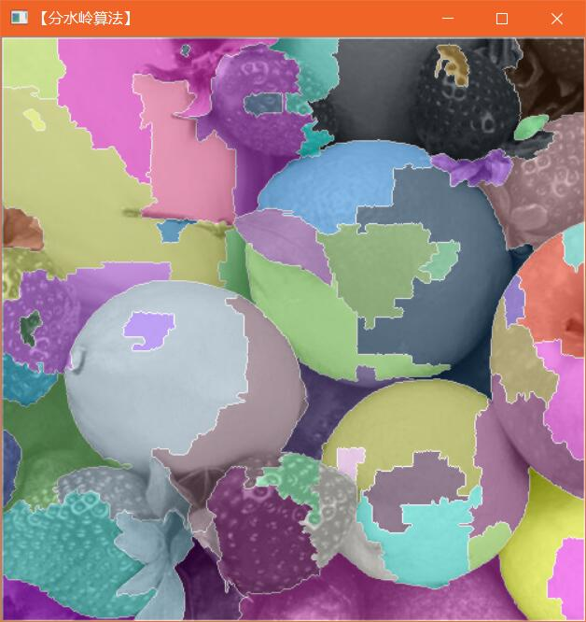

① K = 50：

当K = 50的时候，产生随机点个数56，程序用时0.435795s，满足实验要求。

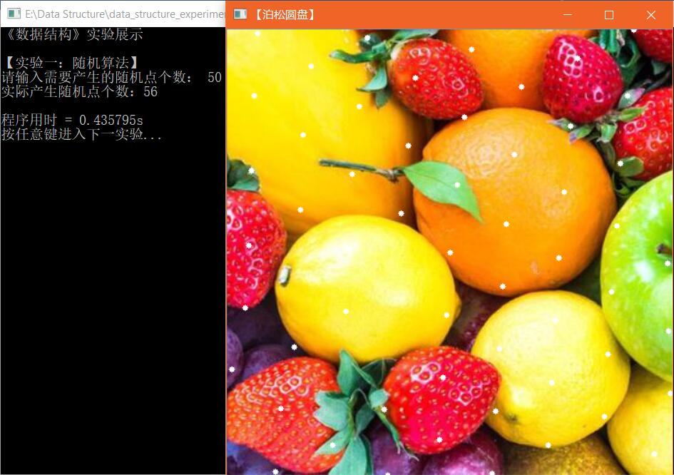

② K = 100:

当K = 100的时候，产生随机点个数107，程序用时0.512817s，可以看到时间开销已经往上走，但是依然保持在1s以内，满足实验要求。

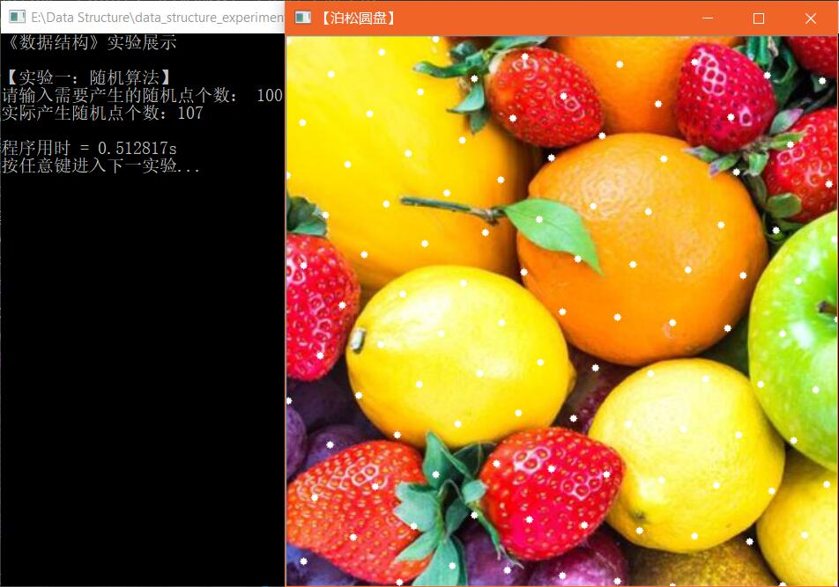

③ K = 200:

当K = 200的时候，产生随机点个数208，程序用时0.653463 s，依然保持在1s以内，相比其他算法，时间开销非常小，但是相对来说，点的分布规则性已初见端倪，但还是满足实验要求。

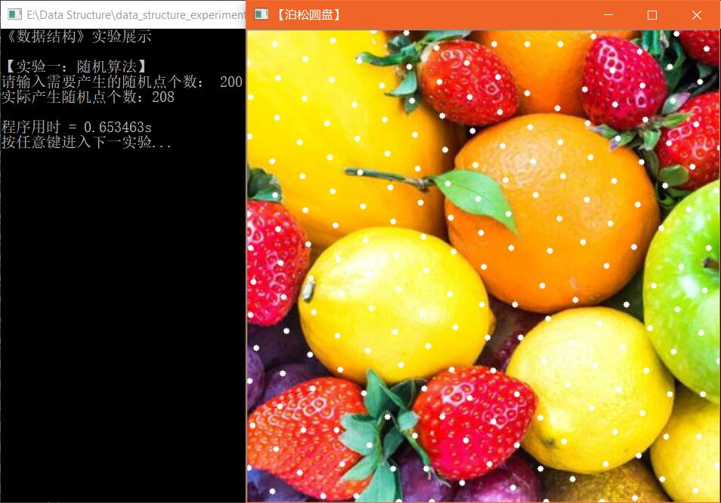

④ K = 500:

当K = 500的时候，产生随机点个数506，程序用时1.05344s，与其他算法相比，速度还是可圈可点，虽然点的分布随机性又进一步地降低，还是满足实验要求。

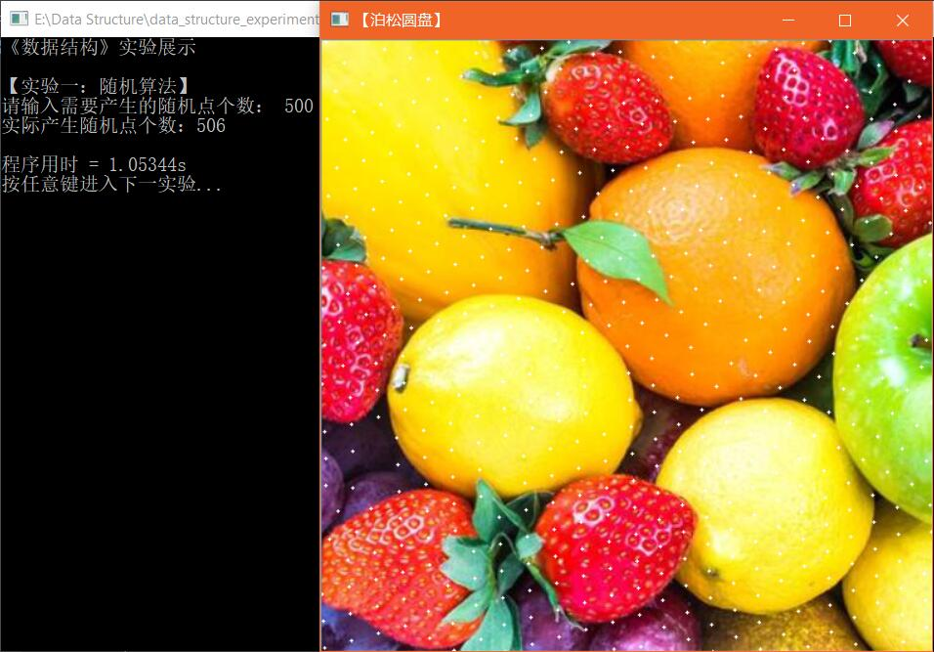

⑤ K = 1000:

当K = 1000的时候，产生随机点个数1015，程序用时1.88203s，可以看出来，点与点之间已经构成了菱形形状，虽然确实是随机的，表现在菱形的朝向与大小等，但不得不说，从时间上来看，依然保持着显著优势，满足实验要求。

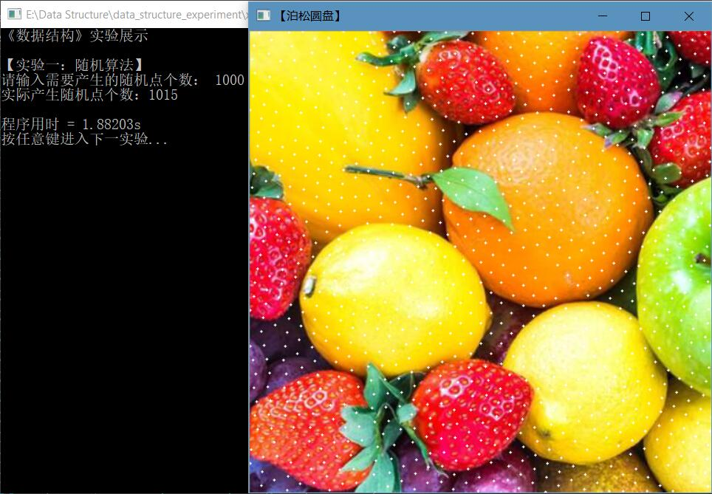

⑥ K = 5000:

当K = 5000的时候，达到了本算法的极限，产生随机点个数4395，已经不及5000，程序用时9.19137s，可以看出来，时间开销上来说还是相对较好，但是从随机点的产生个数和点的分布随机性来看，确实该算法的问题逐渐暴露，不满足实验要求。

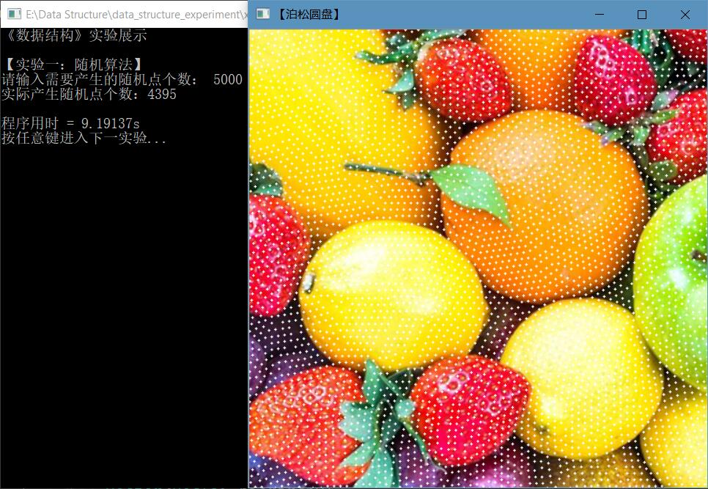

⑦ K = 10000:

当K = 10000的时候，产生随机点个数8777，程序用时24.6975s，可以看出来，耗费较长时间，并且图中空出的区域还是蛮多的，说明此算法对于K较大的时候明显有心无力，不满足实验要求。

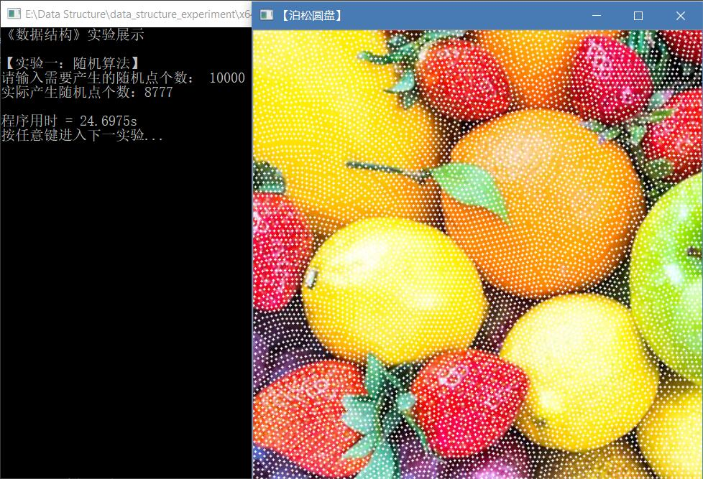

⑧ 异常输入:

当进行异常输入的时候，程序的容错性较好，能够处理用户的异常输入，满足实验要求。

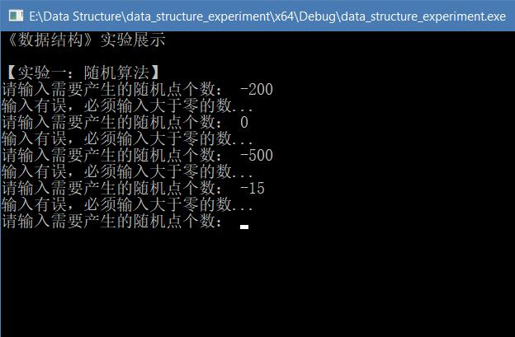

2. 四原色

① K = 50:

当K = 50的时候，满足相邻区域颜色不同的要求，程序用时0.18713s，极为快速，失败率极低，满足实验要求。

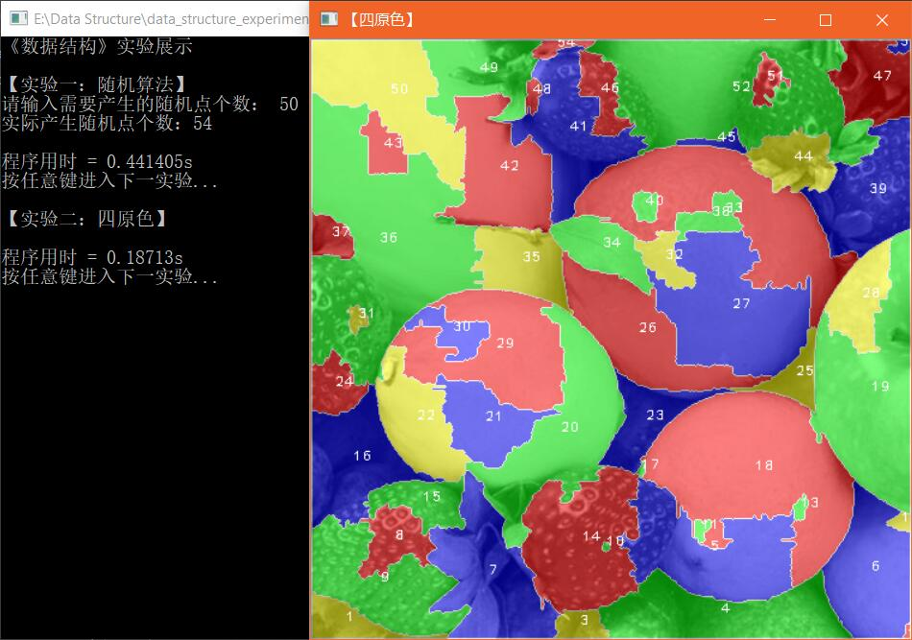

② K = 100:

当K = 100的时候，满足相邻区域颜色不同的要求，程序用时0.244821s，极为快速，失败率极低，满足实验要求。

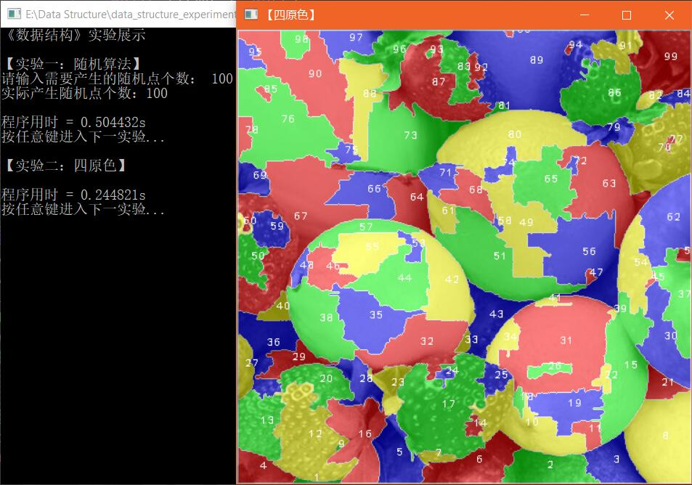

③ K = 200:

当K = 200的时候，满足相邻区域颜色不同的要求，程序用时0.397041s，极为快速，失败率较低，满足实验要求。

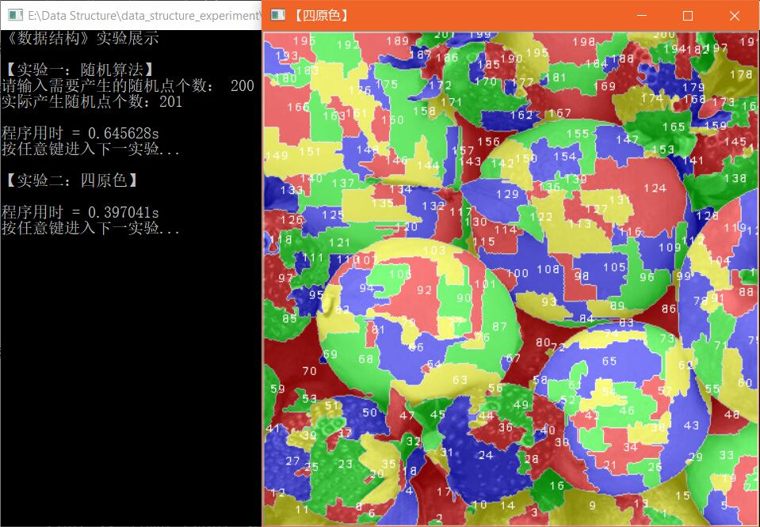

④ K = 500:

当K = 500的时候，满足相邻区域颜色不同的要求，程序用时1~2s不等，失败率10%，满足实验要求。

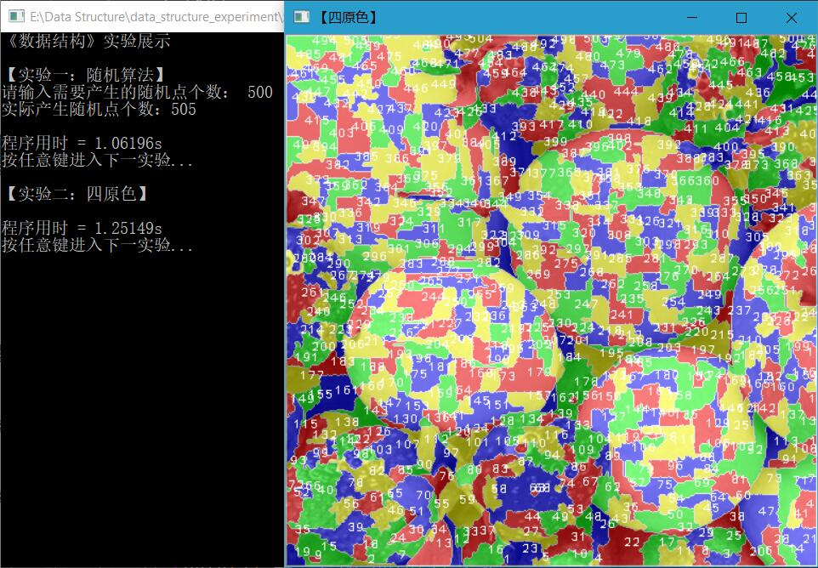

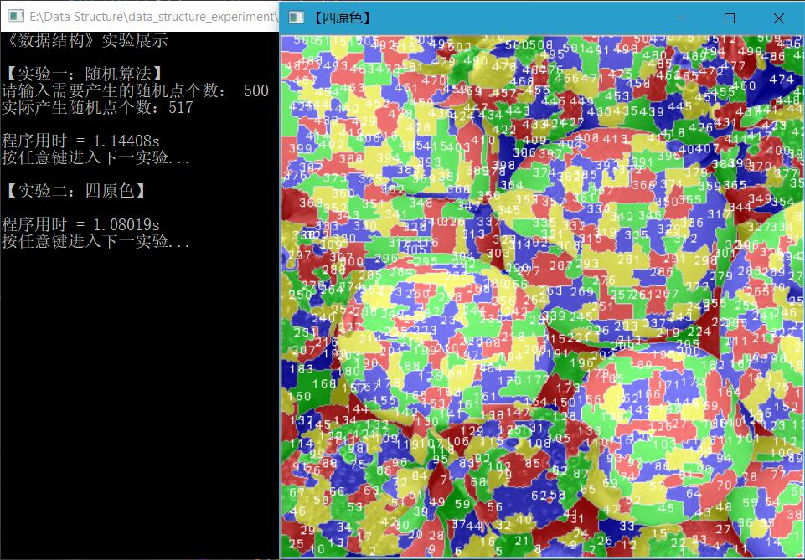

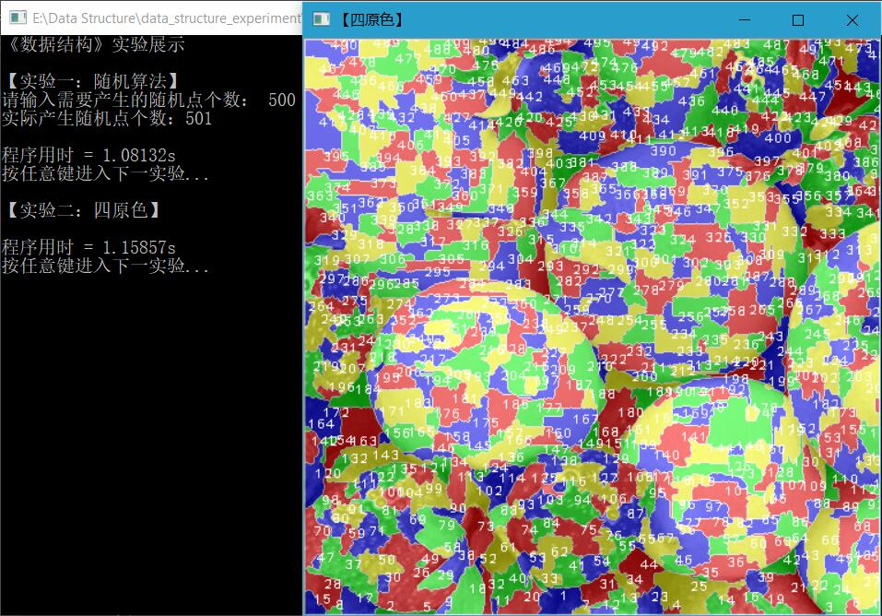

⑤ K = 800:

当K = 800的时候，满足相邻区域颜色不同的要求，但涂色程序执行稍显吃力，程序用时2~8s不等，与运气的有关系，失败率20%，满足实验要求。

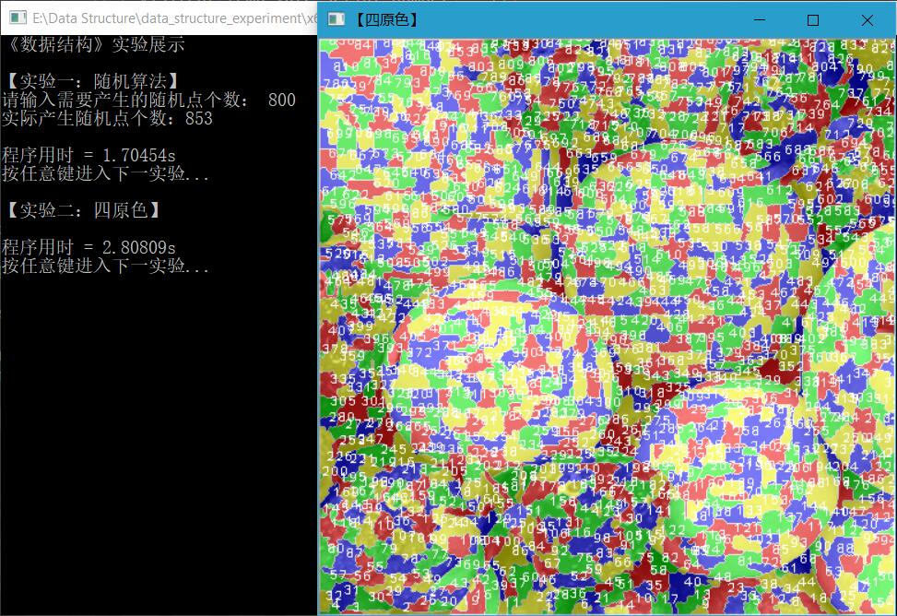

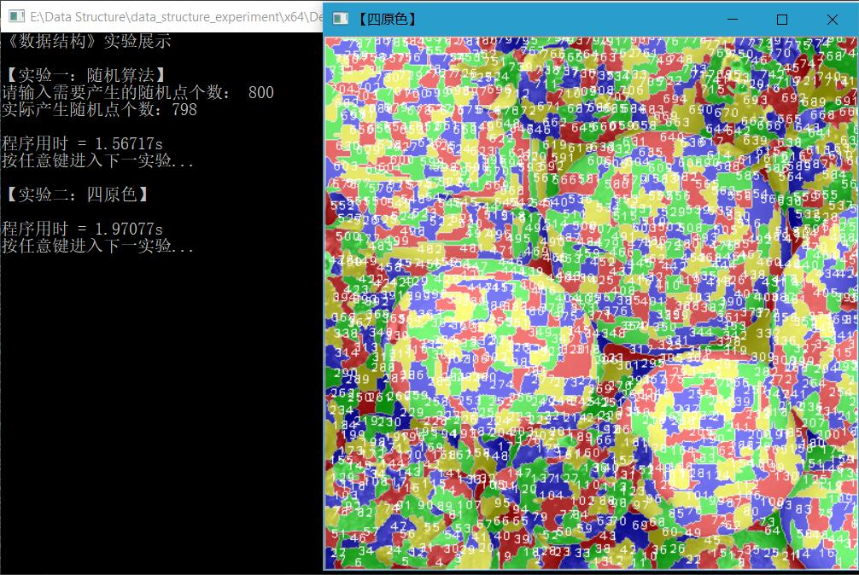

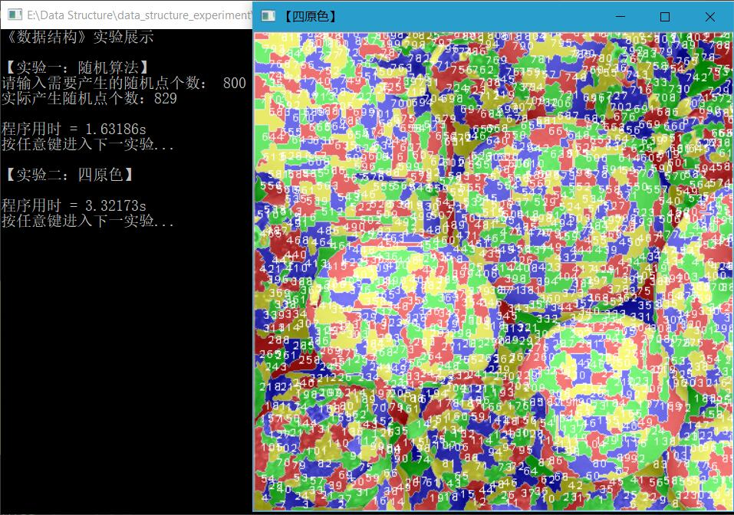

⑥ K = 1000:

当K = 1000的时候，满足相邻区域颜色不同的要求，但涂色程序执行比较吃力，程序用时4~10s不等，与运气的关系较大，失败率40%，满足实验要求。

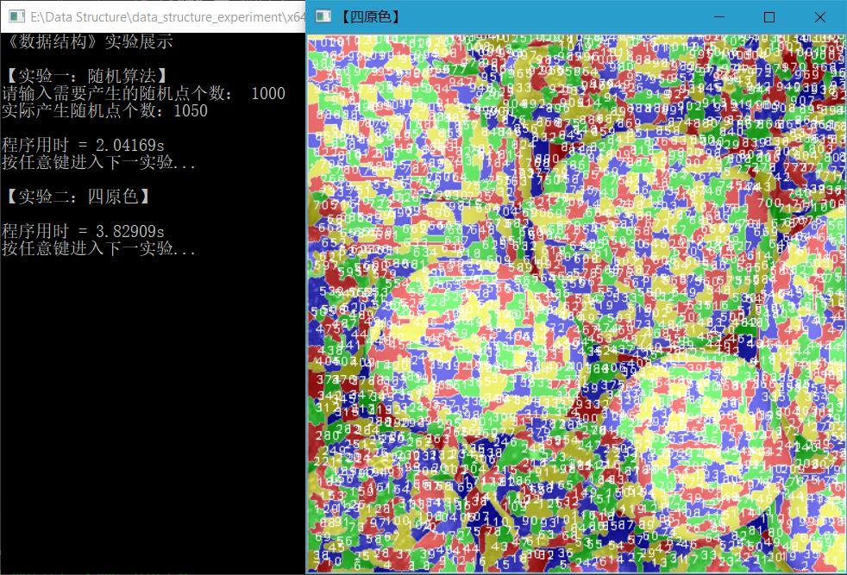

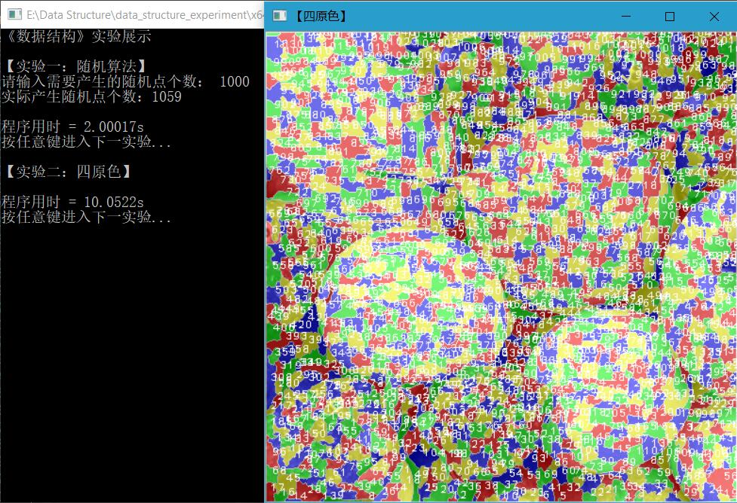

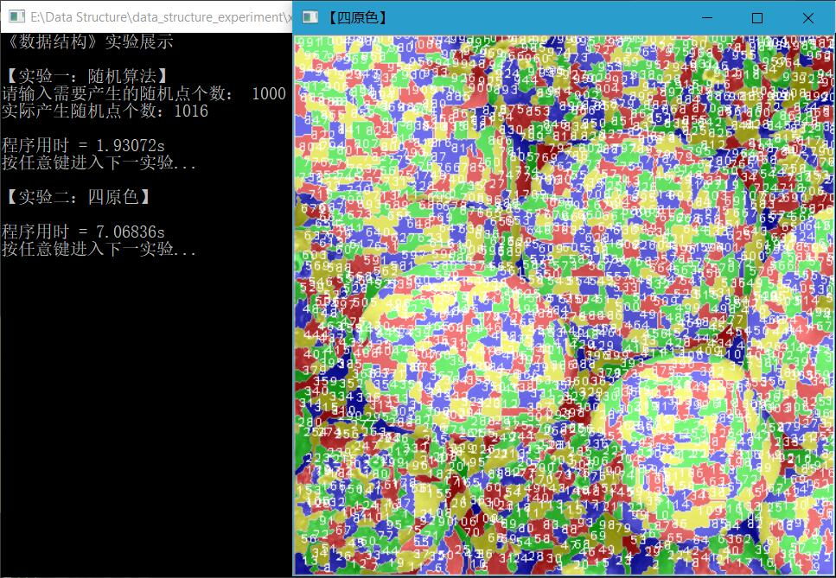

3. 哈夫曼

① K = 20:

当K = 20的时候，哈夫曼树不会交叉，满足实验要求。

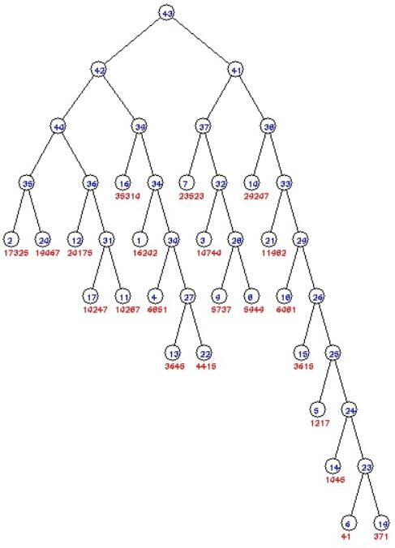

② K = 50:

当K = 50的时候，哈夫曼树不会交叉，满足实验要求。

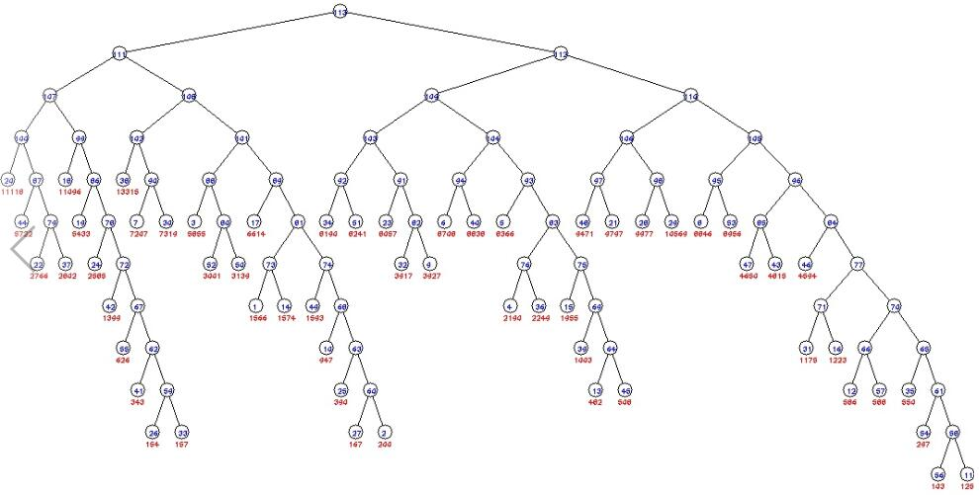

③ K = 80:

当K = 80的时候，哈夫曼树不会交叉，满足实验要求。

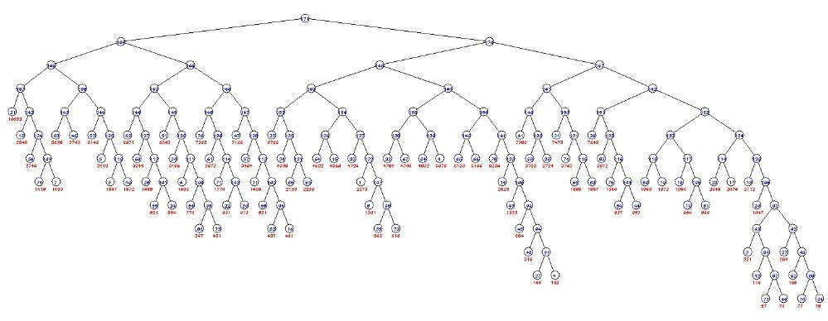

④ K = 100:

当K = 100的时候，哈夫曼树不会交叉，满足实验要求。

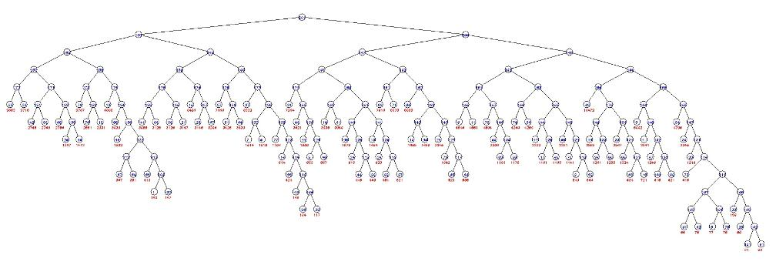

⑤ K = 200:

当K = 200的时候，哈夫曼树不会交叉，满足实验要求。

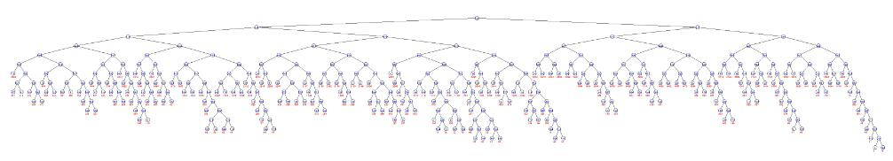

⑥ K = 500:

当K = 500的时候，哈夫曼树不会交叉，满足实验要求。



可以无限验证下去，使用本程序画出的哈夫曼树永远不会交叉，运行时间也不会超过1s，满足实验要求。

4. Dijkstra

① K = 50:

当K = 50的时候，任意输入两个区域，都能找到最短路径并高亮显示，满足实验要求。

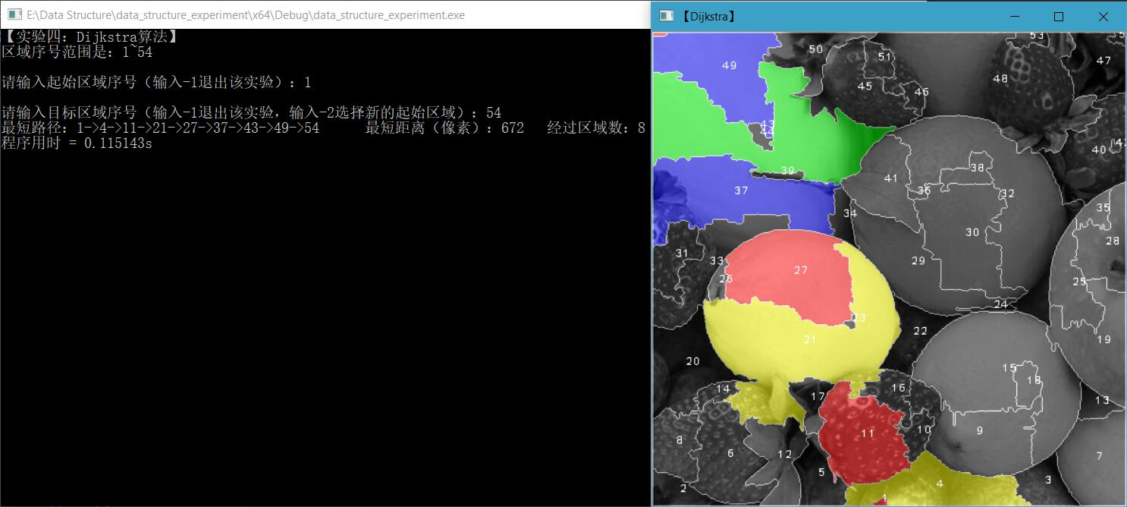

② K = 100:

当K = 100的时候，任意输入两个区域，都能找到最短路径并高亮显示，满足实验要求。

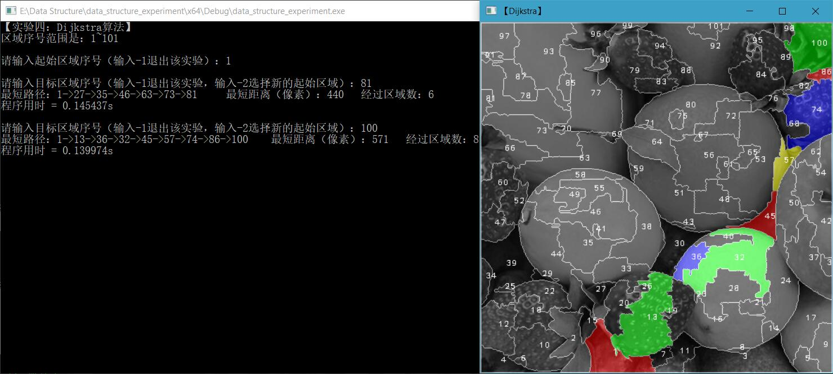

③ K = 200:

当K = 200的时候，任意输入两个区域，都能找到最短路径并高亮显示，满足实验要求。

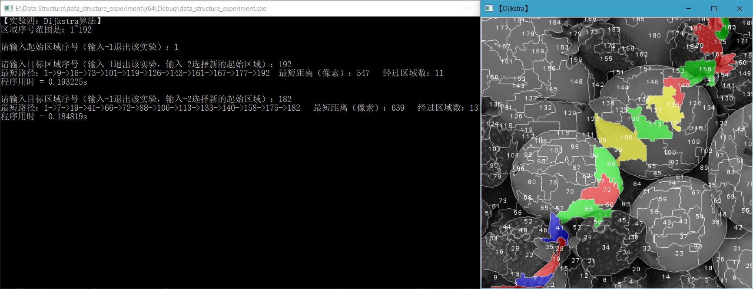

④ K =500:

当K = 500的时候，任意输入两个区域，都能找到最短路径并高亮显示，满足实验要求。

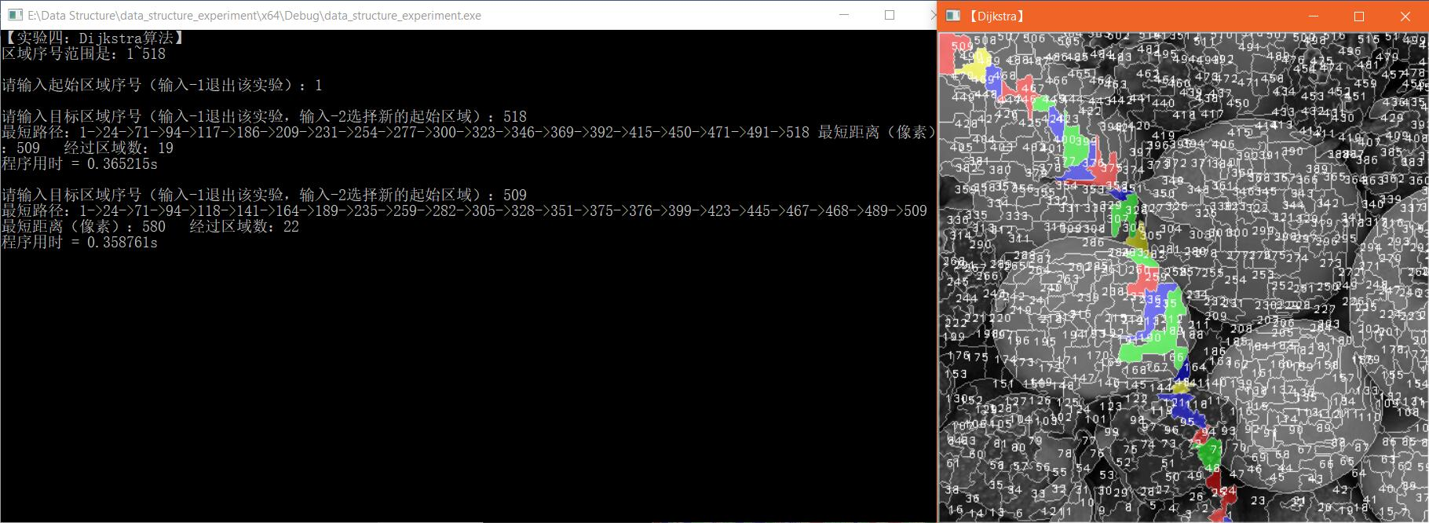

⑤ K =800:

当K = 800的时候，任意输入两个区域，都能找到最短路径并高亮显示，满足实验要求。

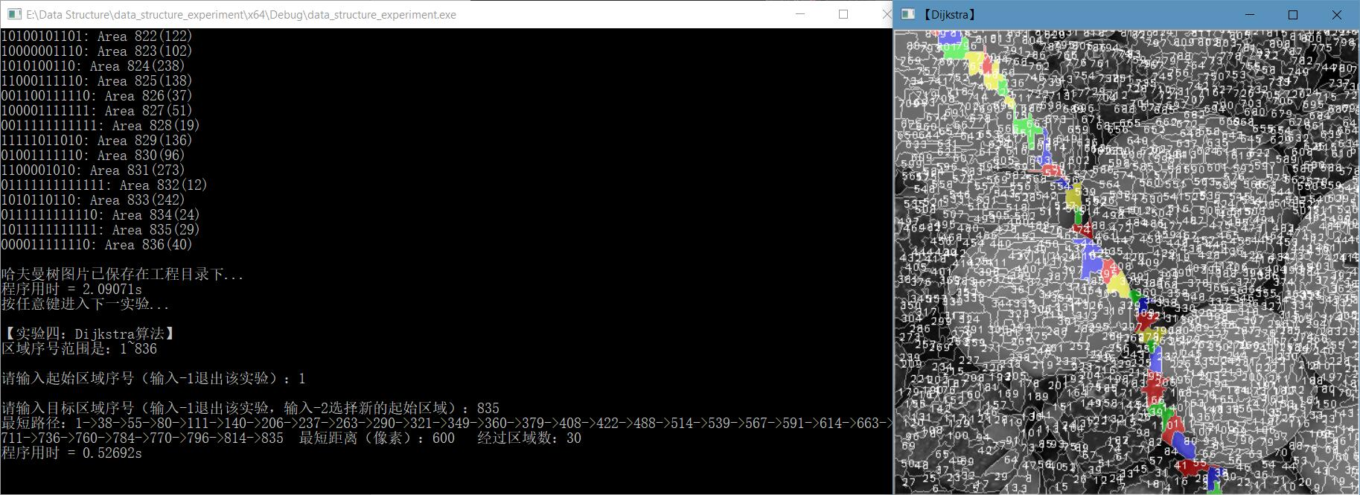

⑥ 异常输入:

当进行异常输入的时候，程序的容错性较好，能够处理用户的异常输入，满足实验要求。

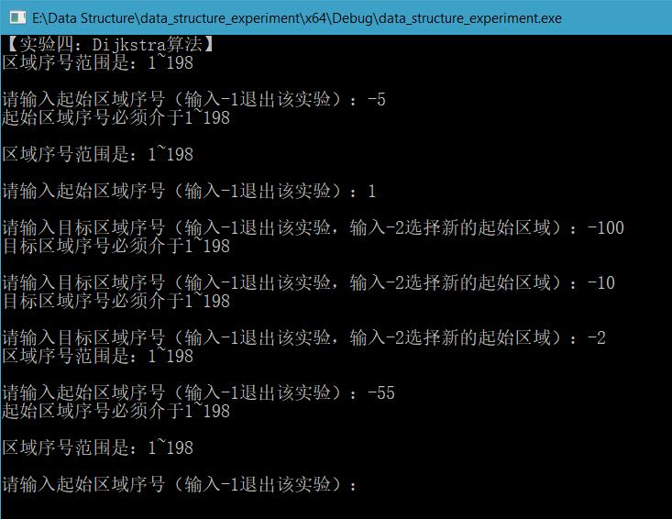

5. 堆排序

① K =50:

当K = 50的时候，升序、降序排序正确，可视化完成，时间1s以内，满足实验要求。

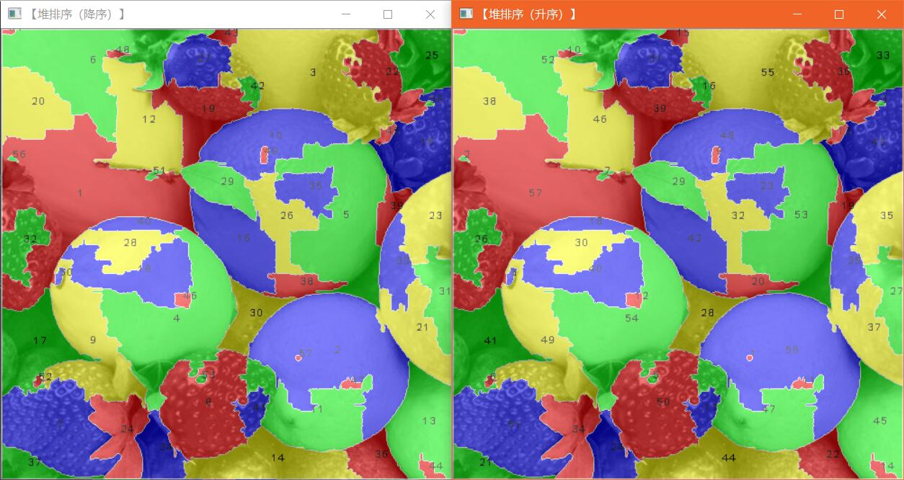

② K =100:

当K = 100的时候，升序、降序排序正确，可视化完成，时间1s以内，满足实验要求。

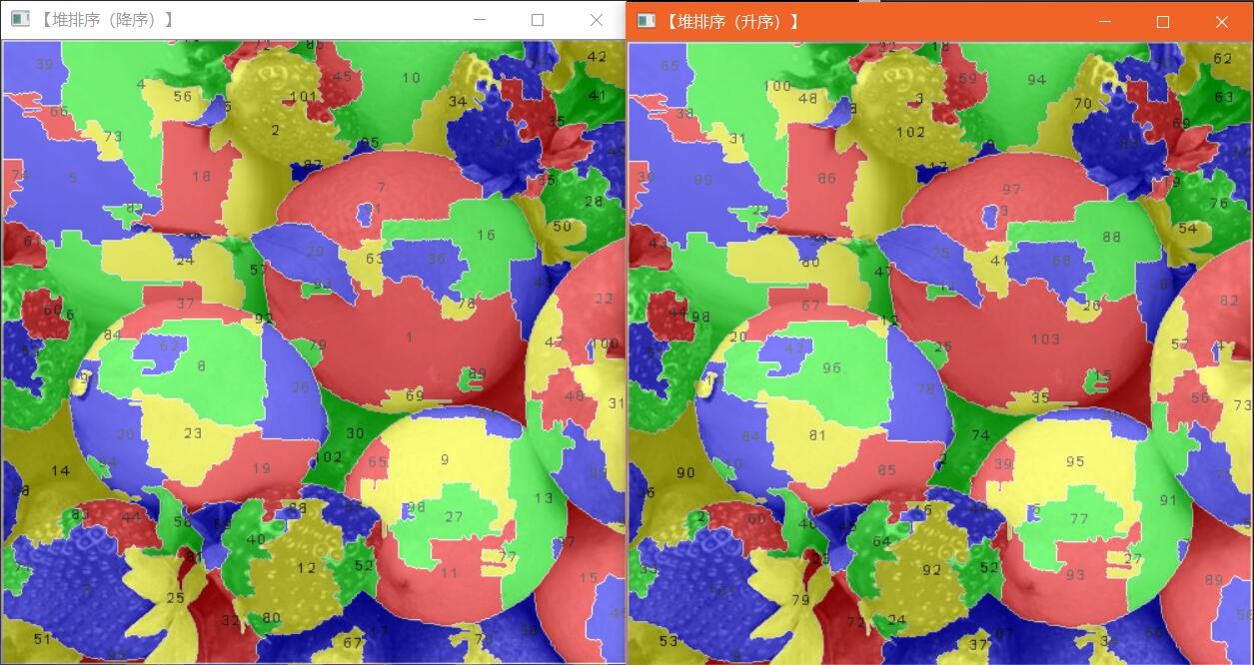

③ K =200:

当K = 200的时候，升序、降序排序正确，可视化完成，时间1s以内，满足实验要求。

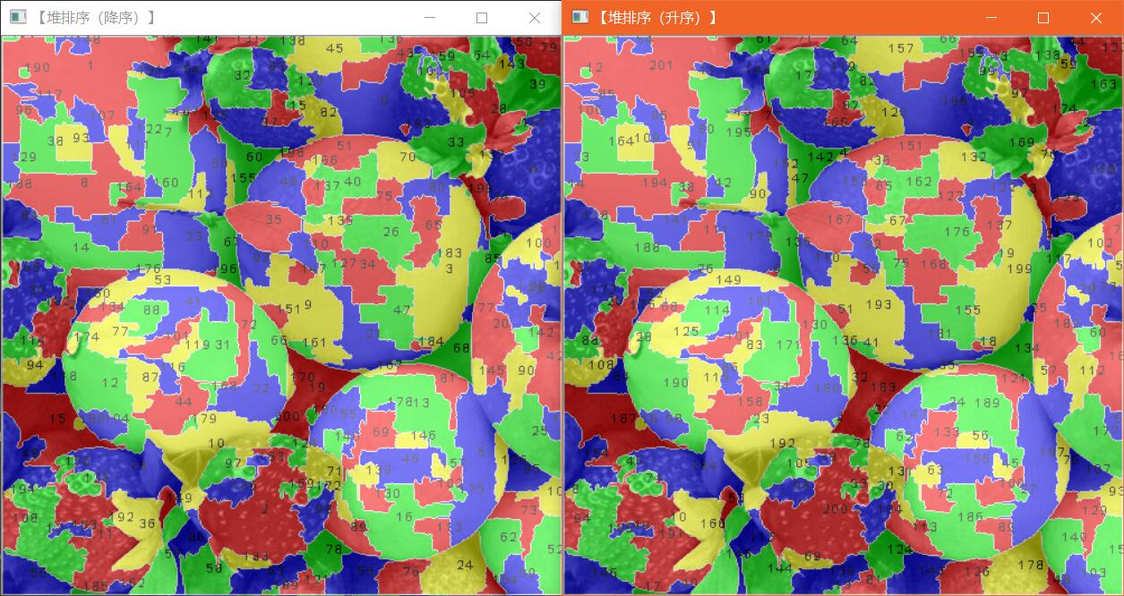

④ K =500:

当K = 500的时候，升序、降序排序正确，可视化完成，时间1s以内，满足实验要求。

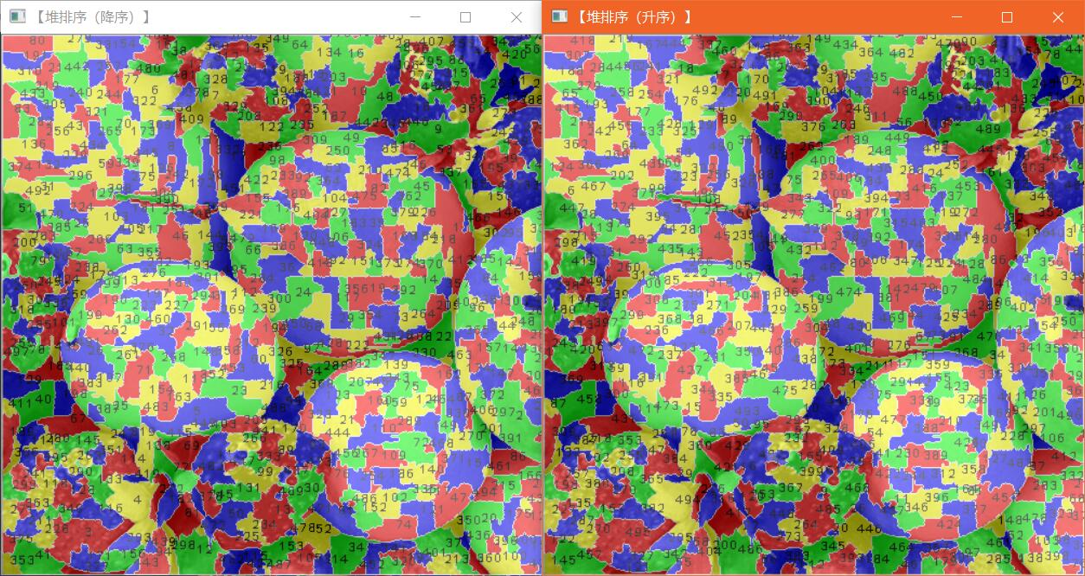

⑤ K =800:

当K = 800的时候，升序、降序排序正确，可视化完成，时间1s以内，满足实验要求。

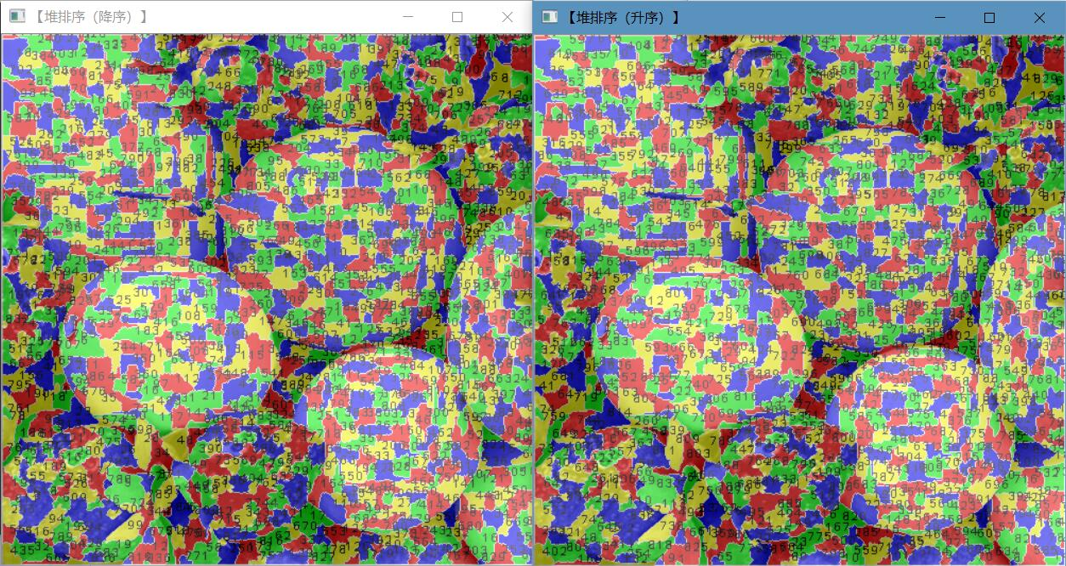

6. 折半查找

① K =50:

当K = 50的时候，折半查找正确，可视化完成，时间1s以内，满足实验要求。

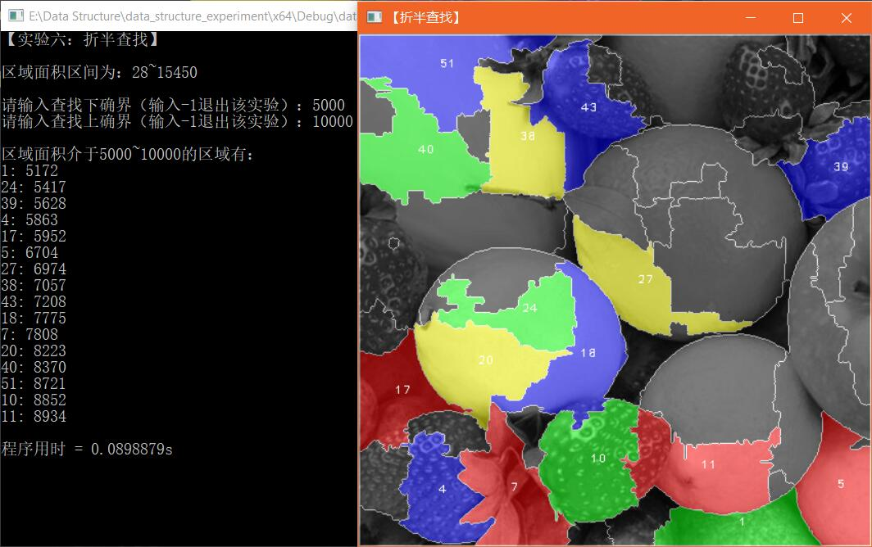

② K =100:

当K = 100的时候，折半查找正确，可视化完成，时间1s以内，满足实验要求。

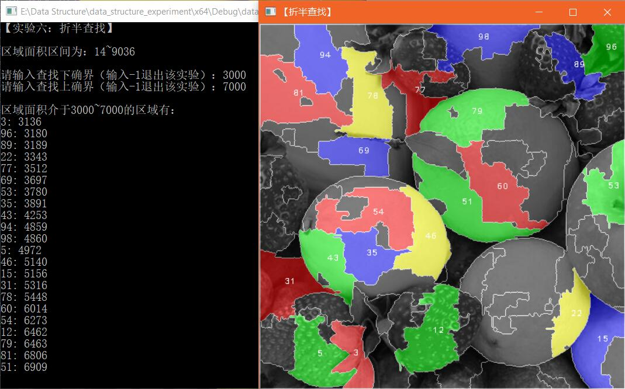

③ K =200:

当K = 200的时候，折半查找正确，可视化完成，时间1s以内，满足实验要求。

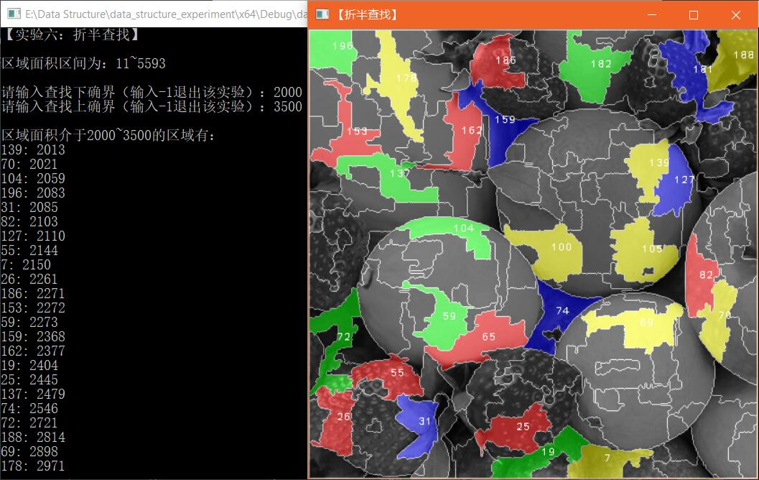

④ K =500:

当K = 500的时候，折半查找正确，可视化完成，时间1s以内，满足实验要求。

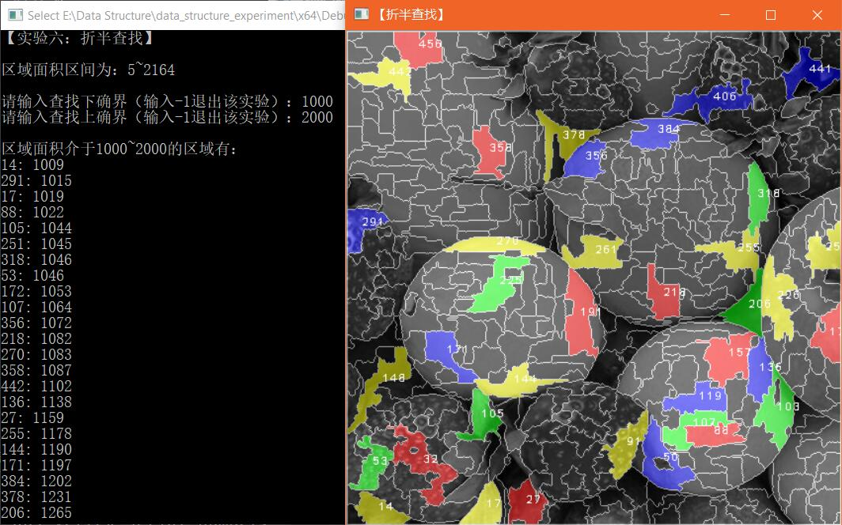

⑤ K =800:

当K = 800的时候，折半查找正确，可视化完成，时间1s以内，满足实验要求。

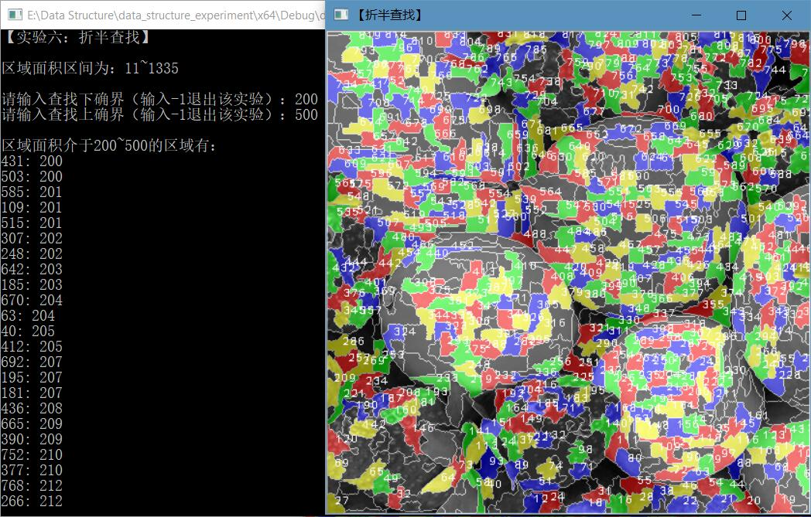

⑥ 异常输入:

当进行异常输入的时候，程序的容错性较好，能够处理用户的异常输入，满足实验要求。

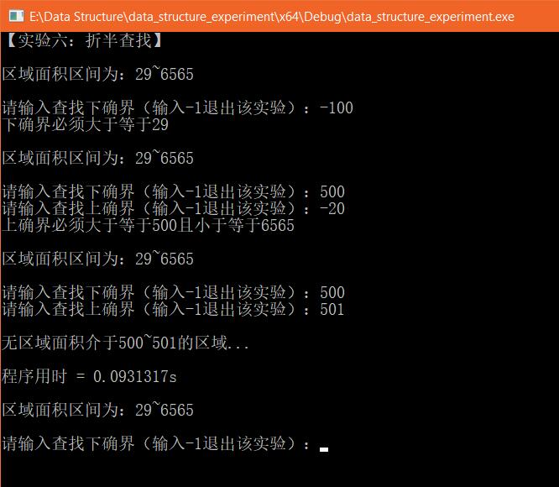

# 五、问题分析

1. 随机算法

1. 问题发现：

① 时间开销大。最开始做这个实验的时候，脑海里最初的想法是产生的随机点与所有已经产生的随机点去比较距离，但是实践证明，该算法虽然易实现，在点数不太多的时候取得的效果也还可以接受，但是其时间开销不是一般的大，远远不能符合要求。

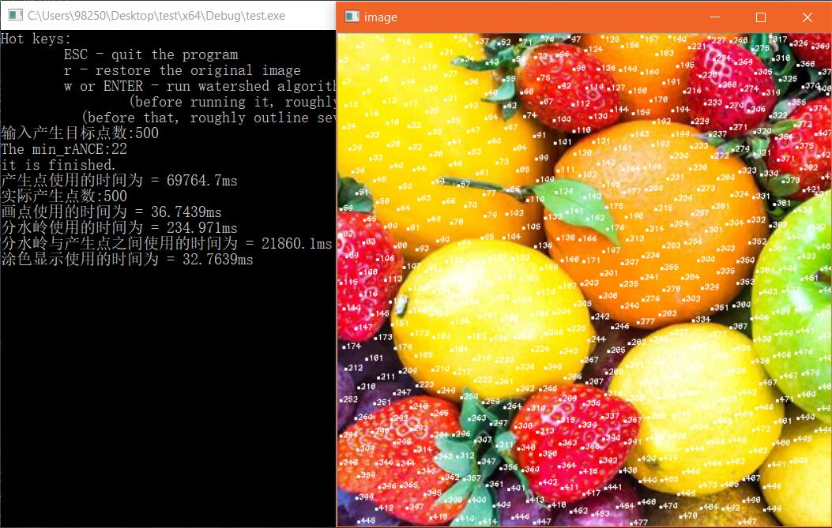

② 打点的点数不能符合要求。要求是用户输入K，无论K多小或者多大，打点数都必须大于等于K，而在最开始做此实验的时候，由于采用的是传统的泊松圆盘算法（即半径在r到2r随机，角度在0到360度随机），打点数几乎不可能满足要求。

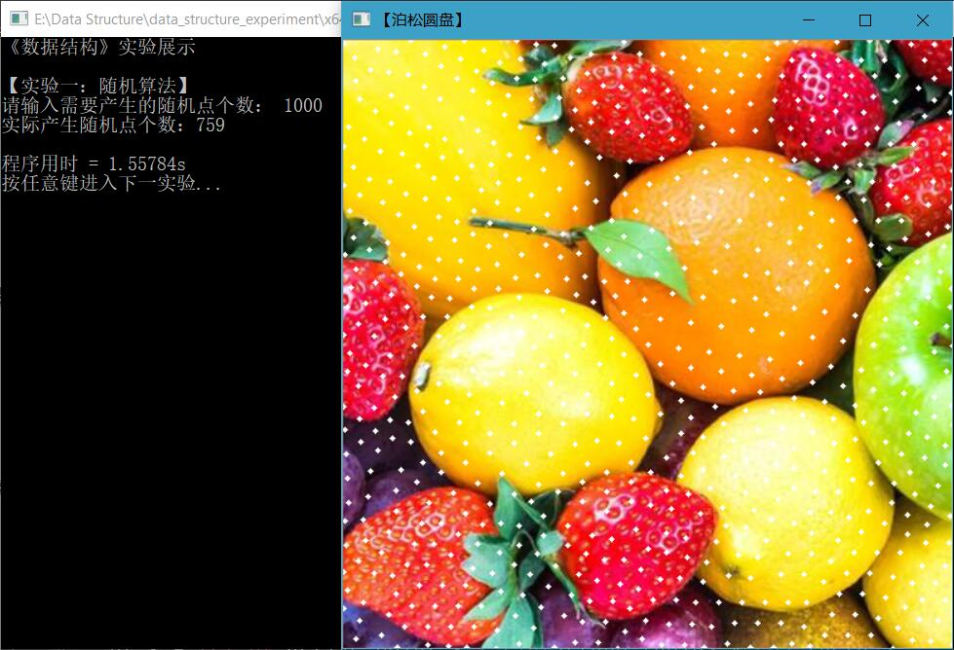

③ 打点分布稍规则。在采用改进了的泊松圆盘算法之后，虽然打点数已经大概率的满足要求，但是随之产生的问题是，由于将半径固定为r+1，只让角度在0到360度随机，根据几何学可知，产生的点大概率会是以一个菱形的形状分布，虽然角度在随机，确实菱形的角度、朝向稍有变化，但是不免看起来还是比较规则。



1. 问题解决：

① 对于第一个问题，位于较为远方的点，是完全没有必要距离的比较的，为了避免跟已经产生的所有点进行距离比较，我采用了划分网格的思路，即将整张图划分为一个网格，并且保证每一个格最多容纳一个点，这样如果要比较距离，只需要取出该点所在格的邻居进行比较距离，此举可减少大规模的距离运算，从而大大提高运行速度。

② 限制打点的其中两点因素分别是，距离在r到2r之间变动与图像边界利用率低，这两点都难以避免地会浪费一些空间，因此我采取的方案是，先在图像边界打满，然后令半径固定为r+1，只让角度随机。

③ 对于第三个问题，不得不说，这其实是打满点与点的分布规则的一种平衡，点打地越满，分布地越规则，反之，分布越不规则，点越打不满。因此，此问题是无法通过简单地优化而改进，实际上只能更换其他算法来改进打点效果。

2. 四原色

1. 问题发现：

当K大于200时，涂色程序会很容易陷入一个死循环，即不断退栈、出栈，不停地走之前走过的老路，不停地犯之前犯过的错误，一直找不到合适的涂色方案，永远出不来。如图所示，涂色辅助栈不断在48~51之间频繁出栈退栈，迈不过这个坎，程序就卡在此处。

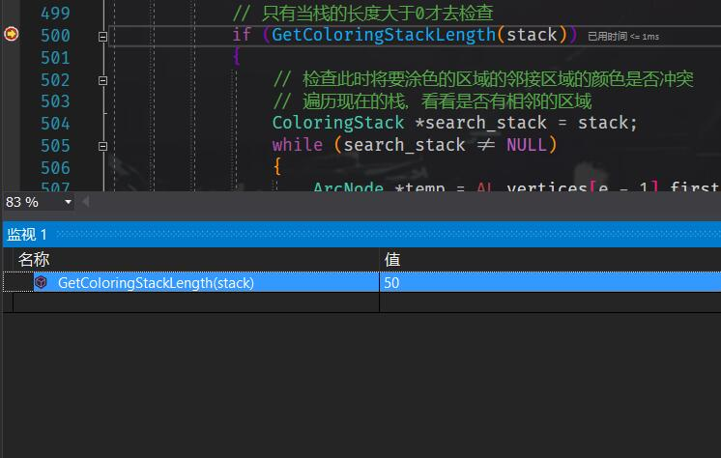

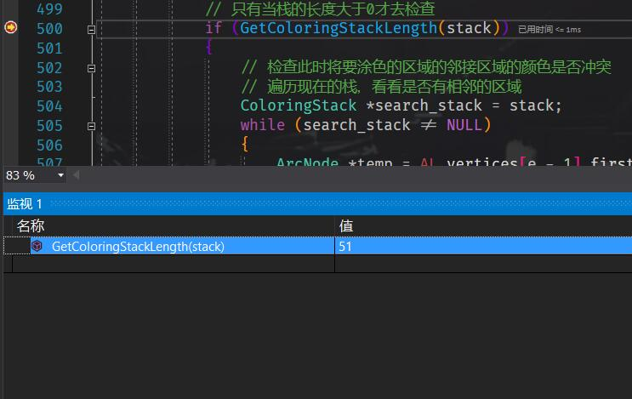

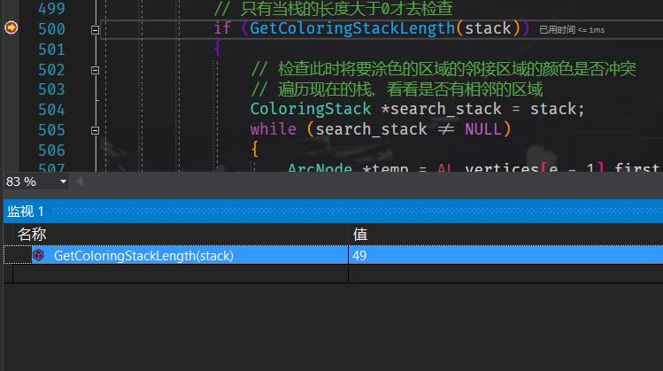

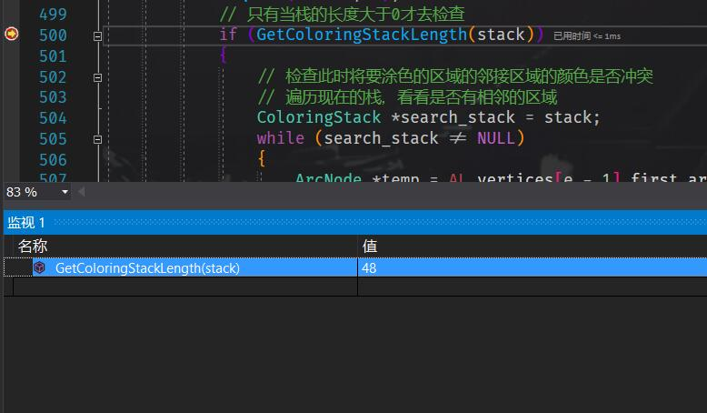

1. 问题解决：

该问题的解决方案是，如果涂色过程一直卡在某个地方，既不能继续往前涂，又不能往后退，说明陷入了死循环，那么就往回退50个试试重新规划路径。就在程序中补了如图所示的一段出入栈频率检测与措施的代码，涂色程序涂色上限便从200一跃而到1000，最终效果见程序测试分析。

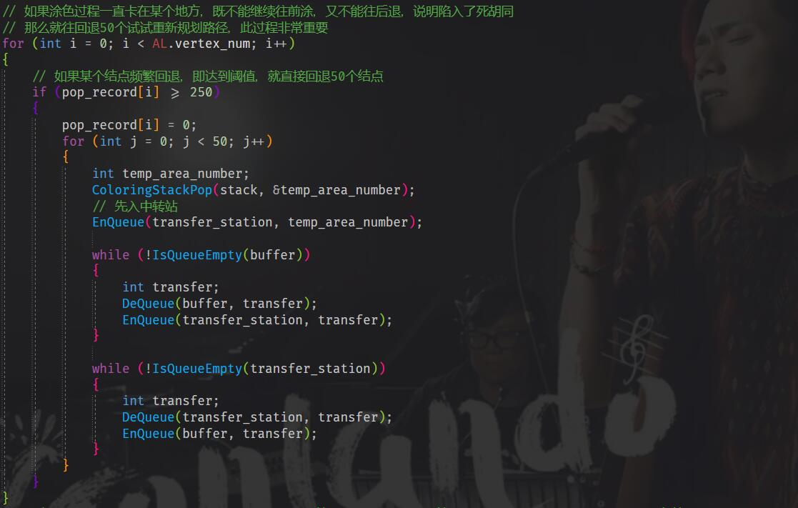

3. 哈夫曼

1. 问题发现：

第三个实验的难点主要是画哈夫曼树。在画哈夫曼树的时候，采用较原始的算法的时候子树与子树之间在K值很大的时候很容易发生交叉。

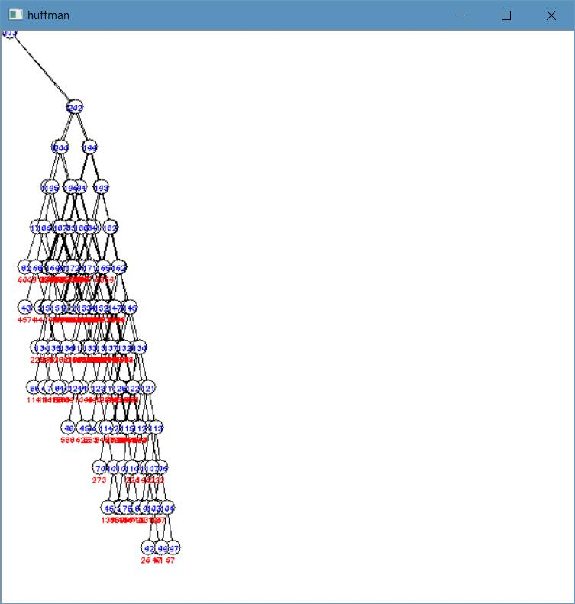

1. 问题解决：

之所以子树之间会交叉是该算法本身的缺陷，算法本身只考虑了一颗子树内部的交叉关系，没有考虑到不同子树之间的交叉关系。因此我采取了一个弥补措施，即在初步确定了每个点横坐标以后，再遍历一次这棵树，检查子树与子树之间是否存在交叉，若存在交叉，就将两颗子树背向远离，如此便可将子树与子树之间拉开距离。加入以下代码便可完美解决问题。

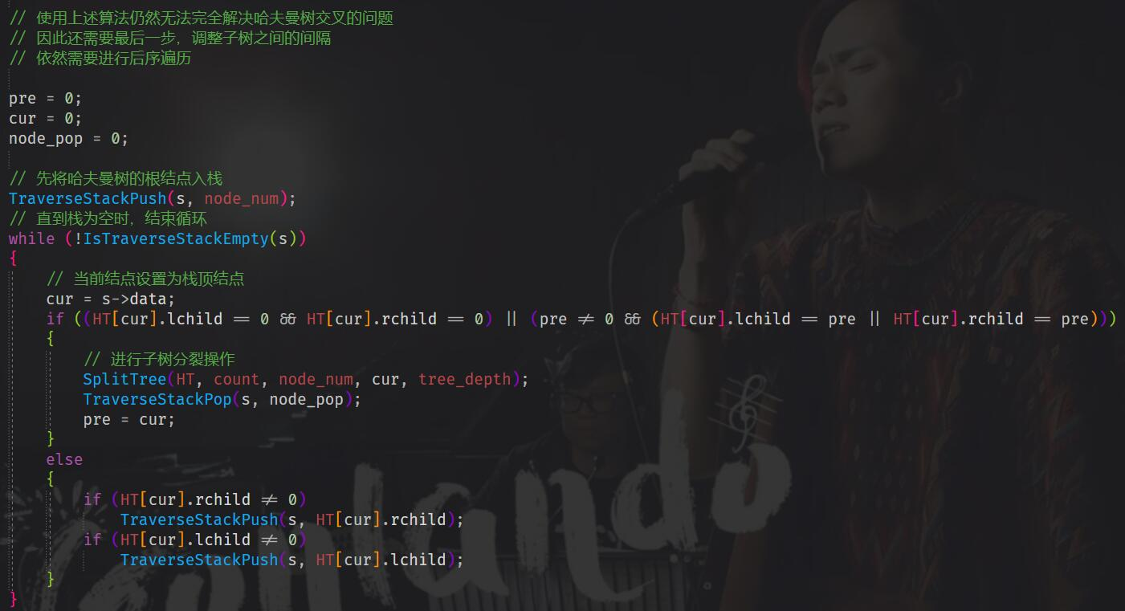



4. Dijkstra、堆排序、折半查找

1. 问题发现：

这三个实验整体上没碰到什么问题，但是其中的可视化问题是一个可以商榷的问题。Dijkstra要求高亮最短路径，堆排序要求将面积进行升序、降序排序并在图像上标示，折半查找则要求将面积介于用户输入的区间范围的区域进行高亮，因此，这三个实验除了算法本身的实现外，还有很重要的一点就是可视化。

1. 问题解决：

可视化问题的解决主要还是基于之前得到的maskImage，因为之前正是通过maskImage得到区域轮廓信息并且通过maskImage才能进行四原色可视化。因此同样地，传入maskImage，模仿四原色的可视化，便可依葫芦画瓢做出这三个实验的可视化。效果图见程序的测试分析。

5. 关于泛化与代码可移植性问题

经过多次测试，发现我的代码对于其他大小类型的图片有可能会出现不兼容的现象，有时候运行正常，有时候会出现问题，我推测原因可能是我自始至终都按照我的图片尺寸来写代码，没有考虑到泛化的这一层，并且我写的代码可移植性并没有达到我的期望。如下一系列图片是换了另一张1000*750的水果图后进行的代码测试。

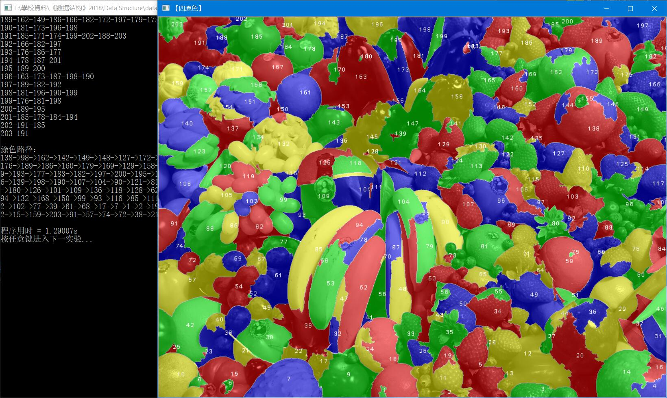

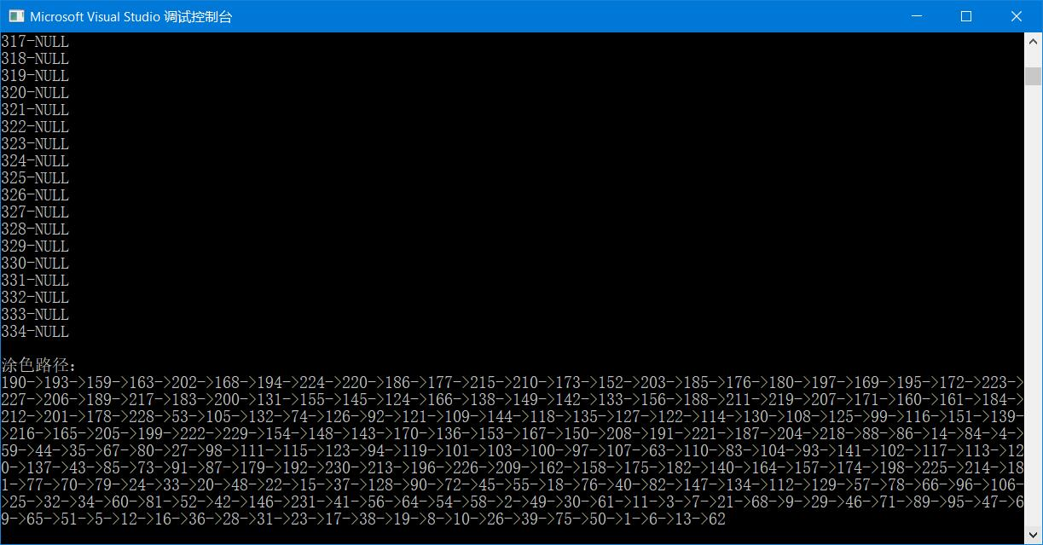

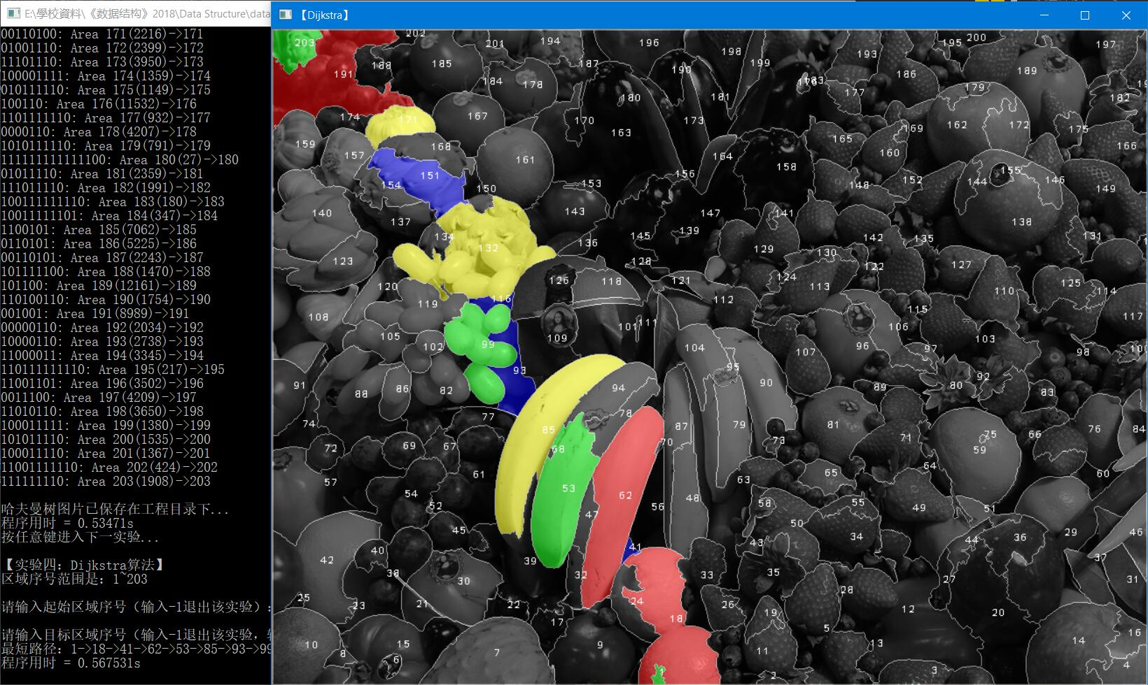

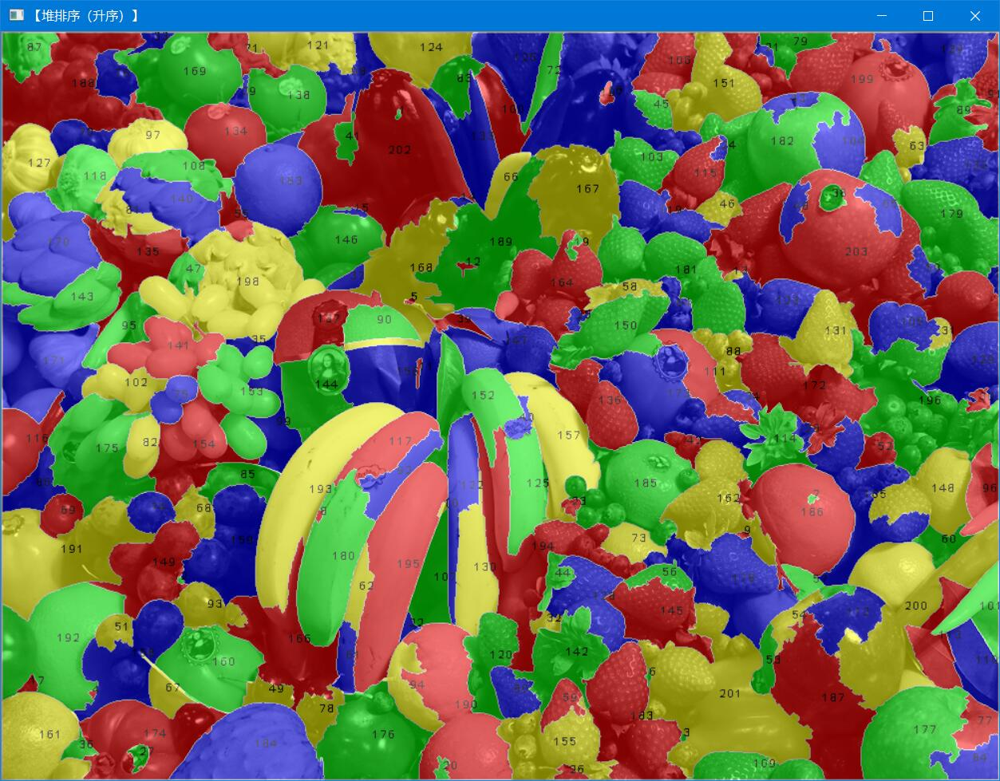

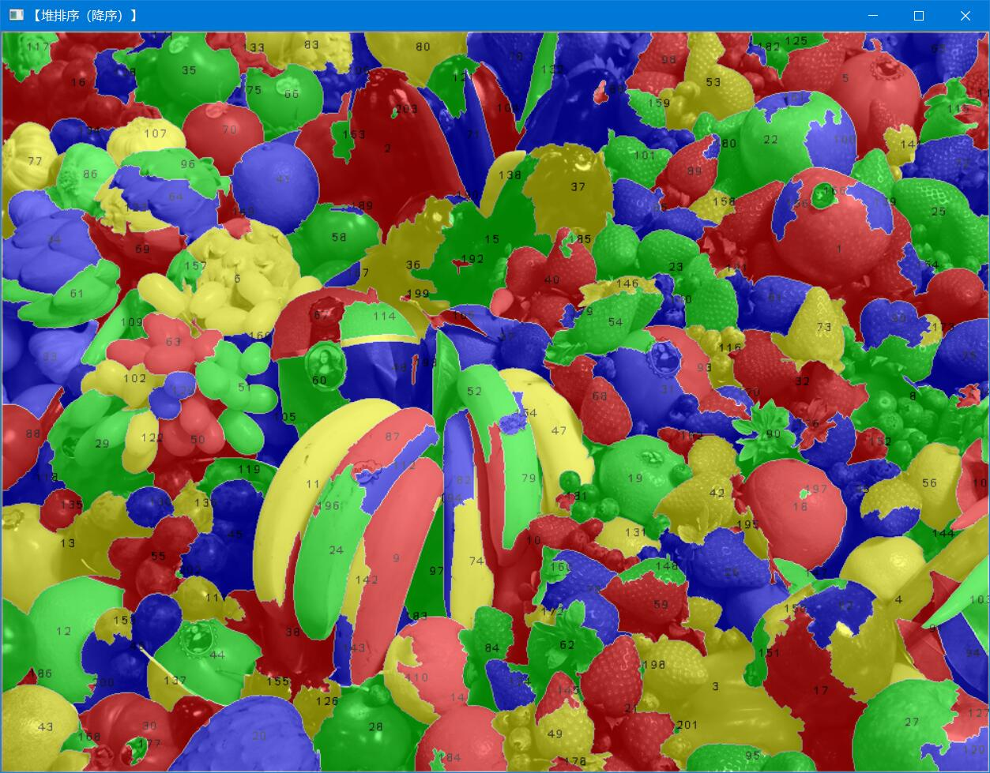

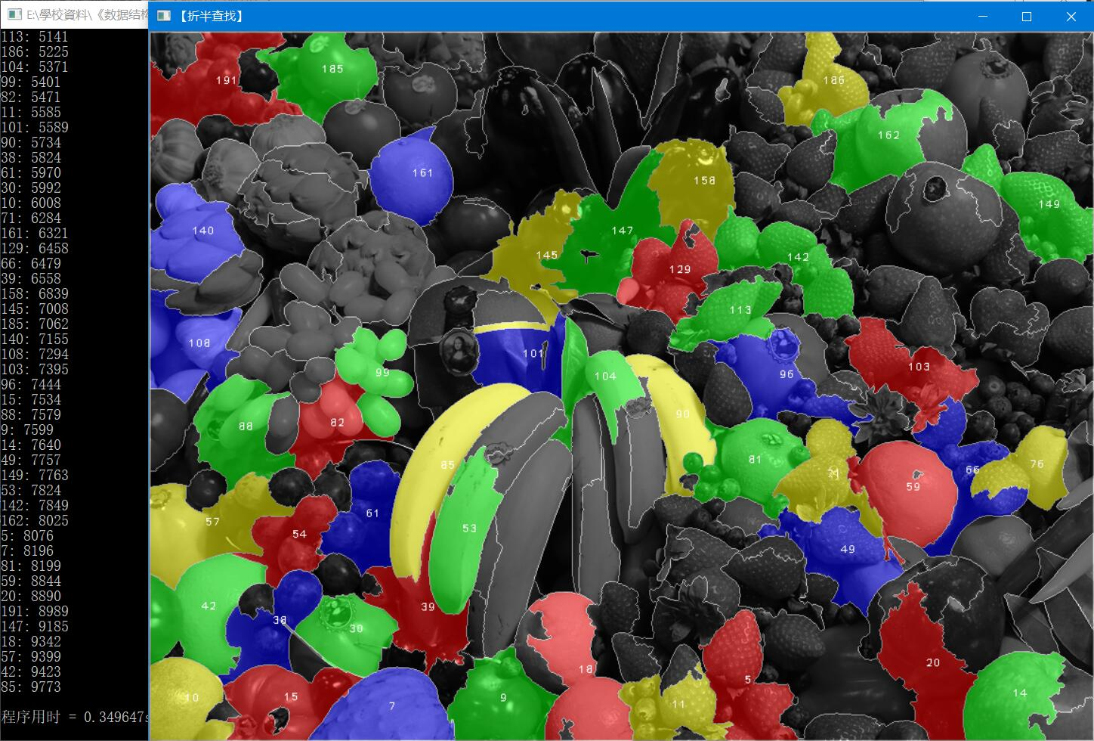

# 六、总结与展望

我从2018年9月19日开始着手《数据结构》实验，期间经历过处处报错、不符合要求的绝望，也经历过程序圆满完成任务的欣喜若狂，最终于2018年10月19日正式将六个实验全部完成。

我第一个实验足足做了一周，可能是因为我还没有进入状态，期间我常常找不着头绪，最初我是在百度搜索，但是百度实在是令我失望，什么有用的信息都搜索不到，最后我抛弃百度，直接去Google搜索，搜到了国外大牛的论文和论坛，对我帮助极大。当我完成了第一个实验的时候，已经快临近第一次验收了，当时这着实令我着急。我认为在六个实验当中，第二、三个实验是较其他四个实验中难度较大的两个实验，因此我用了四天的时间才把第二个实验完成，用了国庆四天晚上才把第三个实验完成，也正是在这两个实验中我收获了许多，成长了许多，因为从中我明白了有时候在一个小地方犯了一个小错，就会导致整个程序的崩溃，因此学会如何调试也是十分关键的。并且，先理清算法逻辑比直接上手写代码要效率更高。而第四、五和六个实验相对较简单，因此如行云流水般用了两三天就全部解决了。

另外，我明白了解决一个问题可以有很多种不同的算法，片面地说，有的算法运行很快但可能空间复杂度较高，有的算法运行很慢但效果较好，并且在调试中我了解到，即使我们写出了一个比较合适的算法，它也很难做到能够满足所有的需求，比如第一个实验中的打点，我采用的算法如果打满点，就不能很好地满足随机性，如果追求随机性，就大概率地打不满点，鱼与熊掌不可兼得，这个是算法本身的问题，因此如果要想取得更好的效果，显然应该抛弃这种打点思路，采用其他算法才有可能解决这个问题。

其次，我还想谈谈开源精神。首先声明，此次《数据结构》实验均由我独立完成。其次虽说韩教授说不允许抄袭，但是我认为其实韩教授只是想让我们独立完成，掌握其中的知识。从长远的角度来看，开源是十分重要的。Windows 10为什么频遭诟病、Bug频出？虽然微软公司的员工都是精英，但是毕竟人的精力是有限的，Win10操作系统的Bug可不是单单靠一个小小的团队就可以应付的。反观Linux操作系统，Linus Torvalds只身一人坐于自己的办公室，就有全球网民一起为Linux操作系统贡献力量。因此，在以后的道路中，我会始终坚持开源精神。

最后，说说一些遗憾。经过多次测试，发现我的代码对于其他大小类型的图片有可能会出现不兼容的现象，我推测原因可能是我自始至终都按照我的图片尺寸来写代码，没有考虑到泛化的这一层，并且我写的代码可移植性并没有达到我的期望。关于代码可移植性的问题，我想谈谈我的想法，对于我自己而言确实可移植性并没有什么，但是如果对于一个团队而言，代码可移植性就显得十分重要了，因为编程这件事本来就是后人踩着前人的肩膀才能爬的更高，如果每一次都要重写函数，那人类在软件方面就不可能取得长足发展，那么对于我个人而言，我对我自己的编程要求还是比较严格的，因此以后关于代码可移植性也是我改进自我的一个方向。而对于泛化，我对我自己的要求是一定要具有一定的泛化能力，不然的话，写的代码只可能适用于自己的机器，只适用于自己给定的环境，这样的代码不具有任何实用意义和借鉴意义，这是属于不合格的代码。因此，今后我一定会注意到泛化与代码可移植性这两个问题，尽可能地将函数接口修改地更普适，写代码要考虑到多种情况，多种细节，将所有情况抽象成一种模型，使得代码能够泛化地更好。

我希望我能够对编程永葆热忱，不断严格要求自己，促使自己的编程能力更上一层楼。最后，感谢韩守东副教授在这一学期的辛勤执教。

参考文献

[1] R. Bridson, Fast Poisson Disk Sampling in Arbitrary Dimensions.

[2] 毛星云, OpenCV3编程入门, 电子工业出版社2015.

[3] 严蔚敏、吴伟民, 数据结构（C语言版）, 清华大学出版社2012.

[4] Wikipedia, Huffman Coding. <<https://en.wikipedia.org/wiki/Huffman_coding>>).

[5] Wikipedia, Dijkstra's Algorithm.

[6] Wikipedia, Heap Sort. <<https://en.wikipedia.org/wiki/Heapsort>>).

[7] Wikipedia, Binary Search Algorithm.